Clinical governance standard:
As per this standard, leaders of healthcare have responsibility to govern and be a part of continuous improvement. As per standard 1.6 (a) of Governance, leadership and culture, clinical professionals must understand their duties and responsibilities. Moreover, they must add to the role of providing quality care to the care seekers. Moreover, as per standard 1.8 of Measurement and quality improvement, safety,
quality must be maintained as per the safety protocols of an organization. Records must be managed in the “My health record system” as per standard 1.18 of Healthcare records. These standards belong under the amendments of Clinical governance standard (safetyandquality.gov.au, 2019).
Preventing and Controlling Healthcare-
Associated Infection Standard: as per this standard, healthcare professionals must ensure that harm and intensity of infections from exposure is reduced. In this concern, standard 3.1 of Integrating clinical governance can be considered, which mentions policies and procedures of reducing infections must be in place and professionals must adhere to the norms. As per standard 3.6 of Standard and transmission based precautions, clinicians must assess transmission based risk for the care seekers and arrange safety equipments as per that. As per standard 3.8, hand hygiene and as per 3.9 aseptic environments must be mentioned. In this case, clean environment must also be maintained as per the indications of standard 3.11 of clean environment (safetyandquality.gov.au, 2019).
Implementation in the area of RN
As mentioned above governance and safety requirements must be maintained well. In case of registered nurses, the nurses must maintain hand hygiene as per the norms of NSQHS. Additionally, they must adhere to the practice of providing quality care. In this concern, proper record management and maintaining a viable environment for the care seekers stays of empirical need.
Clinical examples
Practical examples of the above standard implementation include workforce immunization programs, which most the hospitals adhere to. This includes immunizing the workforce against infections first as they can act as the main carriers of infection. Instance of Sonic healthcare can be taken, which provides “workplace flu vaccinations” as one of immunization strategies. This can be a part go governance framework in healthcare organizations. Another instance of hygiene and use of personal protective equipment by healthcare organizations can be taken which confirms to the standard of preventing and controlling healthcare.
Reply to post 1:
NSQHS standards actually have been helpful to bring about continuous improvement in the system. This can be helpful to deliver quality care, which most of the hospitals fail to provide. Additionally, standard of partnering with consumers can be helpful to provide holistic care, which in turn involves patient centered care. However, revamping the standards cannot be enough and in fact can cause trouble healthcare organizations. As per a survey carried by Criterion this year, it has been observed that most of the hospitals are struggling to partner with consumers and maintain governance.
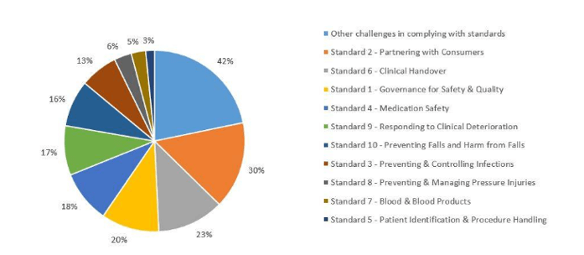
(Source: https://www.criterionconferences.com/blog/professional-development/nsqhs-standard-hospitals-struggling/)
In this concern, RNs play a valuable role and can actually help the organizations to deliver better services. As RNs communicate with the care-seekers most of the time, they can contribute to the process of partnering with consumers.
Reply to post 2:
I agree that comprehensive care standard can be helpful to deliver quality care as this address the following areas:
- Screening of risk as per standard 5.10 as this help to address history of care seeker and take actions as per that
- Clinical assessment before hospital admission as per standard 5.11 as this would help to allocate necessary environments (Farmer et al. 2018).
References
criterionconferences.com. (2018). Which NSQHS Standard are hospitals struggling with most? Retrieved on 23 May 2019, from: https://www.criterionconferences.com/blog/professional-development/nsqhs-standard-hospitals-struggling/
Farmer, J., Bigby, C., Davis, H., Carlisle, K., Kenny, A., & Huysmans, R. (2018). The state of health services partnering with consumers: evidence from an online survey of Australian health services. BMC health services research, 18(1), 628.
safetyandquality.gov.au. (2019). National Safety and Quality Health Service Standards. Retrieved on 23 May 2019, from:https://www.safetyandquality.gov.au/wp-content/uploads/2017/11/National-Safety-and-Quality-Health-Service-Standards-second-edition.pdf

