Influence of sexual objectification of women in advertising, on consumer purchase decisions

SUPERVISOR:

STUDENT NAME:
STUDENT NUMBER:

WORD COUNT:

“I’ve seen the future and it is blue.”
By Matthew Friedman (2003)

ACKNOWLEDGEMENT

Firstly, I’d like to offer my humblest thanks to God, the most merciful and most compassionate having all knowledge and wisdom.

I feel much pride in acknowledging the inspiring guidance, encouraging attitude and valuable comments; I received from my dissertation supervisor Prof. Charles Dennis; who has been very helpful and supportive at every stage of my dissertation progress, by continuously motivating me to stay on a right track and work effectively with his excellent coaching.
My sincere thanks are due to the contestants of this study for giving their valuable time and participating in the study. Without their contribution my research would not have been completed. At the end, I feel great depth of obligation to my loving parents whose prayers have enabled me to reach this stage.
Thank you very much all for your help and support.

DECLARATION

I confirm that this report is wholly my work. The dissertation does not incorporate without any proper acknowledgement of the particular author in referencing. I also confirm that the work is not a copied from any previously published materials. The referencing and citation is fully provided in the text and footnotes, using (Harvard Reference Style) and the full reference list is provided as well. I have given my best in this research, by trying to provide all knowledge obtained about the research topic. I accept that on submission of this research report, it becomes the property of Brunel University who may further use this report for research purposes if required, without my consent.

Student ID:
Date:

ABSTRACT

This research focuses on differentiating the decision making of consumers towards brands that are promoted through sexually objectified ads on women. The study highlights the perceptions and attitudes of consumers towards purchasing such brands. It also seeks to understand the influence of present situation on consumers’ attitudes and decision to buy.
The research literature shows the consumer behaviour responses towards advertising. It reflects on whether ads objectifying women as sex objects have a positive or negative influence on the consumers. And in turn how does it affect their purchase decisions.

This research is based on quantitative research approach where the data is collected using a questionnaire survey. The survey is carried out in two different situations to fill in the gap in the literature, determining and comparing the different responses of the two different groups of participants.

The findings from the research reveal that consumers have neutral attitude towards such ads, they do not have any negative feelings towards the ad, as they consider it as a normal routine advertisement. This is the case due to much of sexual content used in media these days. However, the results also show that the first Group of participants not inclined towards purchasing the brand, due to the environment they were provided to answer (right after viewing the ad), while the second group had almost equal ratio of respondents inclined towards purchasing the brand and not effected to purchase it. This shows that it’s not the “sex sells” slogan that works, but consumers just take it as any other advertisement. Moreover, path for further research studies is also recommended in the end.

TABLE OF CONTENTS

Acknowledgements ………………………………………………………………….3
Declaration.............…………………………….………………………………….....4
Abstract……………………………………….……………………………………...5
Contents of dissertation…..........................................................................................6
List of figures………………………………………………………………………...9

Chapter 1: Introduction

1.1 Introduction..……………………………...………………….…………………10
1.2 Significance of study……………………………………...…………………….11
1.3 Aims and objectives…………………………………………………….……….13
1.3.1 Objectives…………………………………………….……………..13
1.3.2 Research question………………………….………….…………….13
1.4 Structure of dissertation...……………………………………………………….14

Chapter 2: Literature Review

2.1 Introduction ...……………………………...………………….…………………16
2.2 Consumer behaviour and decision making……………………………………......16
2.2.1 Consumer Behaviour….........................................................................16
2.2.2 Understanding consumer behaviour....…………….……………….….18
2.2.3 Consumer decision making processes .........................................….....20
2.2.4 Advertising and consumer behaviour …………………………….......24
2.3 Sexual objectification of women in advertising .....................................................27
2.3.1 Advertisers’ perceptions …...................................................................27
2.3.2 Consumers’ perceptions ………….……………………...................…29
2.4 Consumer attitudes and purchase decisions towards brands using such ads.....….29

2.5 Advantages and disadvantages of such ads ………………....................................35
2.5.1 On Consumers …..................................................................................35
2.5.2 On Society .................................................................................….......35
2.5.3 On Business .................................................….....................................36
2.6 Contemporary Issues of Gender Differences & Age...…………..………….……37

2.7 Problem identification..................................................…………..………………38

2.8 Summary………………………………………………………………....………39

Chapter 3: Methodology

3.1 Introduction........ ……………………………….………………………………..40
3.2 Research design…………………………………………………………………..40
3.3 Research methods……………………………………………….………………..42
3.3.1 Primary Research Methods.....................................................................42
3.3.2 Secondary Research Methods……………………….…………………43
3.4 Participants of study…………………………………………..………………….43
3.5 Data Collection ...........................................…………………….………………..44
3.5.1 Data Collection among Group A.............................................................44
3.5.2 Data Collection among Group B.............................................................45
3.6 Method of Data Analysis……………………………...…………………………45
3.7 Limitations and Potential problems...............…………………………………….46
3.8 Summary………………………..………………………………….…………….47

Chapter 4: Findings

4.1 Introduction........ ……………………………….………………………………..48
4.2 Findings from Questionnaires...…………………………………………..….….48
4.2.1 Findings from Group A.........………………………………….………49
4.2.2 Findings from Group B.........………………………………….………56
4.3 Summary…………………………………………………………………...…….63

Chapter 5: Discussion

5.1 Introduction........ ……………………………….………………………………..64

5.2 Consumer perceptions about sexually objectified ads on women.........................64
5.3 Consumer attitudes and purchase decisions towards brands using sex appeal in their ads...............................................................................................................................65
5.4 Consumer responses in two different situations…...................................………67
5.5 Summary................................................................................................................68

Chapter 6: Conclusion and Recommendations

6.1 Introduction........ ……………………………….………………………………..69
6.2 Conclusion..............................................................................................................69
6.3 Recommendations..................................................................................................70

References

References……………………………………………………………………………72

Appendixes

Appendix A: Ethical form of the research study………….......…………………….80
Appendix B: Questionnaire ...............................................…………………………82
Appendix C: Findings from Group A ………………………………………………85
Appendix D: Findings from Group B ………………………………………………89
List of figures

Figure 1: Attitudinal stages with the effects model ..................................................18
Figure 2: The pyramid of consumer behaviour .........................................................20
Figure 3: Consumer Decision Making Model ...........................................................21
Figure 4: The Conceptual Framework ......................................................................22
Figure 5: Model of Consumer Decision Making ......................................................23
Figure 6: AIDA Model..............................................................................................28
Figure 7: Elaboration Likelihood Model ..................................................................31
Figure 8: Three Hierarchies of effects......................................................................32
Figure 9: The induction Process................................................................................41

CHAPTER 1
INTRODUCTION

  - Introduction

Marketing is gaining substantial power in the modern world and advertisers are the people who play with the minds of the customers by using different tools and techniques to attract them for their products. They keep on searching for new ways to attract the clients for their upcoming products and new brands. Along with several other advertising tactics, nowadays women have been identified and used as a major tool of attraction while promoting different products through advertisements. Women are not only used as the suitable instrument for advertising instead they are also considered as the sexually attractive object for promotional activities.

Advertisers think that highlighting the sexual objectivity of women in ads would attract a major segment of market a huge number of consumers for their product. And this research would simply answer this statement, either by proving or disapproving it through past researches, interviews and surveys from different consumer segments of the society. This study would mainly focus on the decision making power of customers for any product or brand which is promoted by using sexually objectified ads on women. This study would show whether clients are attracted through such ads or their response is neutral or bad by focusing the increased or decreased demand of that product or brand.

One more considerable rationale is the significance of advertising in business outlook, every business now focuses on customer behaviour realizing its interior consequence for their sales and profit, and so the advertising sectors are expected to plan outcome oriented advertisements highlighting the increased sales. This can be accomplished if the clients certainly react to the commercial, thus taking encouraging buying decisions towards the brand or product. This might also be due to the reason of immense competition which is present in consumer markets these days. Women are targeted as the sexually attractive tools for ads because not only a large number of buyers are usually interested in watching such ads but they attract more toward those brands and products who are using such objects in their advertisements. Advertisers need attraction of the consumers so that they can send their promotional messages affectively and if consumers are going to find it attractive and interesting they would retain it for a longer period of time (Robinson & Hunter, 2008).

Although in older times such trends were not seen because there was no major competition present in the market and also marketing was not considered as the significant tool of attracting more and more customers, but nowadays due to immense competition and presence of a large number of sellers, one has to focus on attractive marketing strategies to survive in today’s competitive market. But in the study our main focus is on the sexual objectification of women in ads, different problems related to such strategy, customer’s response against such objectification of women and lastly the change in demand of the specific brand and product which is the ultimate purpose of the advertising and marketing. The study has tried to spotlight on a very essential gap present in the historical research, particularly the power of customers while their preference for the brand through their general insight towards sexual objectification of women in ads.

In the history of marketing, advertising has been thought of as a key factor to communicate with the customers. Advertisers, nowadays, are confronted with increasing competition. Thus they have been looking for ways to present a brand in such an arresting way so that consumers will retain information and possibly change their buying behaviour. (Manceau and Tissier-Desbordes, 2006)

However, the advertising strategy used must answer all questions relative to its effects on target audiences, including the changes in the decision making towards the brand. (Manceau and Tissier-Desbordes, 2006)

Since the seventeenth century advertisement has been used to attract customers towards certain product or business (www.mediaknowall.com), however the content of advertising is being criticized in many aspects. One of the concerns regarding advertising since the feminist era is the portrayal of women in advertisements as a decorative object. Several researches have been done in this regard, conferring its effects on the public. Various media literacy efforts have been made to educate people in this regard (Reichert, LaTour, Lambiase, and Adkins, 2007).

Sexual objectification of women in advertising is a quite sensitive and important problem as such ads have considerable unintentional effects on the attitude of people, especially regarding the women’s' role in the society and the way it is perceived. Another significant reason is the importance of advertising in business perspective, every business now focuses on consumer behaviour realizing its core importance for their sales and profitability, and thus the marketing departments are expected to design result oriented advertisements emphasizing on increasing the sales. This can be achieved if the customers positively respond to the ad, thus taking positive purchase decisions towards the brand (Reichert, LaTour, Lambiase, and Adkins, 2007), but that might not always be the case?

The research to date has tended to focus on a very important gap found in the literature, specifically the influence of consumers' situation while buying the brand on their overall perception towards sexual imagery in advertising.

1.2 Significance of Study

If somebody says in this modern world that sexual objectification is not good from marketing point of view then it seems like a very old concept. As now this concept has gained much importance in the field of marketing and sales. Marketers are aware of the fact that in one or the other way they have to make their sales higher day by day, thus they have been adopting new strategies to do so. Now the sexual objectification has been accepted by majority of the marketers but still few have objections over this. They think humans should not be used as objects while we are talking about tools and techniques of marketing. Research on marketing persists to make obvious that women’s roles are sexually originated and they are predominantly used as items which may please viewer’s eye. Old researches have shown significantly depressing reactions of females about such ads. And if the depiction of females as sexual objects in ads develop into more extensive use than, such women would go badly behind it while the educated ones feel that it is quite acceptable when we talk about marketing and promotions.
The dilemma also caters that if there are no pessimistic trademark inferences, and then these schemes of marketing, may outcome in an acquisition. Constant depiction of women as sex objects in ads, on the other hand, seems to have subliminal effects on the inhabitants. It lefts with an argument which is studied about whether culture should find it surprising, upsetting, or giving power to the young ones, sophisticated women, previously the people most important of sexually imaged marketing, now indifferently acknowledge the show off of their sexual category and does this in point of fact cause no impact in their buying decisions? The impacts of sexually objectified ads, in case if pessimistic will tend to effect the acquisition decisions of customers, to a degree of getting impolite towards the brand. This apprehension of female depiction in promotional ads will help make such changes in commercials that are in assistance for the brand and will direct producers of commercial ads to use the proper content. It will also help examining the apparent role of women in the culture due to such ads, and discovering effects of media awareness in other contexts of media as well.
This study would specifically follow the comparison of two beauty product companies in regard with the sexual objectification of women in their advertisement. Further comparison will be made in the lateral part of the study but the companies which we have chosen include Olay and L’Oreal. Olay is making more severe sexual objectification of women in their ads while L’Oreal is although having females in their ads but the extent of sexual objectification is very low. Both these companies are trying to portray the beauty of women in their ads through sexual objectification. Further details of this comparison will be done in the lateral section of the paper in complete details. This paper would not only give a deep insight into the issue of sexual objectification of women, but it would also show the behaviour of different marketers in this context and the response of clients against such ads. The conclusion of the paper would be very helpful for both the marketers and the company owners. This research study would fulfil the gap which is present in the old researches that how women should be objectified in ads. Both perspectives of women and their usage in advertisements as sexually objectified objects would be discussed in the paper to give a complete overview to the customers, marketers and companies. And this would be beneficial for all of them and thus the scope of the research would become more extensive.

1.3 Aims and Objectives
The objective of this research study is aimed at identifying the differences in decision making criterions of the clients towards specific brand or product that are promoted through sexual objectification of women in advertisements. This paper would highlight the instant beliefs and perceptions of clients for such products. This study will also study the impacts of such ads on the currently present brands in market on the buying decisions of their clients. This study focuses on distinguishing the administration of clients headed for brands that are encouraged through sexually objectified ads on women. The research gives a deep insight into the awareness and approaches of clients for buying such products due to that type of ads. It in addition tries to appreciate the power of current circumstances on clients’ approach and choices for products to purchase. It imitates on either ads objectifying women as sex objects have a positive or negative influence on the consumers. And in turn how does it affect their purchase decisions. This research is based on quantitative research approach where the data is collected using a questionnaire survey. Research is basically based over two main types of surveys for filling the literature gap and to compare and contrast the responses of two groups of respondents. The key study objectives which are going to be focused in this study are as follows:
- To find out and explain the client perceptions about sexually objectified ads.
- To investigate customer attitudes and buying decisions towards brands using such ads.

Along with the major objectives of the study there is a problem statement or question which this research study would answer which is mentioned below: “How sexually objectified ads on women influence the customer perceptions which again control customer buying decisions?”

1.3.2 Research Question

The primary research questions of this study are:

- How sexually objectified ads on women affect the consumer perceptions which in turn influence consumer purchase decisions?

The questionnaires completed by the consumers will very much reveal the perceptions of the consumers towards sexually objectified ads, and will even reveal what purchase decisions do they intend to take against such brands.

- How does the situation or environment influence consumers’ perception towards nudity and sexual suggestiveness in ads?

This research will expose the consumer decision making towards buying such brands in two different situations, at the Point of purchase (on the high street) or in a more goal-oriented environment given to the consumers (while watching the ad).

- Why do young, educated women, now casually accept the sexual objectification of their gender and does this actually cause no effect in their purchase decisions?

The results will also confirm the attitude of such consumers, who do not consider sexual on objectification an issue at all, and are very casual towards any type of ads viewed.

- What are the affects of such ads on consumers, society and business?

From the result of the questionnaires, this study will explore the ways by which the brands are affected by using sexually objectified ads on women and what would be the implications in future for their higher sales and profitability.
Other than the industry, the results will also reveal the effects on the society, for future advertising strategies.

1.4 Structure of Dissertation

This dissertation is divided into six chapters, and each section presented in this research study will help to develop a better understanding of the research topic, and serve as a step by step guide to achieve the research aim.

Chapter 1 (Introduction): This chapter covers introduction of dissertation and significance of this study for different stakeholders discussing the importance of the research topic. Additionally, the research aims and objectives are also covered in this chapter.

Chapter 2 (Literature Review): This chapter will analyse the existing literature undertaken in the field of topic in hand. Consumer behaviour, Advertising and relationship between them referring to sexually objectified ads are discussed in details. This chapter covers the affect of such ads on consumer, society and, most importantly, business.

Chapter 3 (Methodology): This chapter takes account of the description of research methodology involved in this study. Research strategy, methods, sample size and context of study are also covered in this chapter.

Chapter 4 (Findings): This chapter presents the findings from the primary research i.e. the participants’ responses. The statistical data outputs will be will be presented in tables and graphs.

Chapter 4 (Discussion): This chapter on includes analyzing and presenting the data, collected using a questionnaire. The results obtained in chapter 4 will be compared to the previous studies presented in chapter 2.

Chapter 6 (Conclusions and Recommendations): Conclusion and Recommendations will combine all the aspects of the study by analysing the aim and objectives; thus keeping the information congregated from the literature review and the data collected through the questionnaire survey, a brief Summary, Conclusion and Implications will be presented.

CHAPTER 2
LITERATURE REVIEW

2.1 | Introduction  Past researches have extensively given their insight into the issues and problems regarding marketing tactics and different positives and negatives associated with them. And it has also been identified that the major focus of the whole marketing and advertising remains over the clients and potential purchasers of the products so their needs and wants should be the major focus of advertising approaches (Frith, Ping and Hong, 2005). Another important aspect of marketing is proved through this statement given by a renowned researcher Blythe in his paper that “Marketing is about consumers if it is about anything”. Advertisers now focus the whole thing they do on the customers. As a result, customer behaviour is the opening point for all marketing strategies and techniques.  Now what customers want and desire for is the basic purpose behind any new product and thus marketing strategies associated with that product should also attract the need of the clients for their products, which can be done through several different methods among which one is the sexual objectification of women in ads. But whatever strategy might be used, it should create an interest among the viewers so that they get attracted toward the product and retain the information provided in the ads and lastly all this should lead them to the purchase of that specific product (Soble, 1997). This again gives details about the customer behaviour more exclusively relating to specific product or brand. Customer behaviour is mainly inclined by words of mouth, details given by the mass media, promotional campaigns, newspapers, and television ads and comments, and the environment (Earl, 2009). All such things should be kept in mind while planning marketing strategies for new or existing products (Roberts, A, 1999).  Speaking of a relatively stable consumer personality, equivalent to the more general concept of human personality in psychology; a consumer decision-making style is defined as a patterned, mental, cognitive orientation in the direction of shopping and purchasing, which persistently dominates the consumer's choices. As marketers basically are concerned about the consumer behaviours so they want to impact the consumers mind with the best of their marketing efforts so that the consumers end response is to buy the specifically targeted product. Few old researches revealed that clients purchase decision is very dynamic process and a number of factors are their which change the mind of clients for the final purchase (Papadaki, 2007). One more important thing to mention here about consumer behaviour is that they usually research for the best possible option, and thus they carry out a basic research for any of the products they want to purchase.  Along with that clients also want to get satisfied for the privileges a product would give before acquiring it (Bartky, 1990). Consumer behaviour is very much about the reality of customer behaviours like how they think, how they feel, what reasons they carry against the nature of ads, and on what traits they usually evaluate different alternatives. Similar other questions raise in the mind of marketers when they think off any ad to make. Marketers always have consumers in their mind whenever making a packaging or advertising strategy and design. As the product varies the nature of advertising to target the specific market also changes. And using all such researches and technologies marketers reaches the minds of their clients and that is reason why most of the ads get huge success when released.  Along with the marketers the companies also base their new product decisions on their target markets (clients), starting from the basic theme, designing, content, packaging and final launch of the product. And most importantly whenever a product is launched the next question comes of positioning that product in the minds of consumers and for that again the companies and marketing departments rely on consumers and category of products and brands (Friedan, 1963). And the process doesn’t ends here; instead a new process starts from here. And customer’s perceptions need to be renewed after every short interval of time so that consumer’s satisfaction remains high and he may not switch to the other product or brand. Clients always take brand and products into their minds whenever thinking of the choices to make for product purchase so it is very important to built a strong brand image for the company and its products too.  Moving toward the main research objective, nowadays advertisers are more focused toward the sensory attentions of their clients toward their products. And for that they have been performing surveys and by using them they design their advertising themes which in return generate responses in terms of increased sales (Zimmerman & Dahlberg, 2008). To penetrate this confusion and to gain the consumer’s attention, advertisers and marketers are using different ways including use of women in ads and colour preferences for the clients. Marketing focus on the sexual objectification of women in ads has been identified as the major tool used by different promotional ads shown in media campaigns.  As the clients preferences are changing along with the changing trends of the society so the marketing strategies also need some modification. But the important question here is whether the clients of the modern world are really attracted toward the ads which have the sexually objectified aspects of women or it’s just a wrong myth which is being practiced by our marketers. Advertisers think, with no doubt that visual aspects of an ad are more liable to take a clients’ mind. A past research done on eye movement studies showed that 90% of viewers look at the dominant picture in an ad prior to observe the copy or still listen to it for that matter (Bessenoff, 2006). So the visual content is more important so that may be the basic reason behind the women’s sexual objectification in ads.  One thing which should be considered here is that those clients who are very well aware about such issues and they don’t hesitate to talk about such ads has usually been observed showing neutral or good response for such ads which is quite appreciable. Mittal and Lassar (2000) have characterized these sorts of people as "sexually unconventional" (Lass and Susan Hart, 2004). Outlook of this sort of clients will certainly be optimistic for these types of ads, or they may not be affected at all. But we would look into deep details to arrive at a conclusion in our study.
2.2 | Consumer behaviour and decision making
2.2.1 | Consumer behaviour  In the past, marketers had some valuable views of consumer behaviour to effort from, but in the recent years both the number and the sophistication of theories, concepts, and models to portray and understand the consumer behaviour have grown vividly (Peter and Jerry C. Olson, 1994a).  “Marketing is about consumers if it is about anything”. Marketers now centre everything they do on the consumers. Therefore, consumer behaviour is the starting point for all marketing planning. (Blythe, 2008)  Speaking of a relatively stable consumer personality, equivalent to the more general concept of human personality in psychology; a consumer decision-making style is defined as a patterned, mental, cognitive orientation in the direction of shopping and purchasing, which persistently dominates the consumer's choices (Sproles and Kendall, 1985, p. 79).  American Marketing Association (AMA) defined consumer behaviour as “the dynamic interaction of affects and cognition, behaviour, and environmental events by which human beings conduct exchange aspects of their lives.” This definition actually reveals consumer behaviour as a dynamic and changing involves interaction between individuals and groups and finally hold exchange. (Peter and Jerry C. Olson, 1994b).  More practically defined, consumer behaviour is a decision process and physical activity individuals engage in when evaluating, acquiring, using or disposing of goods and services (Tyagi and Kumar, 2004).  Consumer behaviour is very much about the psychology of how consumers think, feel, reason, and select between different alternatives (e.g., brands, products); how the consumer is influenced by his or her environment (e.g., culture, family, signs, media); the attitude of consumers while shopping or making other marketing decisions; limitations in consumer knowledge or information processing abilities that influence decisions and marketing outcome; how consumer motivation and decision strategies differ between products that either differ in their level of importance or interest that they bring about for the consumers.  These aspects very much highlight firms and organizations improve their marketing strategies more effectively reach the consumer. (http://www.consumerpsychologist.com/)  All of the above definitions explain consumer behaviour and decision making from different angles but there is no single theory of consumer behaviour that can completely explain why consumers behave as they do (Peter and Donnelly, 2002). All the definitions of consumer behaviour spring out a common theme that is surrounded by consumer thoughts and ideas.  It is very much obvious that detailed knowledge of consumer decision making is an influential instrument for marketing researchers and managers equally (Bauer, Sauer and Becker, 2006).
2.2.2 | Understanding consumer behaviour  It has now been more or less twenty years from the time when marketers began to lay emphasis on consumer research.(C. Glenn Walters,273)  Consumer behaviour can be understood by actually identifying, what they think (cognition), and feel (affect), the things and places (environmental events) that influence, and what they do (behaviour); these all together define the consumer behaviour towards a product or brand and help develop superior marketing strategies (Peter and Jerry C. Olson, 1994c).  As stated above, affect and cognition are concerned with what consumers feel and think, while behaviour deals with what consumers actually do (Peter and Jerry C. Olson, 1994d).  Figure 1: 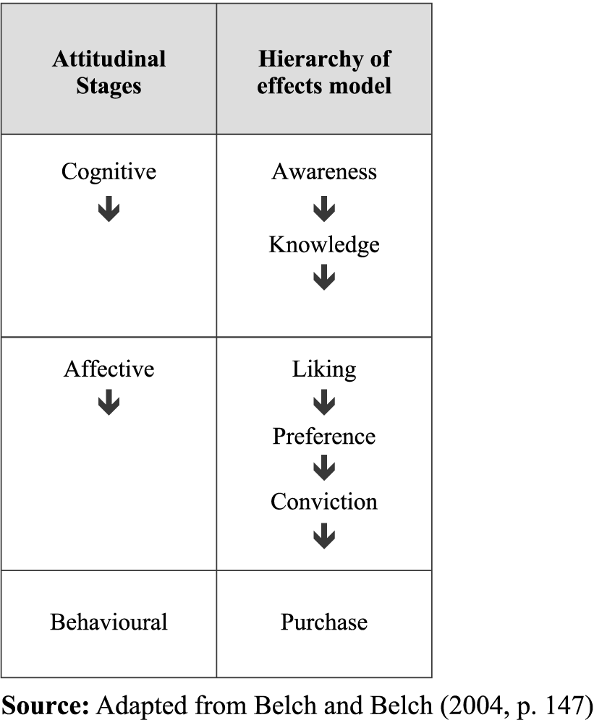  Figure 1, here shows the behaviour of the consumer turning into a purchase of a product or brand. It shows how the attitudinal stages go in parallel with the effects model, and how cognition is the first step towards any behaviour. This also shows the marketers what to focus on to change the consumer behaviour towards their products.  It is the consumer behaviour which impacts their decision to purchase or not purchase a particular product. A business decides which products to manufacture and to continue, depending on the consumers’ decision and their usage. The positioning of the product does depend on the consumption of the product and this behaviour of consumers may be associated to any kind of products or brands. The understanding of consumer behaviour facilitates in classifying the weak points and also reveals the positive aspects of any business (www.articlesbase.com).  Another way of understanding consumer behaviour is the black box model. It shows the interaction as relationship between various consumer behaviour models for instance marketing stimuli, consumer responses, consumer decision course of action, and consumer traits. The black box model has three phases or stages. At the first stage the consumer is exposed to the stimuli. There are two types of stimuli i.e. marketing stimuli i.e. product, price, place and promotion and environmental stimuli i.e. technological, political, economic, cultural, demographic and social. In second stage, the consumer receives the input from stimuli through sensory channels and process it according to its own and unique personality traits and characteristics and decision making process. The final stage is called consumer response. Consumer response shows the responses in terms of various factors like choice of the product, brand, time of the purchase, amount of money the consumer is willing to spend for the product, The choice of seller i.e. retailer like Wal-Mart and frequency of purchase i.e. how many times the consumer purchases the product. These responses vary greatly consumer to consumer because of the differences in perception and information processing style in the second stage. We think of it necessary to mention here that decision process includes the way consumer recognizes the problem, the way he searches for the information about the product or service, the way he evaluates various alternatives, the way he makes final purchase decision and his behaviour after making the final purchase. Purchase decision also depends on individual personality characteristics of the consumer. These characteristics include personality, knowledge, lifestyle, motivation, perceptions and attitudes (Sandhusen and Richard, 2000).  Though, one of the most key functions of marketing research is the development of the understanding of individual differences that lie beneath consumer classification (Bettman,  1979). This better explains the consumer behaviour more specifically relating to each product.  There are other aspects as well that effect the consumer behaviour, such as, researchers (eg. Celsi and Olson, 1988; Petty et al. 1983; Petty and Cacioppo, 1986; Blackwell et al, 2001) have also emphasised the role of involvement in explaining how likely consumers are to process (Hansen, 2005). Even As Bettman (1979) and colleagues have argued that consumer preferences not only arise from fixed properties of products, but also from the particular choice set in which they appear, as well as the more broad context in which decision makers find themselves while making the purchase (for a review, see Bettman, Luce, & Payne, 1998; Payne, Bettman, & Johnson 1993), i.e. the effect of both competitors products and the environment they are in. concluding, there are internal and external influences on the behaviour of consumers. Internal factors include individual factors like personality, attitudes, knowledge etc. and external factors include the reference group of the particular individual consumer, social class, family, ethnic identity, the culture in which he lives etc.  Cultural anthropology  Macroeconomics  Demography  Semiotics  Sociology  History  Social Psychology  Microeconomics  Human ecology  Developmental psychology  Clinical psychology  Experimental psychology  Macro Consumer Behaviour (Social Focus)  Micro Consumer Behaviour (Individual Focus)  Figure 2: The pyramid of consumer behaviour  Source: Solomon M. et al (2006a) Consumer Behaviour: A European Perspective, 3rd Edition, p. 24  Figure 2, shows the pyramid of interdisciplinary influences on the study of consumer behaviour. These disciplines explain the importance of consumer behaviour, in different areas, very much confining it into one piece.
2.2.3 | Consumer decision making processes  Marketers now are aware of the fact that consumer behaviour is an on-going process (Solomon M. et al, 2006b). It initiates from the mental processes of a consumer to the actual action taken.  Consumer decision making is a lot complicated and may absorb a number of constructs. Several viewpoints on consumer decision making have been brought under consideration in the past literature (Hansen, 2005).  Attempts have been even made to develop models that seek out to integrate all the possible complexity of consumer decision making. The 'consumer decision process model' (the CDP model; refer to Blackwell et al., 2001) is one of the often-cited ones, which has been on a regular basis modernized since its first version, that was published in 1968. This model considers, consumer decision making as a problem solving task with five key steps (need recognition, search, evaluation, purchase and post-purchase evaluation). The CDP model highlights the cognitive fact, predominantly information processing and memory factors (Dubois, 2000).  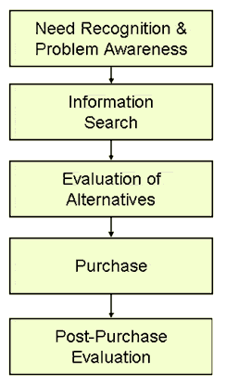  Figure 3: Consumer Decision Making Model  Source: (blogs.praized.com)  Figure 3 shows a typical model of how a consumer makes decision of a product purchase, through a proper process of need arising and then spending time and putting effort in the purchase decision making. However, the question still remains, that does every consumer choose a particular product through the same process?  To explain this process, we start with the first one i.e. need recognition and problem awareness. Need can be in different forms and can be classified and categorized differently. One classification can be the Maslow’s hierarchy of needs theory which presents the types of needs in very elaborative and easy way. According to Maslow, needs are of two types. Number one is deficiency needs which includes physiological, social, security and self esteem needs. Other type is growth needs which includes which are the higher level of needs according to Maslow and includes needs like self actualizations.  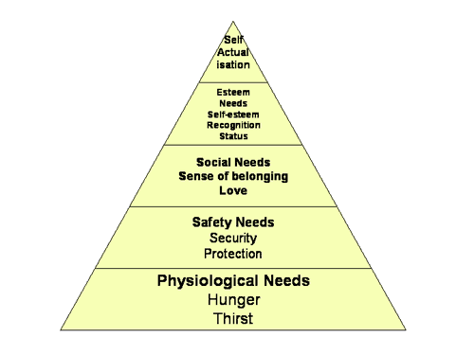  Figure: Maslow’s Hierarchy of needs  Source: tutor2u.net  From the figure, it becomes clear that according to Maslow’s classification, there are five types of needs i.e. physiological needs, safety needs, social needs, esteem needs and self actualization needs. Another way of classifying needs is as presented by Bradshaw (1972). He classified needs as normative, expressed, comparative and felt needs. The consumer in the first stage of decision making model struck by one or more of such needs. The need demands to be satisfied and if not can create problems and anxiety e.g. hunger. The need stimulates the consumer to take some action to solve the problem.  This stimulation or motivation for the solving the problem or in other words satisfying the need leads to the second stage which is information search. The information search is also influenced by various internal and external factors. This second stage, according to researchers, is a whole process in itself. Kuhlthau (2004) devised the information processing model which includes six stages initiation, selection, exploration, formulation, collection and search closure.  Third stage is evaluation of alternatives developed in information search stage. Consumers evaluate alternatives according to their own psychology of judgement and decision making. Like others, internal and external factors also influence evaluation process. It can be influenced by personal characteristics, peer pressure and social class and culture. According to researchers, consumers develop some criterion according to which they evaluate the alternatives. Development of evaluation criterion is dependant upon demographic and psychographic characteristics of the particular individual consumer.  Fourth stage in the decision making model is making final purchase. Final purchase is dependent upon two factors i.e. from where to purchase and the time of purchase. The consumer shows post purchase response after using the product purchased in fourth stage. There are few possibilities for the post purchase behaviour. The customer can be dissatisfied, satisfied or delighted after using the product. These responses will predict his future behaviour that whether the consumer will buy the product again, switch or would not buy at all and search for another alternative for the satisfaction of the need.  Every so often consumers choose first and justify their behaviour after that. Therefore, although rational decision models as such might propose what people ought to do, they are poor guide to what people actually do (descriptive) (East, Wright and Vanhuele, 2008a).  Several writers have documented that there is no single perception that offers a theory of consumer decision making that’s accurate, but such theories or models do facilitate consumer research from several perspectives (Hansen, 2005).  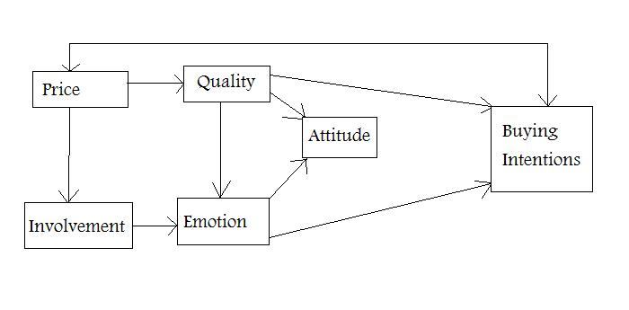  Figure 4: The Conceptual Framework  Source: Hansen, 2005  The conceptual framework is a model demonstrating diverse perspectives on consumer decision making. It can be surely argued that this model does not give a fair treatment as only some of the aspects are represented in it. For example, it may be argued that consumer emotion only represents one out of many possible affective responses, and that others like enjoyment, fantasies etc should be included when seeking to understand consumer affections. Hence, it is not claimed that the framework represents a comprehensive model of consumer decision making. As an alternative, it signifies an attempt to add to the relations amid significant constructs within the field of consumer decision making (Hansen, 2005).  Models have also been designed to understand consumer decision making through how they interpret information they get from various environmental and marketing channels.  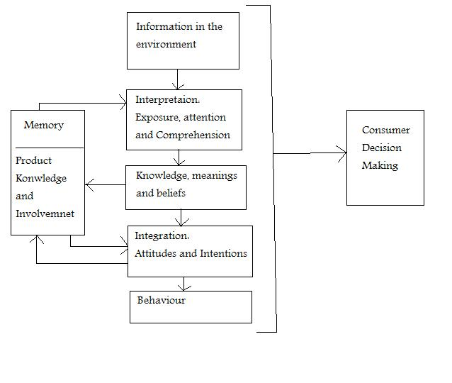  Figure 5: Model of Consumer Decision Making  Source: Peter and Jerry C. Olson (1994e), pp. 157  This model of consumer behaviour shows how a consumer interprets information, based on its exposure, attention and comprehension and then integrates its meanings as attitudes and intentions, which finally causes the action to take place. This refers to the process of interpreting information by the individual consumer that then forms the consumer behaviour.  The consumer information processing and decision making are also affected by motives that can be activated by no conscious primes delivered subliminally, that is, without the consumers’ awareness, or even, with the consumer’s awareness of the prime information but not its intent to influence the consumer itself (Tom, Nelson, Srzentic and Ryan King, 2007)  All the models and theories of the consumer behaviour, in the end, hold the same idea, that consumer behaviour is derived from the mental processes of the consumer. These mental processes all relate to the information acquired by the consumer, which causes a certain type of action towards the brand. Hence we can conclude that information acquired is a key factor in forming consumer perceptions which lead to a certain consumer buying behaviour. Therefore consumer behaviour can be moulded and modified by manipulating the information that consumer receives through sensory receptors for further processing.
2.2.4 | Advertising and consumer behaviour  A considerable question is, “does a change in thinking cause change in behaviour, or does a change in behaviour cause change in thinking?” Traditionally the idea that thought and feelings are the initiators of action, was rejected by behaviourists, though in psychology the primacy of behaviour was called as behaviourism. The main concern of behaviourism holds that observable behaviour should be taken into account rather than un explainable terms like feeling and thought. Behaviourists thought that all forms of our behaviour is like a response learnt at different stages from the environment and that the certain stimuli causes a us to response we term as behaviour. As in the present day, action is described by reference to the environmental circumstances and information that act on a person. Conventionally, thought and feelings were regarded as effects but not as causes which means that they are no longer taken in account as the key aspect determining human psychology.  In contrast to the behaviourism view is the view that thought and feeling can produce change in action directly and it is called cognitive psychology. Cognitive psychology is mainly concerned with studying internal mental processes that is, it tend to focus on how people feel, perceive and think to solve a certain problem. From a cognitivist perspective, behaviour may be modified by communications that change attitudes and knowledge, and then affect the behaviour. To change the behaviour of consumers, it is important to either modify the beliefs and values of the consumers involved in a complex decision or, either modify the consumer’s environment by which they are influenced (East, Wright and Vanhuele, 2008b).  Consumer behaviour is majorly influenced by word of mouth, information received through the mass media (advertising, newspaper, and television comment), environment (East, Wright and Vanhuele, 2008c). Hence theory and research support that consumer behaviour can be altered or modified as desired through provision of information and conveying values and beliefs that support the purchase of certain product and help refrain from buying some other. In other words research support the fact that mass media and peer and social pressures play a significantly important role in developing consumer buying choices for certain products and consumer buying patterns.  These factors are much researched on, but there are some other factors that affect their influence, these are the factors influencing Consumer attention, such as, consumer’s general affective state, the consumer’s involvement with the information, and the prominence of the information in the environment (Peter and Jerry C. Olson, 1994f). General affective state refers to the particular emotion, experience or feeling of the consumer which is important to consider because it is related to consumer’s cognitive processes. Consumer involvement theory is also important for the better understanding of consumer behaviour. It refers to the amount of time, energy and resources people spend to gather information for making the purchase process more meaningful. The consumer involvement is categorized into high and low involvement levels with both rational and emotional state of mind. The prominence of information is important its prominence plays a role in getting consumers’ attention and it builds up focus of the consumer which can some times results into an actual purchase decision.  Considering the mass media influence, television ownership and viewing is still increasing globally and it remains an important medium. In addition, television advertising remains an essential component of the media strategy as a whole. While the television’s share of overall advertising spending have peaked in 2006, its percentage of total spending is yet expected to remain high, even with the fact that advertisers invest in alternative media such as the internet, mobile and newspapers (Tsao & Sibley 2004; Crawford 2007; Ives 2007). Thus, television advertising persists to be a significant tool for interacting with the consumers (Zinkhan, Kwak and Andras, 2009). It is also claimed by researchers, that heavy Television viewers are less sensitive to television ads as compared to the light viewers (Roberts, A, 1999).  Consumers are exposed to information in their environments, to change their behaviour. This also includes marketing information on the media. Their exposure to this information can be accidental or intentional (Peter and Jerry C. Olson, 1994g). The main purpose of promotion stated by researchers is to, arouse the product need, create brand awareness, to create a positive brand attitude, form an intention to purchase the brand and influence the consumers’ behaviours (Peter and Jerry C. Olson, 1994h). Here the advertising is supported by the research as a medium to modify and change consumer behaviours. Various research studies showed that advertising message has the power to create the need for the product which can be artificial need, establish brand recognition and to create a positive image of brand in the mind of consumers which leads to product purchase.  Marketers and advertisers rely a great deal on visual elements in advertising (Solomon et al, 2006c). Image management is the main goal of advertising, i.e., to create and maintain images and meanings in the consumers’ minds (Peter and Jerry C. Olson, 1994i).Visual elements in the advertisements include visual arts which consists of paintings, images, sculptures and drawings etc. Photography, video making and producing animations are some forms of modern day visual arts which are being excessively used in modern day advertising. The modern day advertising is also using computer based arts which is proving helpful in conveying abstract and complex visual messages.  Mostly brands have clearly defined images or personalities created by their advertising, and other marketing strategies that are particularly made to position a product in a certain way. Usually consumers’ use a product offering because they like its image or for the reason that they feel its personality somehow corresponds to their own. Furthermore, a consumer may also believe that by buying and using the product, its desirable qualities will somehow be theirs (Solomon et al, 2006b).  Researchers believe that an ad does not alone induce feelings of the consumers. Consumers with good feelings may have favourable attitude towards the ad (Edell and Burke, 1987; Gardner, 1985). Another factor that affects the consumers attitudes towards a brand are the competing ads. No advertisement operates in a vacuum as competing ads may have detrimental effects on consumers’ selection of a particular brand in a particular ad. Though, existing “information processing theory” suggests that the consumers process information independently for different brands and then compare the value across all relevant attributes of the brands (Fishbein and Ajzen, 1975).  Furthermore, the advertising context is an essential element that can generate, and induce, the consumers’ feelings. Feelings may not only be prompted at the moment (Zajonc, 1980), but it is actually to influence the subsequent processing (Gardner, 1985). Thus, the consumer can also induce feelings due to the content of the ad (MacKenzie et al., 1986). An example is that if an attractive picture is used in an ad, it may induce an individual’s good feelings reaction towards the ad while viewing it. With these good feelings, the consumer may remember and judge the picture easily, and will be motivated to process more ad information. Consecutively, both cognitive and affective responses establish the ad evaluation (Teng, Laroche and Zhu, 2007)  Advertisements construct certain mental associations and beliefs about the brands, and thus trying their best to lead consumers to buy those brands, so marketers should become ever more careful of the communication values of their advertising messages and contexts, in order to productively attract consumers’ attentions (Teng, Laroche and Zhu, 2007).  Another constituent is the increasing proliferation of communications, and the fact that consumers are a lot involved in tasks that dwell in attention and limit communication processing (MacInnis et al. 1991), it is most likely to happen that the majority of marketing communications stimuli do not receive any active processing from the side of the consumers (Bauer & Greyser 1968). Moreover, as brands are usually perceived to match each other in terms of their functional performance, consumers do not any longer feel the need to look for information about brands, which in turn reduces the desire to pay active attention to advertising’ (Heath 2004).  Researchers, such as Heath argues that advertising more often focuses so much on waking the audience up that it does not succeed to communicate anything about the brand itself (Heath 2004).  It has also been argued that usually consumers base their purchase decisions not on what they can plainly remember about an advertisement but very much just on what knowledge they have about the product (Monroe & Lee 1999). This knowledge also is reflected in implicit memory traces, and thus the existence and enhancement of these provide a better indicator of to what extent the mere exposure of advertising effects the brand choice (Lee 2002).  Moreover, it also suggested in recent studies that the effectiveness of advertisements may be understated if they just rely on measures of recall or recognition and, the point to focus on now is to include instruments that measure the influence of unconscious processes (Tom, Nelson, Srzentic and King, 2007).  Recent researches state, the vast complexity of the 21st century media environment, most importantly the ability and evident eagerness of consumers to avoid exposure and attention to any marketing communications messages. However, this point of view is addresses as a basis for their claim that, gaining and maintaining the attention of potential customers is at present more essential than ever before (Skinner & Stephens 2003).
2.3 | Sexual objectification of women in advertising
2.3.1 | Advertisers’ perceptions  Advertisers now are attempting to offset the sensory overload caused by advertising clutter in turn to call attention to their brands (Solomon et al, 2006c).To breakthrough this clutter and reach the capture the consumers attention, advertisers and marketers are using different ways.  The dynamic and changing nature of consumer behaviour implies that advertisers’ should not expect the same marketing strategy to work all of the time, or across all brands, markets, and industries. Additionally, a strategy that is winning at one time may fail miserably at another (Pg7- B4).  New and creative strategies are used to attract consumers’ attention to their particular brands and communications. Due to the fact that the cognitive systems of the customers have limited capacity, only a portion of the information in the environment can be selected for interpretation; in reality most of the marketing information is ignored (Pg112- B4).  Advertisers believe, without doubt visual aspects of an ad are more likely to grab a consumers’ attention. In actual fact eye- movement studies also indicate that about 90 per cent of viewers look at the dominant picture in an ad before they bother to view the copy or even listen to it for that matter (Solomon et al, 2006d).  The AIDA model gives a detailed illustration about the intact procedure of how advertising effects consumer behaviour and the purchase decisions.  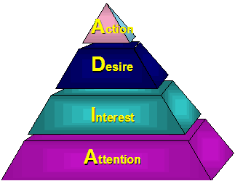  Figure 6: AIDA  Source: blogspot.com, 2009  This figure 6 shows that the first element, that is attention, describes the stage in which the brand gains the attention of the consumer through the advertisement. Then is the interest in the brand, the desire for it and lastly the action. The most important point to be noted in this simple model is that until the attention of the consumer is not captured, the process will not go further (blogspot.com)  For this initial point “attention” advertisers do use numerous different tactics to get people interested in their brands; they use humour, self-esteem, peer pressure and several other things, but the one tactic that is most popular and considered the most effective is using sex in advertising. This is considered to be the most effective, simply because is plays upon the biological needs of every single human being.  According to Richard F. Taflinger, PhD, "Sex is the second strongest of the psychological appeals” (serendip.brynmawr.edu).
2.3.2 | Consumers’ perceptions  Even though the use of sex does appear to capture the attention towards an ad, it may also actually be counter-productive to the marketer. As in one survey, an overwhelming 61 per cent of the respondents said that sexual imagery used in an ad made them less likely to buy that brand. Though there is some evidence that subliminal advertising way using sexual imagery may persuade consumers’ feelings, rather than their cognitive responses, towards the sexually suggestive advertisements. Secondly, a sexually objectified image can be too effective; it attracts so much attention that it obstructs processing and recall of the ads contents. Sexual appeals at times come out to be very ineffective when use merely as an attention grabber. Thus, researchers have also argued that use of a strong sexual appeal is not very well-received by the consumers (Solomon et al, 2006e).  Evidence from literature shows that advertisements containing explicit nudity and sexual appeals have been found to be less positively perceived and are considered more offensive than other ads with moderately clothed models rather than increasing attention towards these ads (Peterson and Kerin 1977). Severn, Belch and Belch (1990) also claim that the use of sexual appeal in advertising interferes with the actual message, particularly when there is ample information available for processing (Lass and Susan Hart, 2004).  Though it has also been found by Zimmerman and Dahlberg, 2008 that at present consumers casually accept the sexual objectification, and this causes no change or effect on their attitudes or purchase decisions (Reichert, LaTour, Lambiase, and Adkins, 2007). This explains the difference perceptions of consumers according to their, age, gender, values or lifestyles. The difference in attitude also depends upon the environment or consumers' situation while buying the brand.
2.4
2.5
2.5.1
2.5.2
2.5.3
2.6
To get the full project, please buy the Assignment by using this Link
http://sampleassignment.com/pay-now.html
Cost - £39

