Dissertation - Cricket, Money, Passion, Talent – The IPL, A Fantastic Success

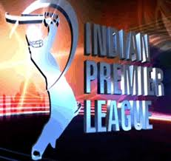 Image Courtesy: Ricoh (2012)

Abstract
Twenty Two yards make a cricket pitch, eleven men make a team and hope, talent and expectation create a sport that is truly world class. This sport saw a radical change in the manner in which it was played in 2003 when The England and Wales Cricket Board (ECB) coined the idea of a Twenty20 version of the game or T20 as it was subsequently come to be known as. The format of the game had few takers and low acceptance levels internationally especially with ‘pundits’ of the game saying that it just wasn’t the real thing.
The subject of this dissertation is cricket. Twenty20 or T20 cricket is what shall be looked at purely in the Indian Premier League. It’s the IPL that shall form the subject of this dissertation. The IPL has been a revolutionary ‘product.’ It has shown us heuristics previously unmapped and unknown. It’s been a new way to play an old game or a new way to play a reinvented game. This paper strives to indicate the success factors behind the IPL and establishes the relationship of the marketing principles that have been followed to achieve the grand success of IPL.

Table of Contents

Chapter 1 INTRODUCTION 4
1.1 Introduction 4
1.2 Sports: As a contemporary source of Entertainment 5
1.3 Sporting Leagues 5
1.4 Research Questions 6
1.5 Research Methodology 6
1.6 Significance of the Study 7
1.7 Scope of the Study 7
1.8 Outline of the Dissertation/Chapter Briefings 7
Chapter 2 LITERATURE REVIEW: 8
2.1 History of Cricket 8
2.2 Different Formats in Cricket 8
2.3 Cricket – Where Will It Go: Ever-Changing Trends 9
2.4 Flash-forward – India 2008: 10
2.5 IPL – The Background 10
2.6 IPL – At Present 11
2.7 IPL – It’s Conduct and Behaviour 11
2.8 Application of the Marketing Concepts in the IPL 13
2.8.1New Product Development: 13
2.8.2 Value Creation: 16
2.8.3 Brand Creation: 18
2.8.4 Innovation 21
2.8.5 The Halo Effect: 26
Chapter 3 Research Methods 27
3.1 Research Methodology: 27
3.2 Primary Data: 28
3.3 Secondary Data: 28
3.4 The Research Questions And Design: 29
3.5 Using A Case Study Approach: 29
3.5.1 Advantages of A Case Study - 30
3.5.2 Disadvantages of A Case Study – 30
3.6 Conducting the Research: 30
3.6.1Primary Data- 30
3.6.2 Secondary Data – 31
3.7 Grounded Theory: 31
3.8 Focus Groups: 31
3.9 Cricket in India 32
Chapter 4 Data Findings and Analysis: 33
4.1 Discussions: 38
4.2 IPL – Finance 40
4.3 Focus Group on Fans: 41
4.4 Focus Group on Players: 41
4.5 IPL Auction 42
4.6 Media Findings 44
4.7 IPL – The Future 45
Chapter 5 Conclusions and Recommendations: 45
References 51
Appendices…………………………………………………………………...………53

Chapter 1 INTRODUCTION

1.1 Introduction
Cricket has a huge fan following across the globe. This research focuses on the success of Indian Premier League (IPL) which was inaugurated in the year 2008. The entertainment factor plays a big role in an event like IPL. Its success is also contingent upon the marketing of the tournament through various initiatives. The objective of this paper is to identify the factors that led to the immense success of the IPL as a tournament (BCCI 2007).
It is thought my many that IPL was yet another cricket tournament. However, its astounding success paved the way for a new interest especially in those who are not quite associated with following the game of Cricket essentially. This includes the groups of people like women and young children. Majority of men are always keen when it comes to following the game of cricket closely (Matzler 2003).
The success of the IPL can be intuitively measured by the fact that the tournament has already been held for 5 consecutively and has also been held in other parts of the world other than India. The scale of the popularity is also evident from the point that similar initiatives have been taken by authorities of other countries which includes examples like Bangladesh Premier League (BPL), Sri Lankan Premier League, Australian Big Bash 20-20 to name a few (BCCI 2007).
This paper identifies the critical success factors of the Indian Premier League and evaluates its success relative to the other forms of Cricket.

In recent times, more money is being ploughed into leagues and teams. In the last decade or so, the English Premier League has seen the acquisition of Manchester United, Chelsea, Manchester City and Blackburn Rovers to name a few. As sports, football and F1 have huge international attractions. They don’t only cater to the local base. You may live in India and be a staunch Newcastle United supporter while someone in Uganda might be rooting for Arsenal (Thomas 2003).

1.2 Sports: As a contemporary source of Entertainment

Times have changed and so has the pace of life. In today’s ever busy world, people have taken to sport as a diversion, a manner in which to unwind or just pass time as the case and or event might be. Across the globe, there are numerous popular sports such as basketball and American football in the USA, F1 in many countries, football in the UK and cricket in India. A common thread is that all these sports are played as a team and by a team, which gives fans a sense of belonging or ownership to a team of their choice, which leads to them being either passionate or fanatical about the same. It’s a sense of belonging. It attaches a purpose to the sport or sporting event (Chen 2005).

1.3 Sporting Leagues

A lot of countries have major and minor sporting leagues. However, history and research shows us that it’s the major leagues that not only survive but also prosper. In America, you have the National Football League (NFL) for American football, Major League Baseball (MLB), National Hockey League (NHL) and the National Basketball Association (NBA). In Australia for cricket you have the Big Bash and Sheffield Shield. In the UK, you have the world renowned English Premier League (EPL) for football. In Scotland you have the Scottish Premier League (SPL). The Spaniards enjoy their football in the La Liga while the French do so in the Ligue 1. Hence, there is a commonality the world over of sports being played in leagues. Most recently, India has seen the phenomenal rise of the Indian Premier League (IPL) – the subject of this dissertation (Reichheld 1990).
Cricket is not a sport played globally; it is basically played by the British Commonwealth nations. In India, fan following is such that cricket far outlives its jurisdiction as only a game – it’s also a religion for many. Unlike many other sports, cricket does not have rules, it abides by laws. The Marylebone Cricket Club (MCC) laid down these laws around 250 years ago. The MCC is different to the International Cricket Council (ICC). While the MCC lays down the laws, it’s the ICC that makes all the plans and organizes events (Samiuddin 2008).
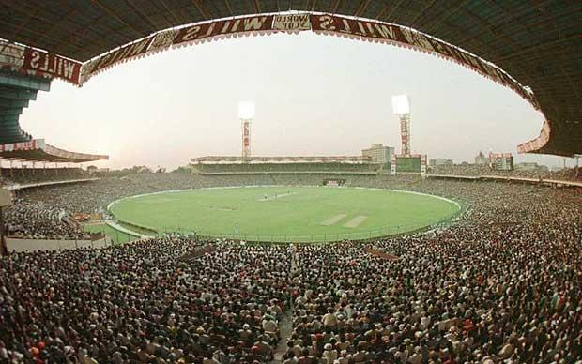
Image Courtesy: Ricoh (2012)
Indian Cricket Stadium showing a capacity crowd of over 100,000 at Eden Gardens, Kolkata 1996 Source: (Dacin 1997).

1.4 Research Questions
After much deliberation as well as study, five research question have been shortlisted and subsequently selected for the purpose of this dissertation. The questions are listed as under:
- Evaluation of the Critical Success Factors of the Indian Premier League.
- Application of marketing principles to the event of IPL and to judge its effectiveness.
- Measuring the success of Brand image of IPL event.
- What is the role of Innovation in the success of the IPL?
- Impact of Financial Bids behind the grand success of IPL?

1.5 Research Methodology
This research primarily identifies the significance of the use of marketing tools in the IPL event.
The research design being used in the study is exploratory. The primary data for the purposes of the study has been collected through personal interviews with the various fans that have witnessed the IPL event at least once. On the other hand, the secondary data has been collected through various books, journals, newspapers, magazines, published and other unpublished sources. The design being used for research is random sampling method (Malhotra 2010).

1.6 Significance of the Study
The motivation behind this study has been the phenomenal success of the IPL event. It is interesting the note the use of marketing principles for successful promotion of the event. Hence, this study implies to use the research techniques to understand the depth of the success of the marketing tools that have been used in order to judge their relative impact on the event as a whole (Majaro 1988).

1.7 Scope of the Study
This dissertation is closely related to Sports Marketing. The study is limited

1.8 Outline of the Dissertation/Chapter Briefings

Chapter 1 Introduction
This chapter presents a brief outline of the parts that would be covered in this dissertation. It also includes the related attributes that marks the success for the IPL event.

Chapter 2 Literature Review
Literature Review explores the theories in detail and relates the concepts of marketing and build a relation of the same in the context of IPL.

Chapter 3 Research Methods
The use of the primary and the secondary data for the purpose of inding answers to the research question has been included in this part.

Chapter 4 Data Analysis and Discussion
This chapter highlights the responses of the people that were asked questions related to success of IPL and other related factors.

Chapter 5 Conclusion
The last part of the report addresses the key issues of the Dissertation again and ties the contents of the Dissertation together.

Chapter 2 LITERATURE REVIEW:

2.1 History of Cricket

According to BBC, the first published references to cricket were in the late 1600s, when fines were handed out for those missing church to play. One theory suggests origins of the game being among shepherds hitting a stone with their crooks and, at the same time, defending the wicket gate into the sheep fold. In its growing stage, cricket was very much an English sport but with the British Empire growing fast, many expatriates took the game with them to such far-flung places such as Australia, Africa, the Caribbean and India (LaBarbera 1983).

2.2 Different Formats in Cricket
At this point in time, cricket is internationally played in 3 formats –
- Test Cricket
- One Day Internationals (ODI)
- Twenty20 (T20)
Test cricket is played over five days. Each team bats twice for an unlimited number of over’s (time permitting), players are dressed in all white and the game is played with a cherry red ball. This is still the vintage and the finest format of the game (Goulding 2002).
One day cricket is played 50 over’s a side. Players wear coloured clothing and this format of the game is generally played in ‘day-night’ format with a white ball. Umpires also dress in a more casual manner. Between 1977 and 1979 Kerry Packer the Australian media giant created a breakaway league called World Series Cricket. This event is largely responsible for today’s one-day internationals. Packer showed the way with his revolutionary mechanism at the time and it was subsequently modified to bring about ODI’s (Hamel 2007).
Twenty20 is the most recent addition with its inception going back to 2003 when the England and Wales Cricket Board felt the need for a shorter version of ODI cricket. The number of spectator’s at grounds was dwindling and there was a falling interest in ODI cricket. The visionaries at the ECB came up with Twenty20 thereby leaving ODI’s intact. It was a smart move by the ECB to create a new product and continue with ODI’s for International cricket. Around the same time the domestic competition was changed from the famous Sunday League (50 over’s) to the Pro 40 (Glaser 1967).
A summary of the above is shown in the table below:
Format |  | Duration | Number of Innings |  | Ball Type |  | Hours of Play
Test Cricket |  | 5 Days | 2 |  | Cherry Red |  | 8 hours per day
One-Day Internationals |  | 1 Day | 1 per side |  | White |  | 8 hours for the entire match
Twenty20 |  | 1 day | 1 per side |  | White |  | 3.5 hours for the entire match

2.3 Cricket – Where Will It Go: Ever-Changing Trends

There’s one constant feature – change. While the sanctity of the sport remains intact with test cricket, there is change across the board elsewhere. For example, South Africa recently played an ODI match dressed in pink in order to support breast cancer – a truly remarkable gesture.

In England, 50 over’s a side has been cut to 40 over’s a side in domestic cricket. Additionally, cricket, which was purely a daytime game, is increasingly seeing all ODI and T20 matches being played under floodlights.

There was a move recently to wear coloured gear during test matches. This idea was shot down in no time. Test cricket will continue to be played in ALL WHITE. That being said, there is a realistic chance that test cricket will soon be played under floodlights in certain countries on a purely experimental basis. Hence, cricket is going places and change cannot be kept away from all formats (Feehan 2009).

2.4 Flash-forward – India 2008:
The year 2008 saw the inaugural version of The Indian Premier League being played. IPL, as its now commonly known, opened the eyes of the world as to what T20 cricket can be. It is believed that the developers of this tournament would have looked strongly at the ever-successful English Premier League (football) to get ideas and other concepts (Doyle 2002).

2.5 IPL – The Background
Indian’s took very slowly to T20 cricket until 2007 when India won the inaugural ICC World T20 in South Africa. The BCCI sold viewership-broadcasting rights for as much as $1018 million for the inaugural IPL (Doz 1998).
The IPL was setup in a different way with franchises being invited and sold and teams being of major cities. In this it is similar to the NFL in the USA and different to the Big Bash in Australia as well as the ECB’s t20, which are county based in nature and not city based. The BCCI didn’t own the teams, nor did the state or county – it was individuals and stars. The idea is to have industry leaders, companies, actors and stars to bid for teams that would compete against each other in a 20-20 format (BCCI 2007).
Other key reasons for the IPL success since its inception has been that it’s a prime time offering. People can finish their day’s work and then watch the game. Furthermore, being a shorter version of the game gets more people tuned in and also attracts the non-cricket fan. However, success for the shorter version of the game has to go to the ECB and not the BCCI. The IPL is also visually appealing with grounds being colourful, cheerleaders present, and music after every boundary or wicket etc. They’ve tried to create a family and fun atmosphere (Cooper 1995).
In April 2008, the inaugural IPL was held and was a success. A report published by India Infoline states,” Over 200 million Indian viewers, 10 million international viewers, 4 million live spectators: the IPL is a sports and entertainment revolution in the making, surpassing all records of viewership on ground and on media. Advertising revenues and ticket sales have exceeded all expectations, making IPL highly profitable for the organizers, broadcasters and successful team owners.” (Mitra 2008).

2.6 IPL – At Present
As we get ready for IPL VI in a few weeks time, we’ve seen plenty of drama including IPL 2 being moved out of India due to terror issues and being played in South Africa.
A key reason for the IPL’s success is that it has participation of top international stars (Mitra 2008).
Teams have stayed and some have prospered. A few have fallen off the bandwagon and those waiting to get in have snapped up those franchises at astronomical valuations.
The Indian’s have to thank the British for showing the way with T20 cricket but it was Lalit Modi who took this format and gave it an all new dimension to change it forever (Chun 2006).

2.7 IPL – It’s Conduct and Behaviour
The IPL benefits from having official status and recognition from the BCCI, which in turn has the same from the International Cricket Council (ICC). In 2007, India did see the temporary rise of the Indian Cricket League whose end was hastened when the BCCI and other cricketing boards like Cricket South Africa and Cricket Australia notified players of a lifetime ban if they participated in it. This cannot happen with the IPL and is a key advantage (Kapferer 2001).
The IPL has also been responsible for churning out some really high quality cricket, which has been both enjoyed both in India and internationally. Samiuddin (2008) states, ”A league needs high profile players to guarantee its success. High profile players provide the public with fantastic competition, spectacular skills, excitement and entertainment which draws the audience to embrace the league.”
The Literature Review focuses on the following key issuesThe ideal as well as key areas to look at are stated as under:
- New Product Development
- Player Valuation- Does Skill Matter
- Innovation
- Brand Creation
- IPL as a symbol of India’s growing economy
- Financial aspects of the IPL and its impact
- The Halo Effect
- The Growth Framework
- Value Creation
This literature review will focus on the key and vital areas of new product development, value creation, brand creation, Innovation and the halo effect and applies the same to IPL cricket event. These are important aspects of marketing, key to any product or organization and knit together to form a successful new launch or product.. For the purpose of this dissertation, we will look at new product development prior to looking at value creation, brand creation, innovation and the halo effect. Of these five key characteristics, it must also be noted that all will not be present in every product or situation. For example, new product development or brand creation could always be present or in a higher probability of cases where as something as unique as the halo effect would not be present in majority of cases (Davis 1999).

2.8 Application of the Marketing Concepts in the IPL

2.8.1New Product Development:
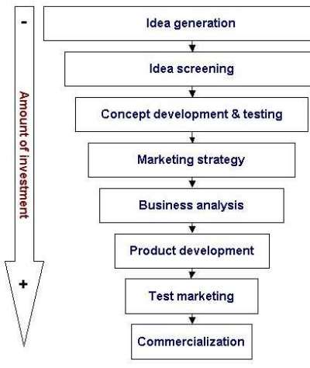
Image Source: (Aaker 2004)
Cooper and Kleinschmidt (1995) studied 161 businesses and found that the most important factor to successful NPD was the existence of a high quality, rigorous new product process – one that emphasizes up front homework, tough Go/Kill decision points, sharp early product definition and flexibility. By contrast, merely having a formal new product process has no impact at all on performance (Majaro 1988).
Dr.Cooper (1995) also feels that timid NPD programs are concentrating more than they used to on safe, marginal product improvements and less on true product breakthroughs.
Some authors on the subject also feel that customers are considered an important and extremely vital part in the NPD process perhaps especially in services rather than in products. Authors such as Brown and Dacin (1997) believe that all the information and knowledge that customers hold about a company can help in creating a long lasting sustainable competitive advantage. Harley Davidson motorcycles in particular make extensive use of their customers in the NPD through their dealer network, and via their website. Von Hippel (2005) asserts that in most cases, empowering customers to take more action in the NPD process has led to more successful results (NDTV Videos 2011).
From the above it can be clearly concluded that involving customers in the NPD process can lead to more successful products, quicker launches and products that are perceived and accepted better by customers.
The same has been applied in the case of IPL as well where the franchises have given the rights to the people to vote about their players to consider their inclusion in the respective teams (Ricoh 2012).
It is also believed that a ‘scrum approach’ can be successful. All interested parties, including customers being involved in the NPD process can lead to larger or more substantial rewards. Large customers or more sophisticated customers can also be more specific or knowledgeable in their demands for NPD. For example, Ricoh involve customers in their NPD process. They believe that adopting a customer driven approach will lead to products with better shapes, sounds and colours rather than if they did NPD themselves (Thomas 2003).
This also holds true in the case of IPL where the top performing players are considered as internal customers and are given the empowered to forward their views regarding the inclusion of team members in the playing eleven.
On the contrary, (Bernstein 2000, Chun and Davies 2006) feel consumers could end up forming less positive attitudes about totalitarian organizations that exert too much power if involved in the NPD process. They believe that organizations should look at NPD from their single point of view and with minimal or no customer involvement. They are of the opinion that a firm should produce what it can or desires to and then put it in the market (Stokes 2002).
However, new product development in the case of IPL is justified as it is targeted towards the end customers and is extension of the popular game and is considered to be no less than a festival for the sport lovers.
Doyle (2002) puts forward that the NPD process begins with generating ideas for new products. Two principles influence the ideageneration phase. First, the business needs to have lots of ideas. A study by Booz, Allen and Hamilton (Doyle 2002) found that it took 58 new product ideas to rule out one winner. In some industries the odds are even higher. In the pharmaceutical industry it is currently estimated that around 10,000 substances have to be investigated for every successful new product introduction. Doyle goes on to suggest that in order to achieve successful NPD a firm must also engage its employees and customers in the process. Doyle further emphasizes that for NPD, firms can look at competitors, distributor ideas and other external sources as well (Lynn 2005).
In contrast, Chen, Reilly and Lynn (2005) emphasises different conclusions – time based strategies work best under conditions of high uncertainty.
As per Doyle (2002) the NPD stage must have six research factors prior to product launch. They are as under:
1. Communicability: Do customers understand the benefit being offered?
2.Believability: Do they believe that the product has the benefits claimed?
3.Need: Do they have a strong perceived need for the benefit offered?
4.Need Gap: If there is a need, is it perceived as already being satisfied by existing providers?
5. Perceived Value: Do Customers see it as offering value at the price being considered?
6.Usage: How would they use it and how often?

2.8.2 Value Creation:
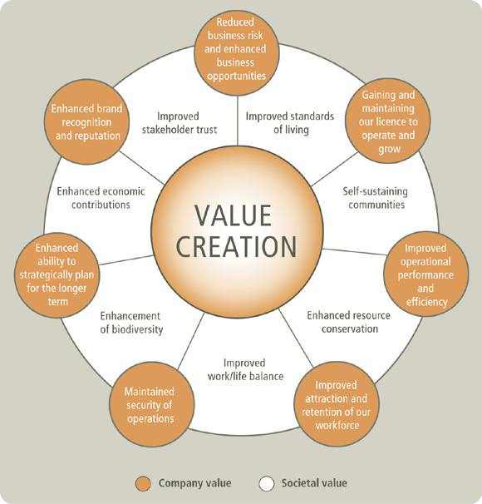
Image Source: (Hindle 2011)
“Companies that focus on competition will eventually die. Those that focus onvalue creation will thrive.” Edward De Bono

C. Anthony Di Benedetto (1999) states, “Successful launches were found to be related to perceived superior skills in marketing research, sales force, distribution, promotion, R&D, and engineering. Having cross-functional teams making key marketing and manufacturing decisions, and getting logistics involved early in planning, were strategic activities that were strongly related to successful launches.” The learned Benedetto, greatly emphasizes a multidimensional approach for value creation.
When Mercedes launched the New A Class in October 2012, they received a mammoth pre order of 70,000 cars from Western Europe making it the company’s most successful launch ever. This came at a time when most of this region was in a deep recession. The company’s smallest model was their largest success. What did they do – while developing the new product; they built in feedback received from customers, dealers and other sources. They put in a very nice power train, good features, fuel efficiency, stylish design and a compact size chassis. All this was termed and offered to customers as ‘affordable luxury’ (Hindle 2011).
Another example is Apple, which would be a company with amongst the most successful launches. On its launch day, the iPad sold 300000+ wifi only units. Three days later the iPhone 4 sold 1.7 million units.
Appplying the above analogy to IPL, On 20th December 2012, the Hyderabad IPL franchise was rechristened as the Sun Risers Hyderabad under the new ownership of Sun TV. The CEO of Sun Risers said,” Sun Risers is a wonderful value creation opportunity for the sun group. This franchisee will help attain synergy amongst its varied interests.”Tim Hindle (2011), a leading authority on Value Creation feels that Value Creation is an organizations raison d’être, the ultimate measure by which it is judged. There have been several debates on what is the most appropriate type of value for an organization to create. Value creation should be for the customer. They customer must feel the value benefit – tangible or intangible. On the other hand, “The path to value creation requires economic profits to be earned. The value creation process is a never ending cycle. It begins with modeling business operations, prioritizing areas for more detailed investigation, identifying opportunities for improvement and then going back over all this regularly. Organizations in order to create value must do this.” David N Fuller CFA (2001)
Gary Hamel (2001) believes the world is one of relentless change and in this change it is organizations that depend upon value creation will succeed. He believes that success will come through forming alliances. Sharing this belief with him is Yves Doz (1998). These two authors are of the belief that maybe forming strategic alliances or coming together will bring value creation (Spreng 1996).
CK Prahalad and Venkat Ramaswamy (2004) also advocate that the world is going through phenomenal changes and the opportunities are numerous if we look at them with new and open eyes. They state that there is new strategic capital available and this will lead to value creation. Prahalad and Ramaswamy have indicated that capital is available today in numerous forms and enhancing or capitalizing upon this will lead to value creation for the firm and success will follow inevitably (Till 2008).
It has been noted from the above mentioned review that value creation is of immense importance in any marketing endeavour. It has been witnessed in the case of IPL as well where the spectators are being offered with many augmented features like post match ceremonies, grand opening ceremony of the IPL tournament, dancing of the Cheerleaders during the match and winning laps by the players so that the spectators get to see their beloved players up close (Yin 1994).
The other noticeable points that create a scenario for Value Creation in IPL is the use of advertisements for promoting the event. The ad campign is strategically timed and involves the famouns players to set up the stage for the event in an intuitive manner.

2.8.3 Brand Creation:
“What’s in a name? That which we call a rose by any other name would smell as sweet.” William Shakespeare.

According to Doyle (2002), a brand can be defined as specific name, symbol or design – more usually, some come combination of these – that is used to distinguish a particular product. Branding is very important (Feehan 2009).
Image Source: (Cooper 2001)
David A. Aaker (2004) states, ”Brand assets are difficult and expensive to develop, maintain and adapt. Brands have heritage, values, assets and liabilities, people and innovation. Brands should endorse (Courtyard by Marriott or MSN by Microsoft). When brands are not doing well, investments in them should be kept up.” Below is a diagram of how Aaker believes brand creation and identity should be handled. He states that the process is continuous and ongoing (Cooper 2001).
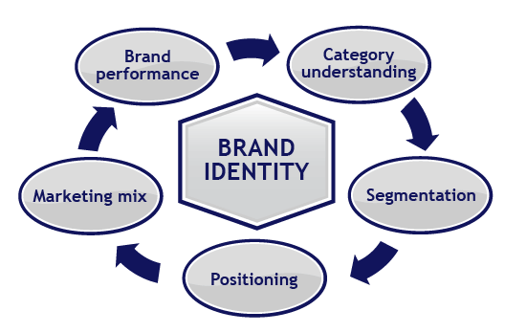Image Source: (Mitra 2008)
Roberto Goizueta, the late CEO of Coca-Cola commented,” All our factories and facilities could be burned down tomorrow but you’d hardly touch the value of the company; all that actually lies in the goodwill of our brand franchise. Our name and brand is the most valuable asset.”
On the other hand, Jean-Noel Kapferer (2001) in his book Re Inventing The Brand, puts forth a debate whether to brand or not to brand. He says, ”We should not allow ourselves to be blinded by the interest in branding. Even if, in modern parlance, the word ‘brand’ seems to have the edge on all other terms and facets of marketing, we should not allow ourselves to be hypnotized by it. Today, everybody wants a brand, as if it were the panacea of modern management. It seems to be a case of ‘brand’ or ‘bust.’ Isn’t this rather excessive?”
Brian D.Till and Donna Heckler in their book, The Truth About Creating Brands People Love (2008) say, “The better the brand connects with customers, the more indispensable the brand becomes.”
Kotler (2012) writes, “Brand name’s should be memorable, meaningful, likable, transferable, adaptable and protectable” (Cooper 2001).
Brand creation is a process that most companies do understand. Why do we feel comfortable in a foreign country when we see a particular product, hotel or car … It’s the brand. Certain products have even succeeded when they’ve not been up to the mark due to the brand from which they came – they had a very strong brand backing. If you want to go for a motoring holiday to the USA and wish to rent a car, there may be some American cars you don’t know about or are not comfortable or familiar with. At the same time, you may know of Ford or Toyota and decide to rent one of those thereby the brand creation coming to your rescue. Similarly, while selecting a hotel for a holiday, there might be local medium priced brands that don’t make sense to many people. Someone living Country A or B might not connect with the Premier Inn brand and may chose Four Points by Sheraton or Courtyard by Marriott at the same price because they know of the brand (Mitra 2008).
Alternatively, there have been some phenomenal products in recent years and the company has felt that there brand wasn’t good enough in the consumer’s eye. They first moved the brand identity from negative to neutral, then positive. For example, when Skoda launched some very nice cars in the UK, they adopted the advertising tagline – “It’s a Skoda. Honest.” Hence, people didn’t think highly of the brand but the company needed to do otherwise to change that brand value (Modi 2008).
On the other hand brands can be destroyed overnight when customer who have reposed faith in a brand have ended up being lied to – Tesco Burger’s would be a very recent example. It could be termed as, “Buy Beef, Get Horse” or “Get A Burger – A Galloping Belly Comes At No Charge.”
It is evident from the above discussion that brand identity plays a major role in the success of any product or service. It also holds true in the case of IPL. The event have their specific logo and consistent message is being used to target the fans across the globe. Since the event is one of its own kind and involves players from different nationalities, media from all over the world follow the proceedings of the event very closely and report it daily for over two months every year (Kapferer 2001).

2.8.4 Innovation
Image Source: (Fuller 2001)
‘Most innovations fail. And companies that don’t innovate die.” – Henry Chesbrough

Joseph Schumpeter is considered to be the father of the innovation theory. He called it the gale force of capitalism. Schumpeter (1986), “the function of entrepreneurs is to reform or revolutionize the pattern of production by exploiting an invention, or more generally, an untried technological possibility for producing a new commodity or producing an old one in a new way, by opening up a new source of supply of materials or a new outlet for products, by recognizing an industry and so on.” Schumpeter feels that new innovation in a new product or in an existing product creating new benefits to the customer is most important. The innovation must not only be perceived but also be quantifiable.
Peter.F Drucker believes that most innovation is well planned and strategized. Drucker believes that Innovation requires knowledge, ingenuity and above all, focus. In his book, The Discipline of Innovation (2002) he says,” To master the discipline of innovation we must do three things – focus on the mission, define the results we are after and assess what we are doing and how we are doing it.”
He says that innovation comes about from one or more of seven scenarios. These are:
- Unexpected Occurrences
- Incongruities
- Process Needs
- Industry and Market Changes
- Demographic Changes
- Changes in Perception
- New Knowledge
Robert Tucker (2011) states, “Innovation is about coming up with ideas and bringing them to life.” Tucker clearly emphasizes the dual need of not only having an idea but also giving it life. Not to innovate is to stagnate. A company that does not innovate becomes stale to its customers, distributors and suppliers (Brown 1997).
David A.Aaker (2004) talks about innovation,” Has the firm provided customer benefits by being innovative? A reputation for innovation enhances credibility. In particular, experimental studies have shown that innovation has made the acceptance of new product offerings more likely.” Aaker clearly believes that innovation is a key step on the ladder of success. He has not stopped short of highlighting that. He also believes that there is no innovation if the customer cannot see or perceive it. There has to be value as well as benefit for the customer.
Aaker (2004) goes on, “However, it is not easy to achieve an innovative reputation. Sony has benefited from being able to capture its innovation from a variety of categories within its corporate brand. Home Depot and Dell have innovated in visible ways to bring products to customers in different and in superior ways.”
Prof. Michael Porter states "companies achieve competitive advantage through acts of innovation." How does "innovation" fit within the process of strategic decision-making? It is a strategic marketing tool. In Porter’s Five-Forces Model, "innovation" is a critical element within the process of strategic decision-making. Innovation can be, as Porter observed, “mundane and incremental”, and it can be in the realms of technology or in the ways of doing things. This leaves a lot of room for good ideas from managers involved in strategic decision-making. Any changes or improvements in these areas can lend the corporation competitive advantage (Doyle 2002).
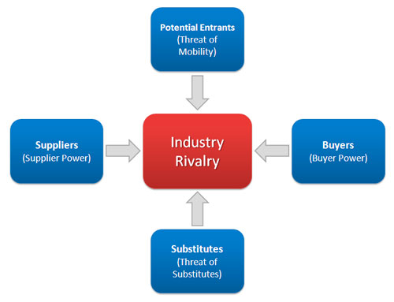
Image Source: (Chen 2005)
The 5 Forces model has been a marketing landmark. In time, it has grown to 7 forces with ‘technology’ and ‘other drivers of change’ being added to the list.
Simon Majaro (The Creative Gap 1988) laments, “Ideas can shower down on an organisation like rain and vanish into the ground without a trace or become pools of unexploited ideas. A metaphorical net is required to capture ideas and should be a publicized focal point. The net should not be concerned with where ideas are coming from.”
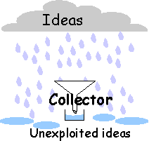
Image Source: (Goulding 2002)
Drawing a parallel from Maslow’s hierarchy of needs is the world renowned Dr.Gary Hamel. Hamel has his innovation stack, which begins with operational innovation, product innovation, strategy innovation and tops it with management innovation. Hamel (2007),”You got to get your competitors to scratch there with what you’ve gone and done. Then you will be successful.” Hamel’s stack or step system clearly indicates that innovation is a stepwise process that all organsiations would be advised to look upon in an orderly manner rather than in a haphazard way (Chen 2005).
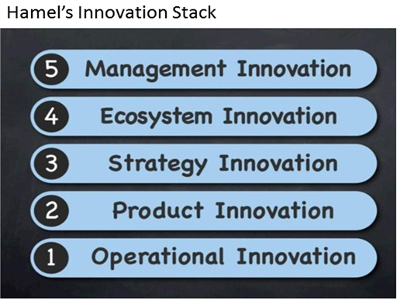
Image Source: (Homel 2011)
Eric Von Hippel (2002) is of the belief that innovation is fast becoming democratized. User centered innovation is what he believes will be prevalent in the days ahead.
One driver for innovation programs in corporations is to achieve growth objectives. As Davila et al. (2006) notes, "Companies cannot grow through cost reduction and reengineering alone... Innovation is the key element in providing aggressive top-line growth, and for increasing bottom-line results."
The man considered to be “The father of robotics,” Joseph F.Engelberger says,” You have to innovate regularly. One requires only three things: a recognized need, competent people with relevant technology and financial support.”
Henry Chesbrough (2003) promotes a concept known as open innovation. “Open innovation is a paradigm that assumes that firms can and should use external ideas as well as internal ideas, and internal and external paths to market, as the firms look to advance their technology” or "Innovating with partners by sharing risk and sharing reward." The boundaries between a firm and its environment have become more permeable; innovations can easily transfer inward and outward. The central idea behind open innovation is that in a world of widely distributed knowledge, companies cannot afford to rely entirely on their own research, but should instead buy or license processes or inventions (i.e. patents) from other companies.”
University of Michigan professors, CK Prahalad (late) and M.S.Krishnan say, “Innovation requires speed and stamina along with clarity of direction.”
Innovation sandbox was a concept innovated by the late Prahalad. He said, “for a truly quantum innovation, in either goods or services, first set the bar really high, Second identify a small set of aggressive constraints and then within that ‘sandbox’ you thirdly begin a radical re-examination of your assumptions and self imposed limits as you develop your breakthrough decision. That combination forces you to do what Apple calls – Think Different.”
According to Prahald, setting a high bar, aggressive constraints and radical re-examination spur dramatic innovation again and again as a continuous and ongoing process.
One innovation that changed the beverage industry was Starbucks. It was a new way to sell an old product – coffee by offering a convenient meeting places and places for conducting business without having to pay rent (Heskett 1997).
It is noted from the above review that Innovation arguably plays a crucial role in the success of a marketing endeavour. As far as the success of the IPL is concerned, the credit has to be paid to the innovative policies. It was India vs Australia in the yester years playing against each other in Blue and Yellow clothes respectively. Now, the same has changed to an Indian player wearing Yellow (Mahendra Singh Dhoni for Chennai Super Kings) and playing against an Australian in blue (Ricky Ponting for Mumbai Indians) in IPL edition 2013. (See Image Below)
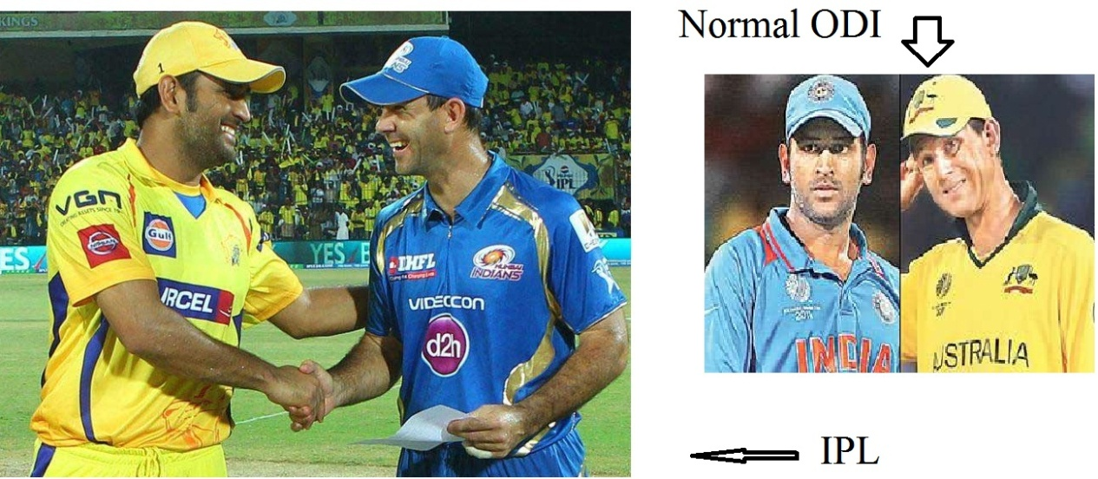
Image Source: (Samiuddin 2008)
Also, a sense of innovation has been created in the minds of those who follow the game very closely. Fans could have only imagined that what would happen if the players would bowl against their same team members, Their dreams have come true by the virtue of the IPL where they see as an example South African bowler (Dale Steyn for Hyederabad Sunrisers ) to a South African batsman (AB Devilliers for Royal Challengers) in IPL 2013.
Also, an innovative effect has been seen from the fact that people used to consider the game of Cricket as long and time consuming. Thus, the newer form twenty –twenty was much appreciated by the working professionals as it was a much shorther version which was full of drama every second.

2.8.5 The Halo Effect:
In India, cricketers have always been people looked up to. While cricket has been played at the corporate level, those with the ‘moolah’ haven’t really got a chance to ‘show it off.’ The format of this particular version of league cricket has lead to all the nine teams being owned and/or financed by large industrialists, International media moguls, politicians, Bollywood actors and actresses so in some manner the league is both ‘wealth-struck’ and ‘star-struck.’ Personal experiences of the last seasons showed that when leading Bollywood Star Shah Rukh Khan (owner of the Kolkata Knight Riders) entered the ground along with his 50+ people entourage and bodyguards, spectators forgot there was a cricket match on and strained their necks to get a brief glimpse of their favourite star (Samiuddin 2008).
Schumpeter (1986) talks of sociological changes in leisure time. This format of the game has brought about huge technological investments leading to technological advances for both the on field and third umpire’s as well as for the spectator on television. The valuation of TV contracts has swelled and there is a demand in an increasingly wealthy population in an emerging economy with more leisure time. The above discussion covers the key areas of marketing such as innovation, brand creation, value creation, the halo effect and new product development. These concepts are invaluable to any new startup firm, business, sporting league or whatever the case might be. One cannot have a successful startup or success in a start up if these key factors don’t knit together. It is vital that NPD, value creation, brand creation, halo effect and innovation all come together or are executed in that manner for success. If you don’t stick to the knitting then there will be a problem. You first have to have very successful NPD and innovation in place, which leads to brand creation and subsequently value creation and in this particular case the halo effect as well (Glaser 1967).

Chapter 3 Research Methods

3.1 Research Methodology:
This chapter on research findings will provide an explanation on the research strategies being used.
Each strategy can be used for exploratory, descriptive and explanatory research (Yin 2003). Some strategies might be deductive while some might be inductive. It depends on the type of research to be conducted, the subject as well as on the author. To quote, Saunders, Lewis and Thornhill (2012 edition) on this subject, “No research strategy is inherently superior or inferior to any other. Consequently, what is most important is not the label that is attached to a particular strategy, but whether it will enable you to answer your particular research question and meet your objectives.” According to Saunders, Lewis and Thornhill (2012 edition) research can be conducted via experiments, surveys, case studies, action research, grounded theory, ethnography or archival research.
Research is defined by Cooper and Schindler (2001) as,” a systematic inquiry which provides information to guide decisions.”
The seven methods of research listed above can either be used separately or in conjunction – you can take a multidimensional approach. There are a multitude of studies that use both, qualitative and quantitative research methods. Furthermore, one can also rely upon primary or secondary data for our research.

3.2 Primary Data:
Noted Maltese Physician and Author, Edward De Bono states, “Most executives, many scientists, and almost all business school graduates believe that if you analyze data, this will give you new ideas. Unfortunately, this belief is totally wrong. The
(with sponsors name’s for 2103 as per the ECB website) – Yorkshire Bank 40, Friends Life t20 and LV = County Championship.
The table below shows a comparison between domestic cricket variants in India and England.
Board Of Control For Cricket in India | England And Wales Cricket Board
- Ranji Trophy – 27 teams. Akin to the county championship and Sheffield Shield in Australia. Round robin followed by knockout | - Yorkshire Bank 40 – 40 overs a side, around 8 hours total duration
- Irani Cup – 4 day match played between the previous year’s Ranji Trophy winners and the Rest of India Team | - Friends Life t20 – 20 overs a side, around 3.5 hours duration
- Deodhar Trophy – 50 over knock out competiton played among the 5 zonal teams – West, East, Central, North and South Zone | - LV=County Championship – Two nine team divisions, home and way in a 4 day match.
- NKP Salve Challenger Trophy – For emerging talent, played 50 overs a side in a round robin and knockout. Played between 3 sides comprising of India’s 36 best cricketers divided into India Seniors, India Red and India Green.
- Indian Premier League. Teams blended with local and international stars as well as emerging talent. 20 overs a side with a match lasting around 3.5 hours.

The BCCI owns the entire cricketing infrastructure in India. Hence it has the power to call the shots. In the UK, grounds are the property of their respective counties.
In 2007, when a breakaway league known as the Indian Cricket League was formed, the BCCI did not allow any ICL matches to be played at its stadium’s. It caused a lot of problems for the ICL including banning players who played in it. This eventually led to the demise of the ICL and birth of the IPL (Eugene 1994).

Chapter 4 Data Findings and Analysis:
Please refer to Appendix C for detailed opinions of key stakeholders of IPL
Detailed Primary Research was conducted to know the opinion of the spectators regarding what they feel about the IPL tournament. The sampling method used was random sampling and 50 respondents were asked the following questions:
Question 1) What do you consider as the most interesting feature in the IPL?
a) Short Duration
b) Well staged Ambience and Environment
c) Innovative offerings in the IPL (Cheer Leaders, Strategic Time Out)
d) Mix and match of international players
Most Appealing feature of the IPL : 50 Respondents

Out of the 50 respondents, nearly haf of them considered as the small duration (3.5 hours) to be the most appealing feature in the IPL editions. Mix and match of International plyers teaming up as one was also appreciated by 21% of the respondents.
Question 2) Which Marketing Channel do you prefer to get latest news, updates and to follow IPL stories?
a) Newspapers
b) IPL website
c) Internet
d) Others

Source of Marketing Channel : 50 Respondents

IPL is marketed to the fans in a very intutive manner. The same includes advertising about the tournamnet and setting the stage up well before the commencement of the tournament. 50 respondents were asked about how do they follow IPL, it was to interesting to note that the IPL website got the highest response and accounted for 51 % of the total responses. Thus, Internet in total accounted for 80% of the responses that the IPL cricket followers use to keep themselves updated about the event.
Question 3a) 50 respondents were shown the logo of IPL to know whether they recognise and answer whether they are aware that it is the official logo of the IPL.

Identification of the IPL Logo : 50 Respondents

It was analysed that more than half of the respondents (63%) were not aware of the IPL logo where the remaining 37% of the respondents were able to recognise it without any confusion.
Question 3b) Do you think that other Twenty-Twenty Tournaments are as famous as the IPL is ?
Brand Identity of IPL : 50 Respondents

It is clear that the cricket followers consider the IPL as their hot favourite and very less emphasis is given to other cricketing tournaments like like Bangladesh Premier League (BPL), Sri Lankan Premier League, Australian Big Bash 20-20 etc. It was also noted that out of the 13% respondents that did consider other tournamanets as successful as IPL included the Champions League as their choice which also includes IPL teams who play against the other twenty-twent top teams from the world.
Question 4) What according to you has been the most innovative offering in the IPL ?
a) Change in the Rules
b) International Players playing in One Team
c) Association of the Bollywood and famous celebrities with cricketers
d) Auction of the Players

Most Innovative Feature of the IPL: 50 Respondents

The fact that the fan followers are able to see the worth of their players in monetray terms has become possible via the means of IPL auction. Hence, 35% of the respondents consider that to be one of the most innovative features of the IPL. The other attributes included 11% for a combined team effort of bollywood celbrities wrking closely with the Cricketers (Sharukh Khan working with Gautam Gambhir for Kolkata Knight Riders in IPL 2013)
Question 5) Do you personally consider that IPL is success ?
a) Yes
b) No
Measuring Success Rate of IPL: 50 Respondents

The responses indicated that a vast mojority of the people confirmed that IPL was indeed a successful endaevour and it has a long way to go in the future.
Question 6) What do you think is the Primary Reason behind the success of IPL ?
a) The Halo Effect
b) Social Media Integration
c) Transparency of the Affairs
d) Others

Reason Behind the Success of IPL : 50 Respondents
Of course, this is looking at the focus group of investors from a purely commercial point of view. Needless to say money isn’t everything to these people and the other tangible, as well as non-tangible gains they have derived from the IPL probably cannot have a price tag attached to the same. For example, the sheer joy and delight on Nita Ambani’s face when Mumbai Indian’s wins a close game or an important one cannot be valued. This is what makes it all worthwhile and click (Modi 2008).
In the light of the above discussion, it is worth looking at the financial aspect of the IPL to determine what role does it play in the success of IPL:

4.2 IPL – Finance
The BCCI had an extremely low cost in setting up the IPL as is amply clear from the article, ‘Jiminy Cricket – India’s cricket board makes a cool billion dollars for not doing much’ (Economist 2008). The BCCI has very low costs with regard to the IPL. All costs for travel, infrastructure, and team marketing and player salaries are borne solely by the teams.
The IIFL report (Mitra 2008) states that the IPL will bring in approximately $30 million per year into cricket between organizers, broadcaster and franchises.
Internationally, teams come forward to form a league. The IPL is different. First the IPL was formed, then the teams and the teams were then auctioned. The owners of these teams have no representation on the IPL board. This translated into the fact that franchisees would have to work together. In his cricinfo interview, Lalit Modi, addressed this fact by saying, “there is no need for concern, We need to work with them. It’s with their success we will achieve ours. It’s not us against them. We are all on the same side. We will ensure we work with our partners and that’s what my job is” (Modi, IPL will revolutionize the game, 2008).
There is also a stipulation in the franchise agreement that after a certain period, a team can list itself on the stock exchanges in India (Economist 2008).

4.3 Focus Group on Fans:
The IPL has changed a lot for the fans. For those who visit the stadium, tickets cost anywhere between Rs 600 (GBP 7.5) to Rs 15,000 (GBP 188). Prior to the IPL, the best seats at a One Day International cost around Rs 10000 (GBP 125) and ticket to a test matches cost around the same. Hence you could sit in the best seat for an ODI or test match for GBP 125 while the same seat in a 4 hour game could set one back around GBP 188. IPL has certainly made this more expensive for the fans. However, reality is different – IPL V in 2012 saw a huge drop in TRP ratings and advertising due to the fact that more people went to cricket stadiums and they were bursting at the seams. Hence, higher ticket prices have not been able to kill the fans appetite to watch a game live.
For those fans that wish to watch in the comfort of their home there hasn’t been much change:
- You have more advertising in the breaks to watch. Ad overkill has led to reduced viewership
- There’s the IPL Pulse so you can log on to the website and vote
- There’s more technology on field which leads to more interactive cricket and better viewing

4.4 Focus Group on Players:
The players are the group for whom the IPL has probably brought about maximum change. The key factor is that people once unheard of have become dollar billionaire’s overnight and icon’s on the world stage. Of course there have been disappointments as well.
Study of data (auction prices) reveals a thread that talent isn’t always matched with price. There have been some terribly high valuations for a player with little or no international experience and some serious talent has gone cheap.
The following table below shows selected results from the six IPL auctions. Have chosen to pick high valuations and some low one’s to represent the talent value disconnect at times.

4.5 IPL Auction
It was seen in one of the Primary Research questions above that Auction played a very significant role in determining the innovative nature of the IPL tournmanent. Innovation stands as a critical tool for the promotion of a product or service and same is the case with the IPL as well. Hence a snapshot of the auction details have been provided in the section below:
2008 IPL Auction
Name | Price | Team | Result
MS Dhoni | USD 1.5m | Chennai Super Kings | Success. He’s been a brilliant captain and led the team to two IPL titles
Adam Gilchrist | USD 0.7m | Deccan Chargers | Success at half the price. Was a terrific player for Deccan Chargers
Andrew Symonds | USD 1.35m | Deccan Chargers | Flop. Performance did not commensurate with remuneration. Symonds performances were very poor
Michael Hussey | USD 0.25m | Chennai Super Kings | Huge Success. Hussey doubled up as an opening batsman at times.
2009 IPL Auction
Name | Price | Team | Result
Kevin Pietersen | USD 1.55m | Royal Challengers Bangalore | KP was very good in his performances for RCB. He turned the innings in their favour regularly.
Andrew Flintoff | USD 1.55m | Chennai Super Kings | Played only a few games and sadly his infamous knee raised it’s head once again forcing him into retirement. Truly sad

To get the full project, please buy the Assignment by using this Link
http://sampleassignment.com/pay-now.html
Cost - £39

