FEASIBILITY REPORT (EXPORT INCENTIVES) Assignment Sample
Executive Summary
The feasibility report has been done in the export incentives that an exporter doing business in the jewellery industry would earn from trading with other countries. The focus has been given on how the initiatives by the Government of India of the jewellery industry can improve the industry as a whole. Financial projection has also been made which shows the overall profit earned by the jewellery industry from the trade with the foreign countries. A project schedule and 5-year financial projections have been presented.
Table of content
Introduction | 4
Description of products and services | 4
Technology considerations | 6
Technology considerations | 7
Marketing strategy | 8
Organization and staffing | 9
Schedule | 9
Financial projections | 10
Conclusion and recommendation | 12
References | 13
Introduction
A feasibility report is a document that provides a solution to a business organization for developing its business by working on the problems that the organizations have been facing. This report will be based on the export incentives that an exporter of gold and diamond jewellery doing business in India can receive. Export incentive is the additional income that a country can earn after the export of the goods and services within the domestic country. In the study, the discussions will be done on the description of the products and services and the technological advancement will also be highlighted. Moreover, few recommendations will also be discussed in the study so that the business through export of goods and services could be improved and can maximise the earning by the country.
Description of products and services
According to the case study, around 85% of gold and diamond jewellery that are produced in India is consumed in the domestic market and only 15% of the total production is exported in the global market. The main buyers of the gold and diamond jewellery are USA, Hong Kong, UAE, Singapore and Belgium. As per the case study, around 0.1million gold jewellery and 8,000 diamonds jewellery is produced by around 2 million workers working in the jewellery industry. However, the exporter of gold and diamond jewellery aims to avail the incentives from the export under the provisions of the Foreign Trade Policy (FTP). According to the case study, India has benefited from the foreign trade policy by increasing the cost of personal carriage from US$ 2 million to US$ 5 million. Additionally, 100% Foreign Direct Investment in the Jewellery Industry of India has been permitted so that India can become a diamond trading hub before the global market. As per the case study, the demand for gold in the global market has been increased from 338.70 tonnes in the period between January to June in 2018. On the other hand, the export of gems and jewellery has been raised to around US$ 13.18 billion in between the period of April to August in 2018.
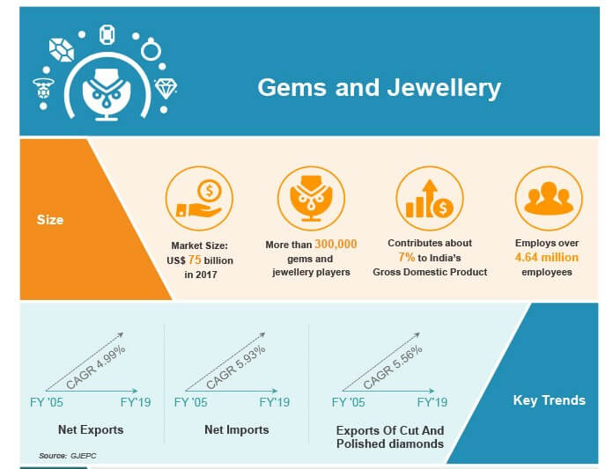
Figure 1: India’s market on Gems and Jewellery
The above figure shows the marketing of gems and jewellery in India. In the figure, the size of the Indian market shows that in the year 2017, the total earning had reached around US$ 75 billion. Moreover, the total contribution to the Gross Domestic Product (GDP) from the jewellery industry had been 7% (IBEF, 2019). On the other hand, this jewellery industry has also generated employment of around 4.64 million employees resulting in the improvement in the overall economy of the country. The key trends also show that between the financial year of 2005 to 2019, net exports have increased to nearly 4.99%, net imports have risen to 5.93% . Additionally, export of cut and polished diamonds has also been increased to around 5.56% in between these financial years.
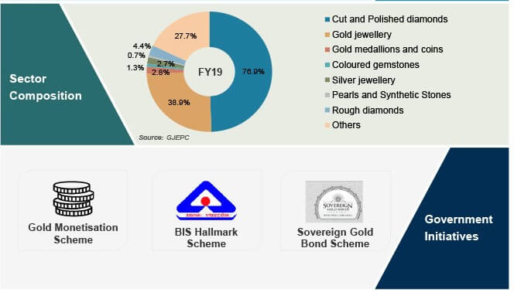
Figure 2: Sector-wise marketing of gems and jewellery in India
The above figure shows the sector-wise distribution gems and jewellery in India. It shows that in the financial year 2019, the contributions of the cut and polished diamonds has been around 76.9% which has been the maximum contribution in the sector (IBEF, 2019). On the contrary, the lowest contribution has been generated from the rough diamond. Moreover, the figure also shows different government initiatives like Gold monetisation scheme, BIS Hallmark Scheme and Sovereign Gold Bond Scheme. The main objective behind this initiative is to ease the common people by providing loans on the basis of the gold mortgages. However, BIS hallmark Scheme provides a warranty on the gold value.
Technology considerations
According to the case study, the domestic production of gold and diamond jewellery in India depends on the raw materials that are imported from other countries. In India, Mumbai has been considered as the special economic zone in India that promoted around 40% of the exports from India in the year 1990. The reason for preferring Mumbai as the special economic zone is due to the presence of the technical equipment like laser cutting units, modern factories and the location of the factories is in Santa Cruz East Economic Processing Zone (case study). On the other hand, Mumbai receives the majority of gold and rough diamond imports that enable the production of jewellery. The other processing units that are developed in India with modern technical features are located in Gujarat primarily in Surat, Bhavnagar and Bhuj.
According to the case study, the initiatives taken by the Government like setting up of Common Facility Centre (CFC) at Thrissur in Kerala along with the introduction of new schemes have added additional advantage in doing the business. On the other hand, the Government of India has also taken necessary steps in order to avoid black marketing by reporting any kind of transactions in gold or any other precious metals and stones to the respective authority. Therefore, the intervention of the Government of India has improved the market of gems and jewellery. According to the case study, the initiatives have increased the number of players associated with the business of gems and jewellery to nearly 3,000,000 players. Moreover, the market size is also expected to rise due to advancement in the technology used in the making of the jewellery from US$ 75 billion in 2017 to US$ 100 billion by 2025 (case study). Additionally, the export of gems and jewellery by India contributes to around 29% of the total jewellery consumption in the global market.
Product/service marketplace
According to the case study, India exports the gems and jewellery to the foreign markets given below:
Name of the countries | Contribution on the overall growth (%)
United States | 28
Hong Kong | 21
UAE | 15
Singapore | 9
Belgium | 8
Table 1: Importers of Gems and Jewellery
However, in order to expand the jewellery industry, the importance of finding new markets plays an important role. As per the case study, in the global market, the jewellery industry is one of the most profitable businesses earning a good profit. However, for a diamond, the profit margins are low as it involves branding of the products that are expensive for the business organizations.
Marketing strategy
As per the case study, several factors determine the performance of the jewellery industry. These factors involve the presence of sufficient stock in order to meet the demand for the jewellery both in the domestic and the foreign markets, effective planning and budgeting, marketing of the products, choosing the stakeholders that would minimise the cost of products and increase the overall profit earned by the jewellery industry.
According to the case study, the marketing strategy that has been chosen by India is based on the product differentiation. The exporters in India have focused on differentiating the products in terms of design, price, quality, polishing of the financial products and in many other ways. On the other hand, India has also brought certain changes in the exporting market of jewellery by focusing on the overall demand and supply both in the domestic market and in the global market. According to the case study, after the successful implementation of the marketing strategies, the gold and diamond jewellery industry had achieved a growth of around 16.26% in between the financial period from 2011-12 to 2016-17. On the other hand, the reason for the growth could also be contributed to the increasing government effort and the incentives that were provided to this industry in addition with the foreign direct investment have boosted India’s export market as well as the domestic market.
Organization and staffing
According to the case study, in order to promote the export of gems and jewellery, the government of India has set up Gem and Jewellery Export Promotion Council (GJEPC) in 1966 that would look after the trade policies that would develop the industry. The council has been headquartered at Mumbai and the other regional offices are located at Delhi, Calcutta, Chennai and others. As per the case study, the main aim for establishing this body has been to facilitate the trade by the conduction of different promotional activities.
The activities include opening of jewellery shows through encouraging international participation so that the buyers and sellers can meet and the international relationships can be established between the parties (Cartier et al. 2018). The Council also plays an important role in improving the relationship between the countries participating in the trade. On the other hand, for the development of the overall organizations, the training of the staff members plays an important role. Therefore, in order to provide required training to the staff members, the Council also provided infrastructure for training in Mumbai, Delhi, Surat and Jaipur (case study). Therefore, the overall development of an organization can be initiated by the improved quality of the staff members who are required to run the overall business (Soroko et al. 2018). Moreover, the Council also provided different brochures, statistical booklets and many other media that have positively affected the export of gems and jewellery in the global market.
Schedule
Activities | Duration in 2020 (Months starting from January 2020)
Discussion of aim to increase gold and jewellery export outside India to earn profit (market research, evaluation of policies and objectives) | January 2020
Marketing about Indian jewellery in the global platform | March- December 2020
Conduction of international seminars for engaging jewellery organisations in India in the plan | January - February 2020
Increasing export of raw gold and diamond | February-November 2020
Manufacturing of jewellery | March - June 2020
Organising buyer-seller meets to showcase Indian jewellery to foreign countries (USA, China, Singapore) and signing bonds | May-November 2020
Increase exports | June-December 2020
Table 2: Project schedule
Financial projections
 | Measures | Year 1 | Year 2 | Year 3 | Year 4 | Year 5
Cash outflow ($) | Planning | 3000 | 1000 | 1500 | 1000 | 2000
 | Marketing | 15000 | 15000 | 20000 | 20000 | 15000
 | Organising meetings with Indian jewellery makers | 2000 | 2500 | 3000 | 4000 | 4500
 | Organising meetings with foreign raw metal providers | 5000 | 5000 | 6000 | 6000 | 8000
 | Manufacturing jewelleries | 300000 | 320000 | 380000 | 420000 | 500000
 | Organising meetings with foreign jewellery buyers | 10000 | 15000 | 15000 | 20000 | 22000
 | Total | 335000 | 358500 | 425500 | 471000 | 551500
Cash inflow ($) | Earning | 175000 | 350000 | 450000 | 550000 | 620000
 | Investment by government and organisations | 20000 | 40000 | 50000 | 70000 | 80000
 | Total | 195000 | 390000 | 500000 | 620000 | 700000
 | Profit | -140000 | 31500 | 74500 | 149000 | 148500
Table 3: Financial Projection on Gems and Jewellery industry in India
The above table shows the financial projection of the jewellery industry in India. After the first year, the overall profit earned by the industry was negative. Gradually, every year, the overall earning of the industry has increased. Therefore, it can be concluded that the export incentives on the jewellery industry is feasible for the economy of India as a whole.
Conclusion and recommendation
The feasibility report has shown that the export incentives that the exporter of India could receive the initiatives taken by the government. India has earned well after exporting the various gold and diamond jewellery to various countries. Financial projection that has been discussed has shown that overall profit earned from the jewellery industry has increased. This has improved the overall development of the economy along with the relationship of India with other neighbouring countries. The financial projection depicts a sustainable profit margin in this sector in future. There are a few recommendations that can further improve the export of India. Effective pricing on the export items would increase the demand on the foreign markets resulting in the overall increase in the profit of the home country (de Souza et al. 2016). Careful choice of countries that would find high opportunity cost through import of different goods from a particular country. Tax incentives to the exporting countries by the government can also encourage the export of goods that have absolute advantage while producing in the home country (Domazet and Marjanović, 2017). Legal considerations like permission from the government of the home country and also of the foreign country's government would ease the trade relation between the trade countries (Andersen et al. 2017). Therefore, the countries involved in the trade relation also enhance the relationship between the countries.
References
Andersen, M.R., Kett, B.R. and von Uexkull, E., 2017. Corporate tax incentives and FDI in developing countries. Global Investment Competitiveness Report 2017/2018, p.73.
Cartier, L.E., Ali, S.H. and Krzemnicki, M.S., 2018. Blockchain, Chain of Custody and Trace Elements: An Overview of Tracking and Traceability Opportunities in the Gem Industry. Journal of Gemmology, 36(3).
de Souza, I., Floriani, D.E. and Borini, F.M., 2016. FINANCIAL INCENTIVES TO EXPORTING SMEs IN EMERGING MARKETS. Revista de Negócios, 20(2), pp.31-39.
Domazet, I. and Marjanović, D., 2017. Tax incentives as a factor of economic growth. Review of applied socio-economic research, pp.93-107.
Horst, D.J., Duvoisin, C.A. and de Almeida Vieira, R., 2018. Additive Manufacturing at Industry 4.0: a Review. International Journal of Engineering and Technical Research, 8(8).
IBEF, 2019, Growth of Gems and Jewellery Industry in India – Infographic, IBEF. Available at: https://www.ibef.org/industry/gems-jewellery-india/infographic [accessed on 4th January]
Lucas, A., Bhatt, N., Singhania, M., Sachdeva, K., Hsu, T. and Padua, P., 2016. JAIPUR, INDIA: THE GLOBAL GEM AND JEWELRY POWER OF THE PINK CITY. Gems & Gemology, 52(4).
Soroko, A.V., Shemonchuk, D.S., Bondaletov, V.V., Baklanov, P.A. and Zvezdina, E.A., 2018. Scenario modeling as method of staff training in the organization. Espacios, 39(21), p.31.

