# Exec Summary

Contents

Exec Summary 1

Brief background 2

Customer profile by segment 2

Consumer/User market segmentation 2

Business 2

Customer profile by gender and age 3

Value proposition to customers 3

Operational efficiency (lowest price) 3

Product leadership (best product) 3

Customer intimacy (solution and service) 4

Market positioning 4

Innovation 4

Brand 4

Prices 4

Relationships 4

Market share 4

Market orientation 6

Main strengths and Sustainable Competitive Advantage 6

Main capabilities 6

Main weaknesses 6

Opportunities 7

Threats or potential threats 8

Overall evaluation of the marketing strategy 8

List of References 9

# Brief background

Facebook was founded by Harvard University student Mark Zuckerberg on 4 February 2004 (Facebook, 2013). It was originally intended to be a directory of undergraduate students enrolled at Harvard University and the concept grew rapidly, reaching 10,000 Harvard users by the end of February 2004 and students at leading American Universities including Columbia, Stanford and Yale were invited to join the network by the end of February (Han, 2011). By June 2004, the site spanned 30 Colleges and had over 150,000 users, which led the Founder to go to Silicon Valley to grow Facebook and determine its true potential (Han, 2011). Facebook generates 770 billion page views per month and 200 million people access Facebook via a mobile device each day (Burbary, 2011).

Goldman Sachs has estimated the business value of Facebook at $50 billion in 2011 (Tsotsis, 2011) with approximately $710 million in annual revenue (EMRC, 2010) of which there is a minimum $30 million in profits (Martin 2008), 700 employees and over 1 billion users (EMRC, 2010). Facebook’s

# Customer profile by segment

Facebook has three main market segments and as it does not currently offer subscription fees, income is not a key demographic. Likewise, Facebook can be accessed from almost any location and thus geography is not a major demographic. Facebook users by gender are essentially equal, with 48.8% being female and 51.2% being male (Burbary, 2011). Hence age and psychology, in particular the rationale or reason for becoming a member, become the major determinants of market

## Customer profile by gender and age



*Source: Burbary (2011).*

# Value proposition to customers

There are three main value propositions relevant to businesses (Growth Panel, 2012):

## Operational efficiency (lowest price)

Facebook is essentially a free product for users and they generate revenue through affordable advertising and other corporate means. The free use of the site including unlimited usage of site features, including publishing profile information, controlling access to profiles, storing personal images and videos, broadcasting streams of information or personal comments and a quasi-email inbox makes it efficient for users to stay connected with their friends at any time and any place. Essentially the network overcomes the barriers of time and distance to allow social groups to stay connected. Many people and businesses make it a matter of social courtesy to offer or accept “friend requests” in order to continue to build solid networks.

## Product leadership (best product)

Facebook is the largest and most popular online social networking site in the world (Gafni&Deri, 2012). Facebook’s popularity make it the ultimate meeting place for users to socialise and stay connected in a safe and user controlled environment (Humphreys, 2013). Facebook has no financial or other pre-requisite restrictions on users and has highly popular features including a large storage capacity for users to essentially store their images and personal thoughts and comments.

## Customer intimacy (solution and service)

Due to the immense number of users on Facebook, there is little opportunity for the business to build close relationships with its customers. However, Facebook does send out mass messages, provides free 24 hour support including self-help Q&A facilities and has dedicated Facebook endorsed accounts to allow users to stay in contact with the business (Facebook, 2013).

The first two value propositions are emphasised by Facebook and encapsulate the marketing mix. These value propositions also help to distinguish Facebook from other online social networks.

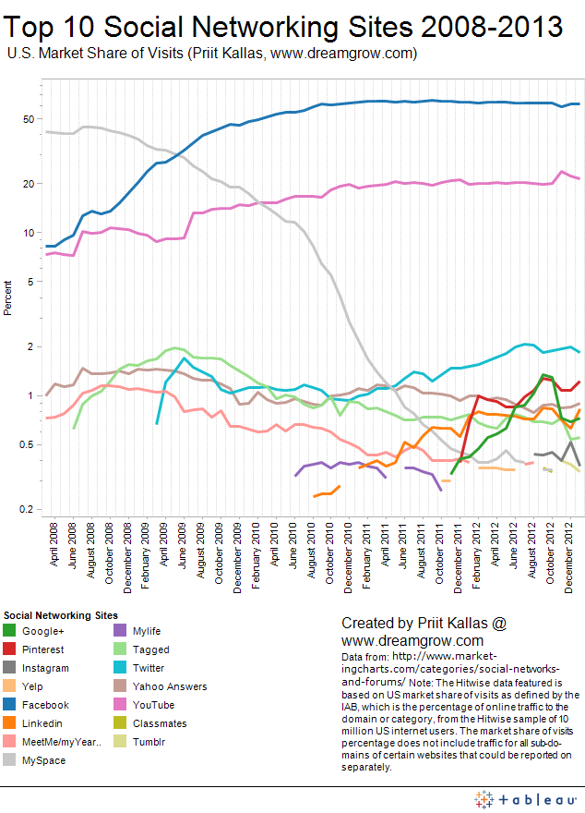

*Source: Kallas (2013)*

To get the full project, please buy the Assignment by using this Link

<http://sampleassignment.com/pay-now.html>

Cost - £19