Chapter: Research Findings

Objectives
The primary objective of this chapter is to identify the impact of changing trends on the role of foundations in the 21st century.
A study of changing Trends in Philanthropy in 21st Century
- New outlook of entrepreneurs who run the philanthropy industry much as same like a business organisation. This also creates new opportunities such as cause marketing, CSR, PR etc.
- Availability of newer tools and Revolution in technology is viewed as one of the key change-makers as Internet creates an opportunity for information to be shared at a very rapid pace. E-philanthropy is an example which has raised the level of awareness to new heights.
- Democratisation of philanthropy and rise of public-private partnerships has raised the operating principles in the industry.

Primary Research
10 Family Foundations in London who gave away between £500, 00 and £2million annually were interviewed to determine the impact of political, social, technological changes in their grant making approach:
(Please Refer to Appendix A for Research Questions)
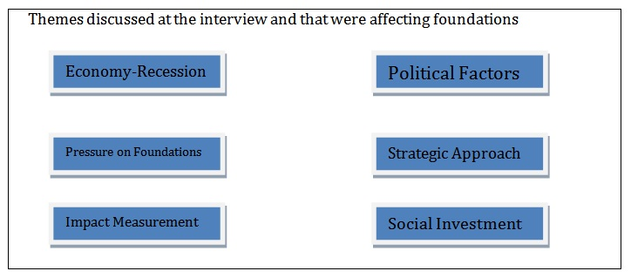

Attributes of the Sample Selected for Primary Research
10 out of the 50 invited ACF foundations responded for both the interview and the questionnaire
Characteristics:
- Majority of the sample operated at local levels
- Half of the sample reported expenditure of £1million.
- Median Average typical Grant awarded= £10,000
- Different foundations had different processes for consideration of grant applications
- Majority employed 1 to 5 salaried employee
- Nearly all respondents awarded grants to registered charities

Interview Questions
(Please Refer to Appendix B for detailed Questions asked in the Interview)
The main results from the Interview Question revealed the following findings:
- Strong sense of sustaining grant making work levels and practices during economic crunch
- Amount of money to be spent on grant was affected as a result of economic downturn
- Revision of Grant making criteria
- Increased number of grant applications

Findings

Patterns in approach to giving – Initial motivations
It was noted that the foundations in the sample used conventional approaches as they began to donate money. They were not too selective in deciding which particular organisation they should favour more. As times changed, these donors have all become more knowledgeable and have begun to stop thinking in terms of which organisations to support, and started to think about how to solve a specific problem, using skills, connections and resources they possess. Today, the donors are using a more strategic approach which enables them to identify the steps needed for adequate consideration which is changing the face of Philanthropy in UK in contemporary times.

Motivations Giving
The findings reveal that there are other factors other than just need which drives charitable donations. The same are donor’s taste, personal bias, perception of charities competence and desire for personal impact.
Philanthropy is being increasingly viewed as the following by the donors:
- Means of dealing with financial success
- Pathway into a new sphere of endeavor
- Life turning point and an obligation to give
- Need to work towards something of broader significance
- Tax relief benefits is not as significant as it used to be
Structured Philanthropy offered a solution to most of the foundations as far as management of their wealth is concerned. The wealth of donors provides both positive and negative motivations to engage in philanthropy. While the taxation incentive to engage in philanthropy is acknowledged by interviewees whose wealth comes from all sources, it is never cited as the sole reason for giving. The strongest of the motivations for giving is feeling an obligation to give back, with seven of the 10 family foundations that articulating a need to return some of their wealth to their community and country.
(Please refer to Appendix C for specific responses from the donors about what they feel about this industry)

Foundations criteria for choosing charities
These points were considered for deciding which charities to support:
- Charity’s vision and strategy (cited by 50% of respondents), that the
- Charity is focused on the greatest need (listed by 42%), and that the
- Charity measures its results and uses its resources well (named by 29% of respondents)
The implementation of these criteria is a challenge for the foundations. How a charity measures its results and how they use their resources is difficult to be accurately determined.

Impact Measurement
8 of the foundations interviewed put a greater emphasis on evaluation and seeking ways to measure change. The goal is to work more efficiently by ensuring that whatever they fund has a measurable and positive impact on both beneficiaries and communities.

Social Investment
Some donors were also identified to be giving out of their foundations, in areas of social investment. This was because the donor and trustees were unsure of their position with the Charity Commission regarding tax and eligibility.
While it is believed that philanthropy are open to considering 'creative' funding options (e.g. loans, crowd-funding and underwriting) which do not fit the traditional philanthropic funding model, this did not emerge from the research. It was done as a separate activity outside the foundation with one exception who donated to a micro-lending organization through his foundation.

Secondary Research

Donation Culture in United Kingdom
UK has a reserved culture when it comes to giving relative to US. Lloyd’s 2004 research ‘Why Rich People Give’ found a widespread feeling of unhappiness about the status and respect given to philanthropy in the UK. It can be estimated that family foundations account for around 38% of all charitable foundation spending in the UK, and 17% in the US (Pharaoh, 2010). These foundations are adding huge and well-publicised financial value to the sector’s total assets, but much less attention is paid to the powerful way they may be shaping the direction of tomorrow’s sector.
Inherited Wealth versus Self Made 15 years ago, 75% of the Sunday Times Rich List had inherited their wealth, and 25% were self-made. Those figures are now reversed. (Source Sunday times)
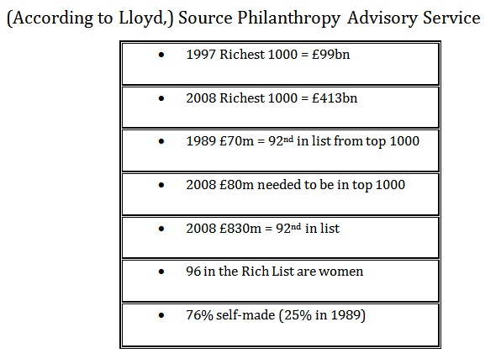
Three trends shape the philanthropy sector in the contemporary times. The same has been provided in the image below.

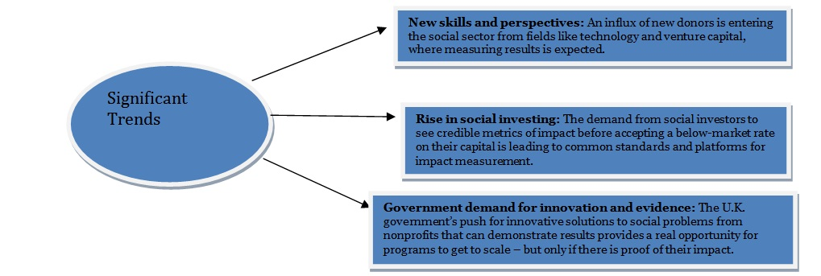

Donor Motivations
There are several factors which influence decision making of founders and the same includes:
- Historic patterns
- Close relations
- Government policies
- External Environmental factors

External Factors Impact
Economic Crisis has led to decreased government spending. This has also resulted in individuals not being able to donate freely due to the impact of inflation. Government also needs to respect the fact that foundations prefer independence and too much government intervention is not conducive for them.
The largest 100 UK family foundations donated £1.33bn to charitable causes in 2010/11 and a total of £6.9bn over the past five years, representing 8% of all private giving.
While there was an overall fall of 1.8% in giving in 2010/11, 47 saw a fall in their giving and 53 saw a rise.
(Please refer to Appendix D for Influences on Reduction in Spending)

Basis of Good Performance in Foundations

Strategic Philanthropy
One of the identified attributes of contemporary foundations is that they develop a clear sense of what their grant programme looks like, includes the size and number of grants, criteria and focus for funding, and also the process which they use to identify and analyse candidates.

Social Investment
- A number of trusts and foundations are already experimenting with various forms of social investment, often in addition to not instead of their core grant making activity.
- The grant funding provided by charitable trusts and foundations is valuable and relatively accessible, but increasingly over-subscribed; risking the assets which generate income to support those grants could threaten the long-term sustainability of grant funding.
- There is huge scope to encourage trusts and foundations to use their assets for positive social change by investing them in traditional ways but according to ethical criteria, as opposed to going for new and complicated products such as Social Investment Bonds which do not have a proven track record.
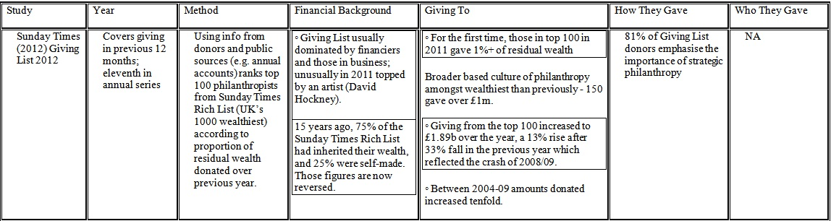
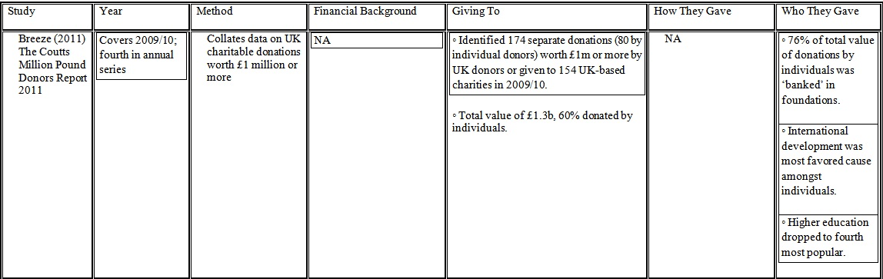

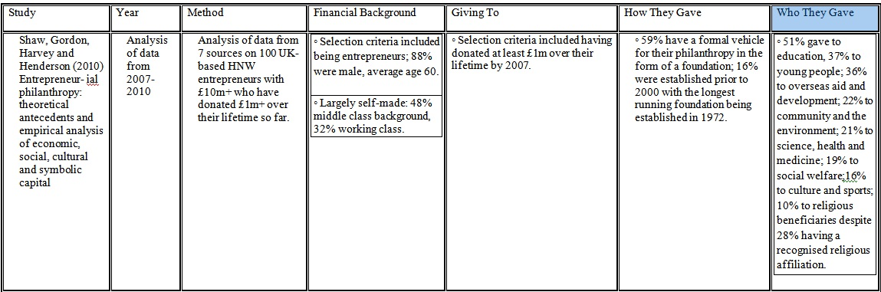
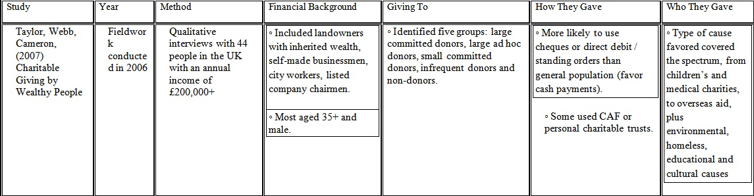

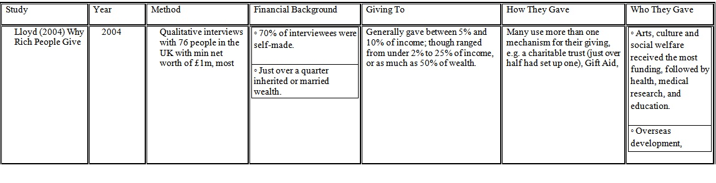

Giving In UK
The most extensive study of major donor motivation in the UK was conducted by Theresa Lloyd in 2004 (Lloyd, Theresa (2004), Why Rich People Give. London, Association of Charitable Foundations)
She grouped the varied motivations that drive giving among the wealthy into five categories:
Belief in the cause: often influenced by a wish to change or enhance society’s systems or structures in line with a particular interest or belief. This was “the key impetus” behind donations; as well as influencing the size of gift and likelihood of ongoing commitment.
Being a catalyst for change: desire to make a difference (to society, institutions or individuals) and for their gift to result in “something that otherwise wouldn’t have happened”.
Self-actualisation: defined as “the realisation of an individual’s personality and development of some or all of its aspects”, or the satisfaction of personal development. This was found to be a more significant driver of recurring commitment than the original stimulus to give.
Duty and responsibility: the satisfaction of conscience, the obligations of the privileged to those less fortunate and the desire to “put something back” into society.
Relationships: “the fun, enjoyment and personal fulfillment” that comes from relationships with a range of people such as charity staff, beneficiaries and fellow donors.

Chapter: Discussion
This chapter highlights the key points of the Literature Review and the Findings Chapter and strives to build a relation between the two. Limitations of the study have also been included in this chapter.
It has been quite a task to link up the Literature Review and the Research Findings in the Study. The major highlights of the Literature Review are as follows:
1. The following reasons account for the change in the Philanthropy Industry in the 21st Century
- Globalisation and Economic Growth: The connected world and creation of wealth has resulted in new wealthy donors coming forward and the same has drastically changed the face of the Philanthropy industry in the contemporary times.
- Technology Revolution: Connected World, Newer infrastructure, improved tools and services have only boosted the Philanthropy world and have provided ample opportunity for its growth.
- New Culture of Entrepreneurship: The young leaders that manage the foundations and the not for profit organisation deals with the affairs in a professional manner. They also apply management theories in order to carry out both short term and long term goals.
- Shift in Values and Beliefs: There has been a change in the value and belief system from the traditional times and philanthropy is increasingly being given more importance relative to the yester years.
2. As a result of the above mentioned points, the motivations, working practices, organisational structures and approaches of foundations are being influenced and affected. This facilitates innovation in the philanthropy industry which is taking them to newer heights.
3. It was noted that Family Foundation is the main source of Philanthropy in United Kingdom currently.
4. There has been a considerable dent in the progress of the philanthropy industry due to the global financial crisis.
To get the full project, please buy the Assignment by using this Link
http://sampleassignment.com/pay-now.html
Cost - £19

