Faculty for Business and Law
INTERNATIONAL BANKING AND FINANCE

Assignment 01:
SPECULATION IN THE FOREIGN EXCHANGE MARKET

Unit Chair:

Account details:
Username
Password

Students:

Executive Summary
This objective of this Report is to detail the online trading and foreign exchange market. The website www.easy-forex.com.au is the platform virtual amount of AUD 20000 was used with the objective of increasing the capital. The closing balance at the end of 171 transactions conducted over a period of three weeks was 24,560.07 AUD.
The major focus of the transactions conducted was on the relationship between the Australian and the United States Dollar. It was speculated that the exchange rate of AUD/USD moved to and fro in the range of 1.02 to 1.08. Thus, a simple speculative strategy was adopted wherein Australian Dollar was bought and the United States Dollar was sold when the rate was falling close to 1.02 and Australian Dollar was sold and the United States was bought when the rate was rising and close to 1.08. This strategy helped and assisted in making profits repeatedly. This is also evident by the fact that out of the 171 transactions conducted, 157 made profit and only 15 made loss which is about 90% profit transactions. Though the duration of time covered in the report is less than 6 weeks, it has provided enough evidence for us which explains the depth of volatility of foreign exchange market. Apart from the technique explained above (which was a direct result of the experience), the website www.wasy-forex.com.au in itself is an institution and is a great source of learning the online trading.

Introduction
The main focus was given to the speculation technique where in the quick reaction upon the financial news was related to the expectations of a currency appreciating or depreciating. A major part of our total transactions dealt with AUD/USD relation which has given us the practical knowledge of stabilizing and destabilizing speculation. One could easily realize that this industry is a perfect example of a perfectly competitive market and is also one of the most dynamic as the rate fluctuates at great degrees throughout the day. The main purpose of trading on the stock exchange is to make a profit and it is all based on speculation. The trader has to be able to anticipate the reaction of the market to different factors in the environment such as political, economic and even social events. The risk is often considerable but can be greatly avoided if the trader is operating with foresight and with the correct information.
The report deals with forex trading performed on the Easy- Forex website. Foreign exchange trading takes place in two sets of dealing rates namely spot and forward exchange rates. The spot exchange rate is the quotation between two currencies for immediate delivery of funds. The forward exchange rate is the rate at which economic agents agree today to exchange currencies at a future date at a predetermined future exchange rate.
All the transactions were done on spot rates. For some transactions the settlement was done a few days later for which transaction costs were also applied. A rollover cost is the cost one pays or receives depending on his position. If one is long on a currency pair where the base currency has a higher interest rate than the counter currency then one receives interest. If one is short then one pays interest. Speculative trading was done using fundamental analysis based on economic data news. Speculators sell currencies if they feel they are overvalued and hence would depreciate or buy currencies if they fell they are undervalued and would appreciate. This technique was used fundamentally throughout the task and thus resulted in a positive outcome

Tools Used for Online Transactions

Graphical Full Charts Station on www.wasy-forex.com.au
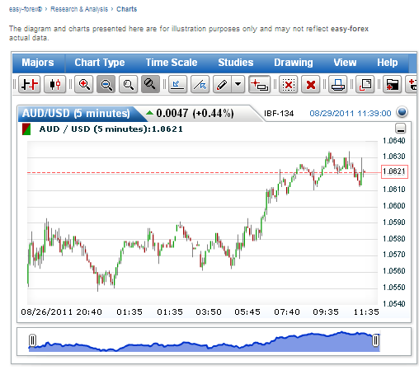

To get the full project, please buy the Assignment by using this Link
http://sampleassignment.com/pay-now.html
Cost - £19

