Introduction Phase of Nokia 8
Student’s Name
University Affiliation

Introduction Phase of Nokia 8
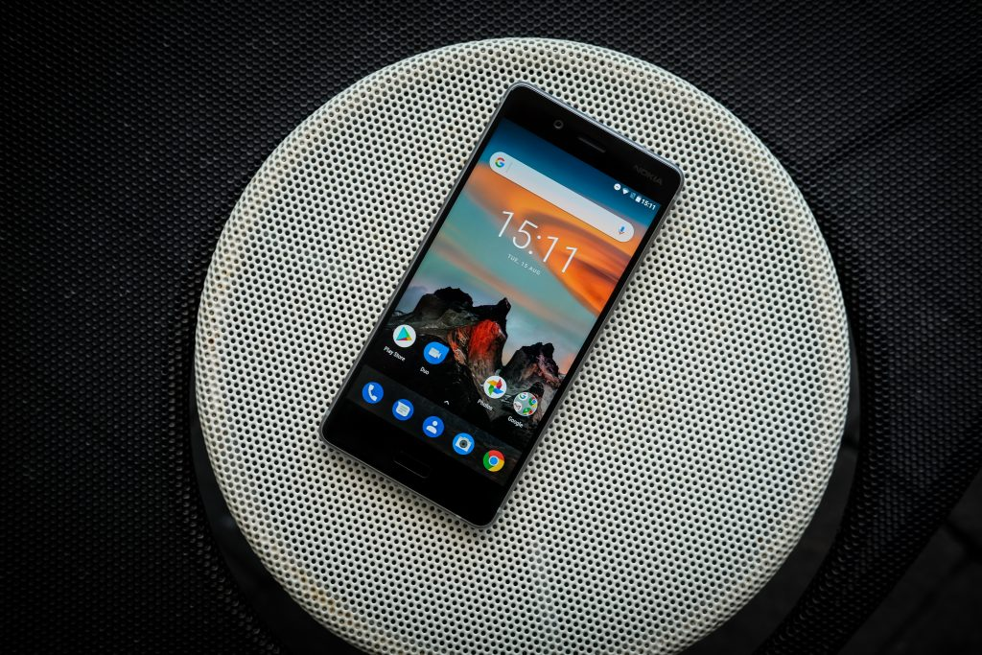
Introduction Phase of Nokia 8
In marketing product life cycle plays an important role in ensuring the success of a given creation since its development until it is eventually removed from the market. Product cycle normally happens in four important stages namely: introduction, growth, maturity, and decline. One of the product that would feature in this discussion is Nokia 8. It is widely accepted that the range of Nokia Android phones are making a comeback in an already saturated market. The company, which is known to have made decisions in the past that ruined what would be a dominant player in the mobile telephony market, has been trying to re-ignite and comeback to life.
Concepts and Theory
The phone has awesome features due to the aspect of reliability, powerful processors, and even a well-crafted screen. What is making it fail to clock the required mark is the fact that it fails to match other Android devices, which have almost the same features. While not dwelling much on the review of the device, it is clear that the phone is at the market introduction phase of the product cycle. The phone was announced on September 2017 and has been trying to gain the necessary market traction since then. With a market price ranging from $484-$543, it is evidently clear that the product is high-end. The price tag, which is slightly lower that other phones featuring the same specifications, suggests that the phone is making comeback due to the aspect of affordability. Several factors explain why the phone is in its introduction phase in the market.
One of the factors is attributable to a squeezed market for the product. It is evident that Nokia 8 which a flagship of the company’s high-end smartphone is being released in market which is full of the giants such as iPhone and Samsung brands. This explains why the device, which was released three months ago, is going to have a low start off. In other markets such as India and Pakistan where most consumers may not purchase the top of the chain phones, the release or rather the introduction of Nokia 8 is going to create a buzz with the sales increasing right away. Understandably, the release of the phone and the overall success accrued will rely upon the type of the market.
It is important also to appreciate the fact that Nokia brand of phones did not perform well in the smartphone industry due to the rigidity of the operating system, that is, Symbian and the unsuccessful Microsoft Windows phone. At the introduction point, some of the features in this flagship product match those of Samsung, HTC, and even LG. The device, however, needs to pull the muscles, if it is going to make it in the smartphone market.
Best Approach in the Entry
The best approach the Nokia can use would entail creating increased demand for their flagship product while at the same time establishing the market value for the product. On the other hand, there is a need for coming up with cost-effective ways of creating the right distribution channels that would help in increasing the market share. Consumers need to be convinced as to why Nokia 8 is the best device to buy among the key competitors. With the visual fidelity, a comparable feature to the competitors and slightly lower price Nokia 8 is making an important entry into the already jam-packed Android market.

