Title:

Observation Report

Observation Site
This report relates to the observation held on Monday 26th March in a local grocery store at Burwood Rd in Melbourne, ‘Safeway’. The timing of the observation period was in the evening
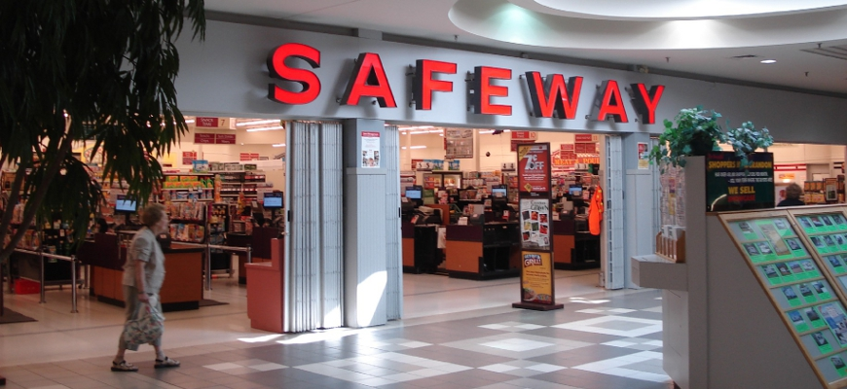
Figure 1 Source : (Swait 2000)
Log of customer behavior
Number and Type of Customer | Nature of customers | Customer Behavior | Customer Needs and Wants | Information on timing | Remarks
1. Middle Aged Lady | Friendly and Specific on what was required | Was friendly with the staff, did not take much time on purchasing the items | Home Stuff purchased like vegetables, sauces etc | 5:13pm | Possibly a regular visitor as she knew the way around comfortably
2. Sophisticated Working Man | Friendly and straight | Discussed with other customers about certain products | Juices, Milk and Stationary Items | 5:27 pm | Probably stopped on his way back home from work to buy a couple of things that were not quite urgent

To get the full project, please buy the Assignment by using this Link
http://sampleassignment.com/pay-now.html
Cost - £19

