Assessment task 1—Academic essay
Due date: 1PM AEST, Thursday of Week 6

Case Study:
Hudson’s Alpine Furniture

The Hudson’s Alpine Furniture was founded in 1998 by Della Hudson and Ralph Hudson in the regions of Queanbeyan NSW. It is relatively small firm which specializes in manufacturing of customized timber furniture. The initial phases were marked by a smooth phase of orders. Recently, the organization is facing a tough time as the number of commercial orders are increasing. This paper focuses the production and operation management techniques used by the firm. Also, a set of recommendations have been provided in the paper which can be applied by the organization to bring in a greater degree of efficiency (Greene 1994).
It has been analyzed in the case study provided that the management lacks a dedicated production department. The management in the traditional times have been dealing with the customised private users where delivery on time was relatively less important compared to value and quality of the furniture ordered. It is also observed that the organization is applying the Intermittent Production system. This type of system is useful when the required orders are constantly changing and the specifications have to be changed substantially with every new order. The other drawback identified with the current operational techniques in place is that the senior management is lacking the required time for strategic thinking. Most of their respective time goes in giving approvals for the peripheral issues. This should be intuitively changed to delegation of the authority to a specialized department who will meet the senior management once or twice in a week to get the due approvals on all the relatively smaller issues. The production manager would also be empowered to take decision of similar nature unless it is of a different nature which would require a discussion with the senior management. It is also identified that Hudson Alpine Furniture must not at any cost neglect the existing opportunities which they are presented with the given increase in the commercial orders. This will potentially lead to expansion of their company. Thus, a there is a great need to devise out strategies which can cater efficiently to both the needs of the customised orders and that of the commercial orders, as both of them have a different nature (Varey 1995).
The Hudson’s Alpine furniture had a vision that they wanted to create a demand for customized goods and they have certainly succeeded in achieving that. However, with this has come an additional opportunity where in the commercial users have also fancied their offerings of furniture and are eager to use the products. This indeed is a result of the excellent services that have been provided by the firm for their private users. One of the differences between the private users and the commercial users is that the commercial users require huge volume of orders and often the same has to deliver on time where time is the most important essence. This is not found in the case of private users as they are more concerned about the value of the product offered and things like quality and durability matter a lot to them. The commercial users are also highly price sensitive in nature and they do expect certain concessions when they order bulk quantities. They are not very possessive about the quality but timely delivery matter a lot to them. Also, it can be observed that customised products take a much longer time in processing of the completed work in comparison to the commercial products where no details have to be checked and hence takes a shorter time in processing. Thus, the two orders should be handled by using different techniques and strategies as the requirements of the two orders are different and hence the system to handle the order should also be different (Whitford 1998).
The organization currently serves both of these potentially different market segments which are quite different in their characteristics as shown above. The orders for both are manufactured in a single manufacturing unit in Queanbeyan (close to Canberra). The raw materials that are used are of similar nature. The capacity of the manufacturing unit is limited and the huge orders received leave out huge volumes of work in progress. This causes virtually no option for the firm to accept more orders and they are not in a state to accept more orders. Hence, there is a need to being in a change in their operational and production techniques so that they better manage the flowing in orders with greater ease and efficiency.
The current scenario in the organization lacks a clear definition of a product manager who can account for taking responsibility at various stages of production. Hudson’s Alpine Furniture lacks a clear definition in their operations and that is why they are facing troublesome time as the production and sales orders came from different market segments (Whitford 1998).
The operations in Hudson Alpine Furniture organization needs to be redefined so that the different involved departments have the required clarity while operating in their various departments.
Initially, they need to focus on analysis and designing of the process that they follow. They need to identify clearly how much does it take for a normal commercial order and how much turnaround time to give final shape for a normal private order. There can also be quality management team which would be dedicated towards checking the quality of the manufactured furniture. The complaints of the end customer would also be noticed by him so that the same is not repeated in the future. The supply chain management holds which is highlighted in the figure below is main importance for Hudson Alpine Furniture House firm and they really have to identify and prioritize the orders so that they are able to cater to the respective needs of the various different customers which are identified as the commercial users and the private users. Lastly, there is a need to manage the project overall which can be handled by the senior management as opposed to handling the daily peripheral activities which is happening currently in the organization. Operating in this manner would give them a snapshot view of the operations and hence they would be in a better position to handle the respective affairs of the organization.
Figure 1
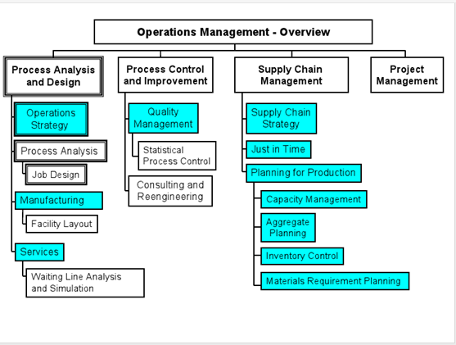
Source: (McQuire 1999)
The diagram below also provides some useful insights for the Hudson Alpine Furniture House. The first is to clearly identify the market place in which they are operating. As given in the case study, the main customers are the private and the commercial users of timber furniture. It is safe to assume that the growing numbers of orders in the commercial customers is a direct result of the excellent services provided by Hudson Alpine Furniture to their respective private users. The next parts of the diagram below shows the corporate strategy which is interlinked by the finance strategy, operations strategy and the marketing strategy. The pre planning stage includes factors such as development of the product and the location of the plant. It also clearly charts out right in front of the concerned department and the senior management what peripheral things are required to be given and undertaken for various smaller tasks that would ultimately be used for the final production process. Also, the diagram above clearly gives the requirements which need to be considered upon the planning stage. Thus, it becomes an important utility as far as the management of the affairs concerning pre planning, planning and control are concerned. The same is lacking in Hudson’s Alpine Furniture firm where the owners have virtually assumed the position of handling all the departments of the organizations. The same notion needs to evolve to better suit the needs of the changing and increasing demands and resulting revenue orders.
Figure 2
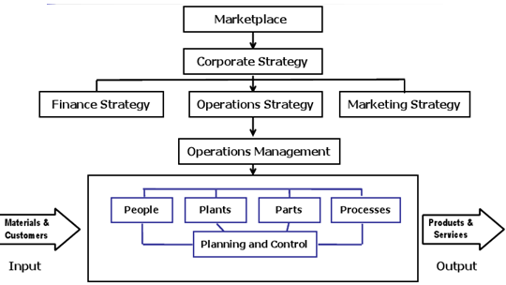
Source: (McQuire 1999).
To get the full project, please buy the Assignment by using this Link
http://sampleassignment.com/pay-now.html
Cost - £19

