Melvin Alexander III
u02a1: A Global Leadership Agenda and Theory
Capella University-MBA6026 – The Global Leader
Professor Sara Orem
July 21, 2013

A Global Leadership Agenda and Theory

I have done a substantive amount of study in the industry of soft drinks. Having the hands on experience of working in Pepsi Co and Coke for nearly three long quality years, I dreamt of starting my own venture in this field. I clearly understood while working in these market leaders’ organizations, the key to forming and running this kind of venture is leadership. One has to be a leader in all aspects; from understanding the needs of the consumers to deriving the best out of the employees and delivering that best in order for the product to meet the high demands of the consumer. It is similar to a chain of events. When transparency becomes evident, demands increase, but also do profits.
To give my readers a better idea about how leadership has been prominent and a phenomenon in the success bouquets, I will analyze the concepts related to leadership, which are religiously followed in my organization.
Leadership flowchart
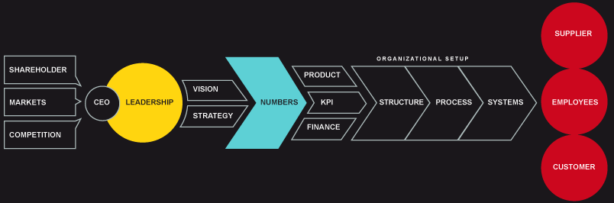
The above concept and the graphical representation have been coined by Patrick D Cowden, who has educated the masses about the various styles of leadership and integrated the structure of the organization, the competition levels faced by them, and the success factors exposed before them. In this image, he has tried to emphasize the relevance of the organizational structure and the levels of competition that are frequently faced by the business at any point in time. In any organization, there are employees, managers, CEO’s, and shareholders. Therefore, the leadership flows in the form of a pyramid and the vision and strategy are designed by the seniors and followed by all. The vision has to be presented in terms the amount of inventory received by the business each year. The orders are then supported by the products, finances, and the KPI techniques. As a result, the focus shifts to the structure of the organization and the process that is being followed in the business to fulfill the orders. Afterwards, the focus is on the employees, customers, and suppliers. One may easily understand the ultimate goals of the whole exercise is to gain the edge in the market, but the process follows a long chain where each element of the organization is involved and collectively, the larger goal of success can be achieved (Pendergrast, M. 1994).
Market research
Another aspect of true leadership is forecasting. To have the edge over the competitors, it may be imperative for the leader to focus primarily on critical data. It may be also important to gather data about the demand that is predominant in the market so that the production can be done according to the estimates and the marketing can reflect the effective sale of the product in that market (Barney, J. 1991). The annual report of PWC indicates this market has a capitalization of $100 billion and is growing at an annual rate of 5%. To capitalize on this, a new
To get the full project, please buy the Assignment by using this Link
http://sampleassignment.com/pay-now.html
Cost - £9

