3
Topic: Management in IT
Paper Type: Assignment
Word Count: 3295
Pages: 13
Referencing Style: Harvard
Education Level: College
Description: This assignment shows how IT can be applied in an organisation

Management in IT
[Name of Student]
[Name of Institution]
[Course]

Q 1
After reviewing the given scenario of Gary’s ‘Game On’ Company, it seems logical that the management of the company should take some drastic measures in order to improve the business situation of the company. In order to give boost to the company, it is advised that the company must implement Information Technology (IT) services to perform different functions at different levels. With the help of implementation of proper and appropriate information system within the organisation, not only enhances the chances of competitive advantages of companies but it also increased the innovative processes of the company (El-Gohary, 2012). The completion of a Plan of Information Systems within Gary’s organizationmeans to guarantee the sufficiency of the key goals of the same and the data required to bolster these purposes. This makes frameworks arranging strategy which covers the whole association and requires thought of various ideas, in arranging methodologies that go past the particular setting of a frameworks advancement philosophy (Ghobakhloo et al, 2012).
Discovering opportunities for innovation processes of a company utilizing the favourable circumstances offered by computers and information technology, underlines the connection between innovation methodologies and business (utilitarian incorporation), utilizing IT as an empowering agent to change the framework and Business forms (Chong, 2014). A technique that can be taken after to execute this methodology comprises of five stages:
- The process of innovation should be selected based on business purposes;
- Identify the area where the change is required and where the IT elements should be implemented to make innovation in the process;
- Creating a plan of the new process, where goals and characteristics for procedure execution are characterized, and a configuration of it is made;
- Design of implementation alternatives, where the way shall be implemented;
- The phase where this new process is implemented (Ahmad & Cuenca, 2013)
Delivering service in the ‘Game On’ organization with related change technique is the one that needs to do with the improvement and usage of innovation arrangements. Key administration concentrates on the most proficient method to react to client needs, and the part of administration is to set needs and adjust the transient results with long haul. In outline, the progressions for key arranging of data frameworks are (El-Gohary, 2012):
- Select and define specific goals and targets and strategies to achieve it;
- How new opportunities of competitive advantages can be created with the help of new technological trends;
- With all the major business processes, a business model should be developed;
- It is important to define the information required for each stage of business model;
- Set application architecture that groups similar processing requirements process data in units of systems (theoretical) and Databases (also theoretical) to meet the information requirements of the company
For implementing the proper IT solutions within the company, ‘Game On’ company requires number of IT professionals, which it has to recruit from the market. However, motivating and attracting high skilled IT professionals to a medium sized company like ‘Game On’ is a daunting task. The company is not in the position to match the high demands of these IT professionals. In such a scenario, the company has to find the alternativesfor the interests of the company. Among the available options, following are important (Bayrak, 2014):
- Outsourcing: There are times when a company chooses another to perform some tasks and functions in the organization. These external companies assume the responsibility to fulfil a particular purpose. To this it is called outsourcing. The outsourcing company makes planning, recruitment and other functions for a designated budget. It is an excellent option to avoid the 'problems' of recruitment. ‘Game On’ should also check this option to outsource some IT professionals or an IT company which can fulfil all the IT needs of the company;
- Hourly workers: this is another option for ‘Game On’ company that they choose to hire hourly workers. This allows the company to perform and fulfil its IT needs and to vary the size of the template at no extra responsibility involved in HR management. This is done at specific times or campaign as events of great magnitude;
- Temporary employees: Known as part-time, they are workers who do not have permanent employment in the company. They are hired when someone in the organization takes no license or specific projects to be completed in a timely manner. Temporary employees are also a good choice in ‘Game On’ company’s circumstances
Q2
Unify and Streamline Support Functions
Gary’s Company ‘Game On’ can use different types of IT solutions for its strategic betterment and to innovate the company to cope up the present challenges. In order to unify and streamline their support functions, the company may use cloud computing. Cloud computing offers all the services of IT, in the Internet cloud, without physically owning the resources. In other words, cloud computing provides the information to the users which is already stored in its servers.
‘Game On’ is going to use Software as a Service (SaaS) concept for unifying and streamlining its support functions. SaaS means that someone stored a program on a server that allows users to perform certain computational tasks (Han et al, 2013). Users send their information to the server, it performs the requested task, and finally sends the results to the user.
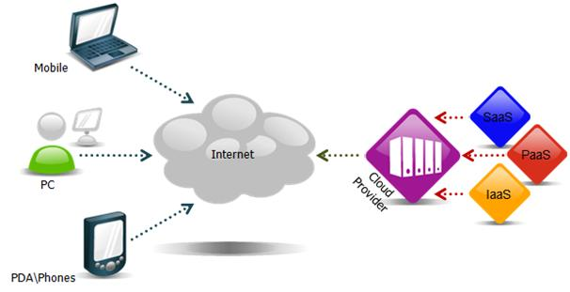
Some of the advantages of using SaaS for support function are:
- It allows backup of valuable information: If the user has suffered a problem with his computer (it was stolen, infected by a virus, or simply do not have access to it at this time), he can access the information instantly from any computer, anywhere the world in which it is located;
- Sharing information is easy: Thanks to cloud users can create documents simultaneously and collaboratively using Google Docs or any similar solution files using Dropbox or Ubuntu One and the like can, in turn, share;
- Increased security: Both administrators and users can stop spyware and viruses that originate in the Web before they infiltrate the private network and jeopardize or disqualify teams, among other functions. Moreover, if we consider that 60% of the information of companies located in unprotected systems; that 1 in 10 laptops stolen 10 months after the purchase; and that 60% of owners say they have lost the device, it is logical that it is better that the information is kept in the cloud and not in a physical computer
Despite many advantages, cloud computing also has several disadvantages, such as:
- Possessing such devices which are not physically present, leave the responsibility for storage of data and its control in the hands of the provider. That is, cloud computing endangers the freedoms of users, because they leave their privacy and personal data held by third parties. Thus, they earn more money (because users become more clicks propaganda) and, they say, provide better service to users because they reduce the "visual pollution" produced by irrelevant advertising;
- Without access to the source code or the executable file, it is impossible for the user to know what makes really the program. It is not necessary that these “bad” things that make SaaS have been intended or designed maliciously; on the contrary, sometimes they come with the intention to help the user. The intention is good, follows the user saves important files in that folder and helps you to make a backup of them in a "transparent", but really gives this happening without the user noticing anything;
- The service provider decided to update and modify the service without the consent of users. It is often beneficial to improving software security. However, it can also be detrimental in cases removing features and functionality required by the user. From overnight, one has to go find a tool that replaces the previous one and to help with the work;
- While all user data are stored on a server, they cannot control what security measures must be undertaken to protect (these decisions will be made ​​by the company that offers the service) but, if evaded such measures will reach the intruder an unimaginable amount of information. In a word, there would be much greater incentive for hackers to infiltrate those servers as thus could access relevant information to millions of users ... all in one blow
Unify and Streamline Operational Functions
‘Game On’ Company is going to use Salesforce software for unifying and streamlining the operational functions of the company. Salesforce is a Cloud computing provider specializing in SaaS, including applications sales, service, support etc. (Kale, 2014). Salesforce is easy to use and configure, user can store, share and manage information securely, easy to customize, without software problems and foolproof security, has 97,700 customers worldwide, most of which are SMEs (Liu, 2012).
One of the most important benefits of Salesforce is that it allows to have an effective marketing, which opens great opportunities the creation and launch of new and improved products made ​​with the customer profile. The user pays a monthly subscription that allows access to the leading cloud platform for commercial applications. Salesforce offers several advantages for companies like ‘Game On’, some of such advantages are:
- The users can choose to have applications according to their need;
- It is productive, having integration between applications, IT removes restrictions for achieving flexibility Business process design without limit;
- It integrates Web services interfaces;
- Salesforce with the Force. Com platform are multitenant architecture principles that guide the service to achieve economies of scale, safety and innovation, access to applications, data and settings;
- It keeps levels of integration, as users can better inform through visual data such as the geographic location in Google etc.;
- It offers a range of products for sales and support and provide advantages for companies, pay a moderate cost according to use, they offer the easiest way for customer benefits and maintain a wide variety of applications;
- The tools offered by Salesforce are helpful for business the company, as it includes the use of business data Jigsaw to access more than 20 million business contacts;
- It provides faster service for customers to contact the company, knowing various data in less time (Takai, 2012)
However, there are also some disadvantages associated with this software:
- It needs that the company must have good internet and electricity for the use of the Software. Contrary to what it may happen during incidents of electricity; companies may halt if there is a power failure;
- It is not free and have a monthly cost
Option to extract Strategic Insight
The world of information has increased the need for optimal, fast, efficient methods to extract and transform data from an organization and distribute information throughout the value chain. Business Intelligence (BI) fills this need, which is why, in the first instance, one can say that is an evolution of the "systems of decision support. Business Intelligence (BI) is the set of methodologies, applications, practices and capabilities focused on the creation and management of information to make better decisions to the users in an organization (Chen et al, 2012).
‘Game On’ Company is going to use Artus® which is full Bitam suite of solutions for Business Intelligence that allows the company to access information it needs for decision making at the appropriate time. Unlike other Business Intelligence solutions, Artus® provides administrative dashboards administrative and analysis to the extent the same product, meeting all needs of the company. The fundamental advantages of this software are:
- Helps to Monitor key performance indicators;
- Deepen detail at any level;
- Run trend analysis over time;
- Using statistics, predictive modelling and analysing "what if" functions;
- Use alerts and signals for analysis by exception;
- Integrate visualization components of various existing applications such as intranet, portals and external networks of customers;
- Create personalized dashboards for each department of the organization (Işık et al, 2013)
The software has minimal disadvantages such as:
- It has a monthly cost;
- It has low valuation in terms of brand image and Confidence in the distributor
Secure the Interface
In order to secure the interface, ‘Game On’ Company is going to use SoftLayer software. It provides a public and private network (VLAN) for servers. Using cloud servers does not mean users or administrators are restricted to learn, or relearn, Linux shells and command line interface (CLI). As a powerful CLI, there is still an option to use a GUI desktop environment. In some cases, this may also be a requirement.
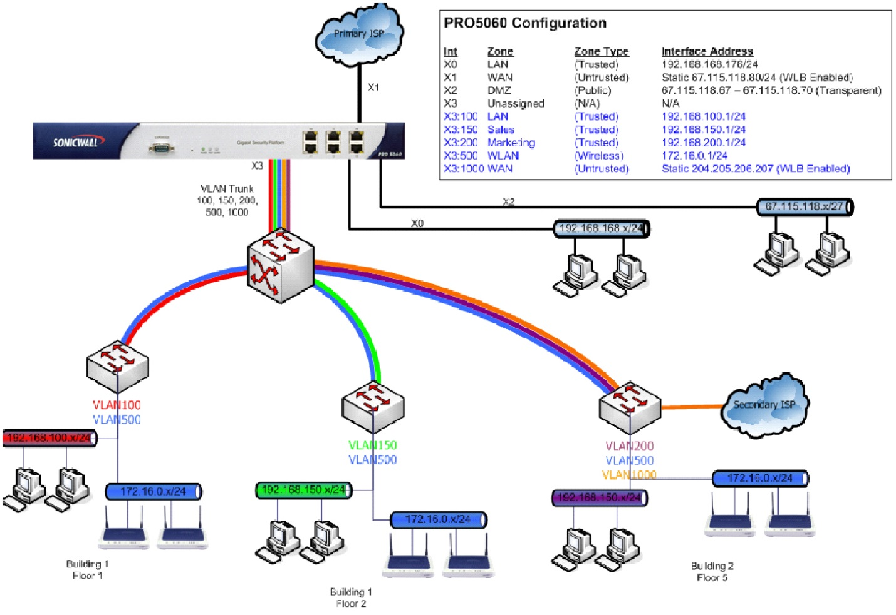
This provides separate and dedicated VLAN to the company and fulfils the security needs of the company. However, the disadvantage is that it is a costly solution but after one time cost, the monthly cost is reasonable.
Q3.
Stakeholders
Stakeholders are individuals or groups that are affected by the operations of ‘Game On’ company. Shareholders or owners are a group of commonly recognized interest (Kavaratzis, 2012). However, company also needs to consider how the customers, community, employees and business partners affect the business as each actor usually increases the viability and long-term success.The owners often have a strong say in the company. The shareholders own a portion of the company and serve as a source of financial responsibility in the conduct of the leaders of the company.
Customers are also stakeholders of the company as they provide the basic requirement of the company, i.e. cash. Leaders of the company and other community members also take care that the company should be responsible for acting with social and environmental responsibility.
Employees provide consistent service that helps the company to attract and retain customers (Rozanski& Woods, 2011). The Franchises of the company can also influence the business significantly. They are the companies with whom ‘Game On’ company collaborates.
Budgetary Aspects
The most important strategic decision the company has to take is to implement the system of budgetary control. The management considers optimal Budget Accounting allows working both on the revenue and expenditure accounts, as of the balance sheet accounts that they consider relevant and each case presents suitable methods (Luftman et al, 2012).Therefore, managing budgets in ‘Game On’ company has two distinct parts: first budgeting and other deviations analysis, by comparing budgeted and what was done.
Associated Risks
Risks associated with business are of different types. Some of such risks are (Dai et al, 2014):
- Economic risk: It is the risk associated with fluctuations in the business cycle of a certain country. The danger of an unfavorable economic change in the economy, and the impact of social problems;
- Political risk: is that associated with the activities of government agencies of a country whose interventionism adversely affect business; If the rule changes, changes in the application of them, ultimately the actions of the government that are harmful to business (Dai et al, 2014);
- Other Risks: there are several other risks associated with ‘Game On’ company
All these risks can be managed by making forward planning for risk management, which is possible by monitoring market trend with appropriate IT tools.
Manage Progress of IT Project
It is important to monitor the progress of IT project by project manager who specialises in IT management and who can identify what has been achieved and what is needed to take the next step. This not only rests with the management direction, but all those involved in some way in achieving a project of international business.
It is obvious that there is a high risk of not achieving the goal, however one should not underestimate the work that was done. Often the fact that international IT projects are not carried out due to cracks in aspects of planning and business management and gaps that should be identified, so it is important to stress the need to improvise and do not have experts in all areas.
The deadlines in a project are a point value to attract attention, it is clear that not everything in planning must be fulfilled to the letter; margin has to be given between a target and another, but above all we set realistic deadlines, goals that are achievable. Thus we should conceive the use of outside counsel, an outside agent to know the company that identify areas of opportunity to develop (Gido& Clements, 2014).
The budget allocated for the project is somehow indicative of how long the investment will pay off. Clearly, with a strong economic boost, the objectives will be met to a lesser term, however, money is not everything and a strong, motivated and ambitious working team, it will work better than one isolated.
Q4.
Role of IT Manager
In the present scenario, the role of IT manager in ‘Game On’ Company should be based on the following responsibilities (Galliers&Leidner, 2014):
- To study the business strategy, the effectiveness and efficiency of operational processes and the degree of implementation of IT in the organization. The study of business strategy is not associated with the definition of the same but in understanding how involved senior and middle management in it and how they affect the strategic plan;
- Transformation of business strategies in the IT strategy and then give way to the definition of the systems architecture that provides a framework for the specification of the application and information integration will be held. It displayed IT as a tool to establish a competitive advantage in addition to supporting administrative and operational business processes. Guidelines that software, hardware and communications must meet as part of the system architecture aligned to the strategic direction of the business are determined;
- The Information Technology Infrastructure Library (ITIL) required to support the strategies, processes and structure of business applications. In this scope and degree of integration of information resources globally defined, priority development systems is established, the relationship between applications and the information needs of the operating areas becomes clear. Planning requires the analysis of different options, applications that best meet the needs of the organization, including at one point the partial or total acquisition of the software solution without losing sight of the guidelines established in the IT strategy to be satisfied by suppliers;
- Measure the efficiency of ITIL processes, for which the processes are identified, evaluated and are associated with the information required for each area without losing sight of their interrelationships. The aim is to establish the information needs both within and outside the IT function. For this purpose it is necessary to perform the analysis of the processes without considering the organizational structure;
- Deployment of Appropriate IT Solutions. The level of IT deployment is associated with:
- Analyse the capabilities of the portfolio of software applications and infrastructure (hardware and communications) focusing on identifying weaknesses and shortcomings;
- Identify the IT organizational structure, evaluating the capacity of human resources and defining roles of staff;
- Make a comparison of investment and return on investment with industry standards where the business is located
Conclusion
The ‘Game On’ company has an emphasis on IT infrastructure investments;however, the task is not so simple. There are many challenges and barriers involved in implementing proper IT infrastructure into the company to make the company profitable again.
Gary and his board of directors must keep in mind that without effective planning process, IT professionals are bound to play a game of physical and psychological wear they cannot win because they are always trying to catch up with growing demands and business units.The involvement of the management team in planning, definition, execution and control of such initiatives to ensure further success of such projects is indispensable.
Planning Information Technology is an initiative that will not be popular in the short term it is the only method that ensures that IT projects are aligned to business strategies and give the result and value that impacts better results.Join the club of companies that make a strategic plan, not guaranteed results, but if you have not planned or already, we have time before our competitors take us forward.

References
Ahmad, M. M. & Cuenca, R. P. (2013). Critical success factors for ERP implementation in
SMEs. Robotics and Computer-Integrated Manufacturing, 29 (3), 104-111.
Bayrak, T. (2013). A decision framework for SME Information Technology (IT) managers:
Factors for evaluating whether to outsource internal applications to Application Service Providers. Technology in Society, 35(1), 14-21.
Chen, H., Chiang, R. H. & Storey, V. C. (2012). Business Intelligence and Analytics: From Big
Data to Big Impact. MIS quarterly, 36(4), 1165-1188.
Chong, S. (2014). Business process management for SMEs: an exploratory study of
implementation factors for the Australian wine industry. Journal of Information Systems and Small Business, 1(1-2), 41-58.
Dai, L., Maksimov, V., Gilbert, B. A.&Fernhaber, S. A. (2014). Entrepreneurial orientation
and international scope: The differential roles of innovativeness, proactiveness, and risk-taking. Journal of Business Venturing, 29(4), 511-524.
El-Gohary, H. (2012). Factors affecting E-Marketing adoption and implementation in tourism
firms: An empirical investigation of Egyptian small tourism organisations. Tourism Management, 33(5), 1256-1269.
Galliers, R. D. &Leidner, D. E. (2014). Strategic information management: challenges and
strategies in managing information systems. Routledge.
Ghobakhloo, M., Hong, T. S., Sabouri, M. S. &Zulkifli, N. (2012). Strategies for successful
information technology adoption in small and medium-sized enterprises. Information, 3(1), 36-67.
Gido, J. & Clements, J. (2014). Successful project management.Cengage Learning.
Han, J. S., Chung, K. Y.& Kim, G. J. (2013). Policy on literature content based on software as
service. Multimedia Tools and Applications, 1-10.
Işık, Ö., Jones, M. C.&Sidorova, A. (2013). Business intelligence success: The roles of BI
capabilities and decision environments. Information & Management, 50(1), 13-23.
Kale, V. (2014). Guide to Cloud Computing for Business and Technology Managers: From
Distributed Computing to Cloudware Applications.CRC Press.
Kavaratzis, M. (2012). From “necessary evil” to necessity: stakeholders' involvement in place
branding. Journal of Place Management and Development,5(1), 7-19.
Liu, W. (2012).Research on cloud computing security problem and strategy. In Consumer
Electronics, Communications and Networks (CECNet), 2012 2nd International Conference on (pp. 1216-1219). IEEE.
Luftman, J., Zadeh, H. S., Derksen, B., Santana, M., Rigoni, E. H. & Huang, Z. D. (2012). Key
information technology and management issues 2011–2012: an international study. Journal of Information technology, 27(3), 198-212.
Rozanski, N.& Woods, E. (2011). Software systems architecture: working with stakeholders
using viewpoints and perspectives. Addison-Wesley.
Takai, T. M. (2012). Cloud computing strategy.Department of Defense Washington DC Chief
Information Officer.

