4
Topic: Organisational Structure, Boundaries and Space
Paper Type: Essay
Word Count: 1635
Pages: 6
Referencing Style: Harvard
Education Level: College
Description: Apple company is analysed by using structure, space and boundaries spatial elements and it is discussed how the Apple company is structured and manage its productivity.

Organisational Structure, Boundaries and Space
[Name of Student]
[Name of Institution]
[Course]

Fig 1: Organisation as Divided

Fig 2: Organisation as Controlled

Fig 3: Organisation as Imposed and Hierarchical
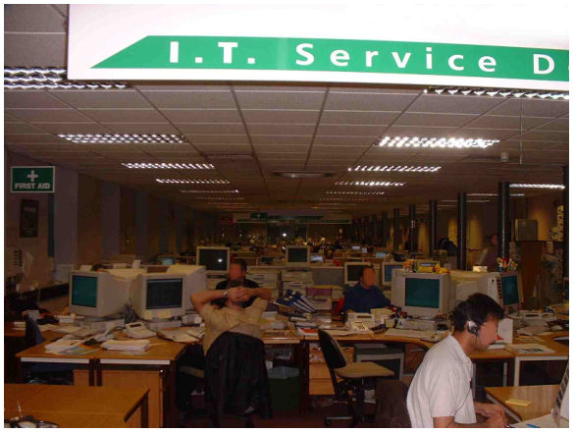

Fig 4: Organisation as Personalised

Fig 5: Organisation as Productive
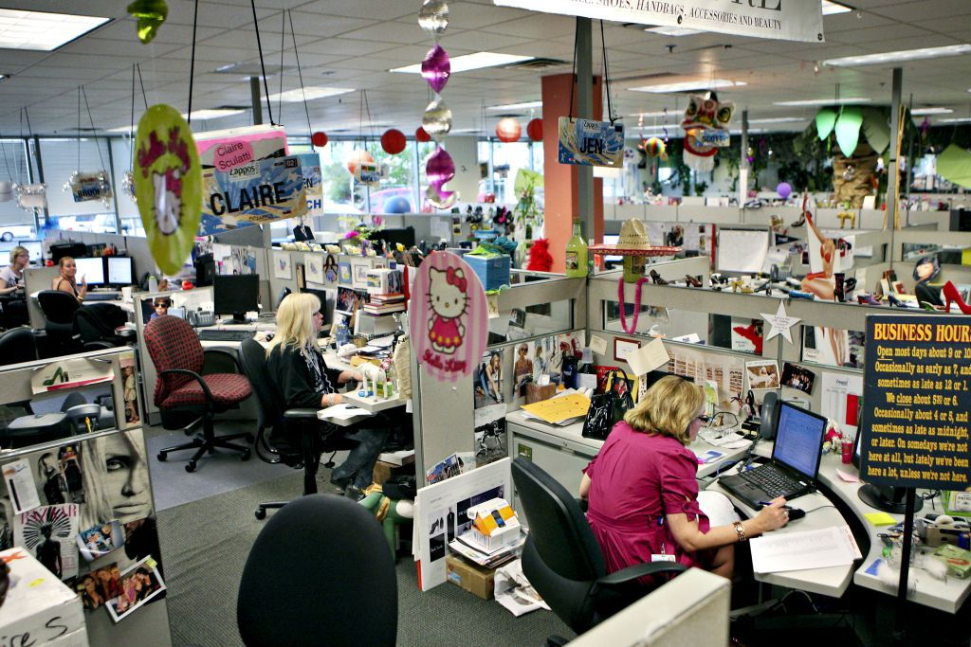
Fig 6: Organisation as Socialised
Fig 7: organisation as Symbolic

Introduction
The delimitation of organisational space is a central aspect of this phenomenon and implies the formation of an internal space in opposition to a space external to the circumscribed by the organisation. The processes of knowledge that produce these differentiated spatiality (San Emeterio, 2011) establish constraints and possibilities of operation and internal articulation for the subjects that integrate them. In order to understand the organisation space properly, Chanalat (2006) suggests some elements, i.e., divided, controlled, symbolic, social, productive and as an imposed and hierarchical space. In the course of this discussion, Apple company is analysed by using these spatial elements and it is discussed how the Apple company is structured and manage its productivity.
Organisation as Divided
In relation to the system of standardisation of organisational structures and processes, the management system is in charge of carrying it out and providing it with stability. Through this operation the management system generates spatiality that transcends the delimited organisation as discrete. In contemporary organisational studies, the notion of boundary does not imply as impermeability to the environment (Clegg&Kornberger, 2006). At this point we would not find it difficult to reconcile our concepts with systemic or cybernetic approaches. From this paradigm the limit is conceived as a "logical space" that regulates the operations between an inside and an outside, as it happens in the model of a cellular membrane. This limit would then allow an internal recursive operation that does not participate or that is isolated in some sense of the surrounding environment in the self-reference of its processes.
The structure of Apple Inc. should be taken into account when making the study of the distribution of space, working relationships between the component units, systems of information and processes of established communication. The nature, volume, frequency and mode of development of the functions assigned to each of the units in order to maintain a logical operational sequence (O’ Regan, 2015). To obtain an effective disposition of the facilities and to make rational use of the resources of an organisation we must have administrative improvement units, operational support areas, external consultants and an integrated working group for that purpose.
Apple is now 35, a mature company by Silicon Valley standards, and there is already an adult atmosphere at headquarters. Apple Inc. is divided into different departments and small segments. That adequate supervision of the work and comfort in its realisation be allowed, as well as possible changes that may arise in the organic or functional structure should be taken into account, in order to distribute the space in such a way as to allow modifications without many changes (O’ Regan, 2015). Complications and above all locate the areas of customer service in accessible places.
In other words, the structure of Apple Inc. is a strong matrix structure where the project manager is the one who controls most of the aspects of the project constantly, presenting an interaction between the project manager and the functional manager, which observes the existence of relationship between a project manager and managers of functional areas. The working responsibility is shared between the managers of each functional area and assignments of tasks and / or activities to fulfill each of the phases of the project (planning, design, product development, product distribution and operations management) (Heracleous, 2013). The administration is managed for each of the tasks and / or activities assigned with their own deliverables and supplies supplied.
Apple Inc. formation of organisational boundaries involves a complex process, which includes the most obvious aspects, such as the tangible assets of the organisation. Actually, in Apple boundaries are formed by the resources of knowledge captured within an organisational space. This capture is necessary since, without it, organisational structures and processes would be undifferentiated from the processes operated in the broad social environment and in other organisational spaces (O’ Regan, 2015).
Although this model is useful, it presents a seductive simplicity that may be erroneous or at least insufficient. On the one hand, one considers that the elements delimited as internal to the system do not participate exclusively in the internal, but also in the external environment, sometimes even simultaneously. On the other hand, we understand that the boundary regulations constitute the organisation as such, in the sense of structures and organisational processes put into current operation.
Organisation as Controlled
The organisational model of Apple Inc. responds not so much to a concept of a theoretical nature, but to a model of how to organise certain social activities, which in certain historical moments was gradually capturing community social processes to structure and delimit them in organisational spaces, where they are transformed by an organisational control system. Thus, the Apple company management that produces these limits operates specifying the knowledge and limits of action of subjects not included in said system (Mitev&Vaujany, 2013). The management system of Apple does not necessarily create limits from its own knowledge, but legitimates some knowledge over others and controls the performance of these knowledge generating impermeability for the performance of other alternative knowledge. To this end, the management system controls the subjects that must support them and takes care of giving them form of dynamic processes.
Organisation as Socialised
In socialisation it is important that the members of the organisation feel fully identified with it and so keeping them informed about the situation they are experiencing is a fundamental step, is the realisation of a maintenance, which can lead to out in different ways, such as conducting regular meetings to inform the status of the organisation to achieve better integration of staff with the organisation through newsletters circulating internally in the organisation, etc. Another important aspects is that the organisation on a regular basis should make known to its members the achievements and at the same time make them part of them, showing them how important they are to the organisation and the way in which they contribute to the achievement of those achievements (Szczepańska-Woszczyna, 2014).
A good and favourable organisational climate will increase initiatives to promote new business, undertake new projects and solve problems; Improve internal communication; Increase competitiveness and facilitate the governance of the organisation. But, this requires the strengthening of good health promotion activities in the organisation; support of the management and the active participation of the workers, with sense of belonging; control of the presence and effect of risk factors associated with accidents and work-related diseases (Szczepańska-Woszczyna, 2014).
The environment of the company is very disciplined and controlled. There are no longer any people wearing Bermuda or sandals or vividly decorated cubicles. This vibe is opposed to the jocosity of Google, with the policy of 'go to work in pyjamas and buffet cafes'. At Apple, there are literally no free meals, although the meals are subsidised and are generally good. Unfortunately, the disciplined and strict environment of Apple Inc. eliminates the motivation of employees to remain dynamic and ensure the development of a policy of hygiene, safety, occupational health and environmental protection (Yoffie&Rossano, 2012).
This merciless corporate culture of Apple is only a part of the mystery that virtually every business executive in the world would like to understand. The fear of punishment has persisted for many years (O’ Regan, 2015). The former Apple activists give an image of the company that repeatedly reaches modern corporate conventions in a way that seems to behave more like a young avant-garde company than as the colossus of electronic products of consumption that it really is.
In the time of Steve jobs Leadership, there was a small group in the management who are the close and confident allies of Steve Jobs. They call themselves Principals and every year or so, Jobs teams up with the chosen ones for an intense three-day strategy session in a safe and secret location. Everything that surrounds this meeting is kept in a secret such as its very existence (O’ Regan, 2015). To those who are invited, they are exhorted not to set the meeting on their calendars. There is no comment about their participation, not even internally. Attendees are not allowed to drive to the meeting.
According to other spatial elements of space, the Management of Apple does not possess the symbolic resources to perceive the limitation of the resources of knowledge available in its organisational space. It is impossible to regulate the process of extension and / or modification of limits of its organisational space (Szczepańska-Woszczyna, 2014). Consequently, this situation would lead to impossibilities of learning other modalities of operation and articulation of organisational knowledge.
In fact, the environment of organisation is a determinant of the productivity and quality of the work someone performs. Intelligent organisations generate new knowledge from their own efforts, but for this, it is an indispensable premise to create an organisational climate conducive to cooperation that generates trust and optimism and banishes selfishness and negative attitudes that impede both individual and corporate (Dale& Burrell, 2008). This influences both the quality of human resources acquired and the intensive use. There was an environment of secrecy and confidentiality and the so called innovation was imposed on the employees of Apple. This has also affected the productivity of the employees.
In conclusion, when Apple is photo montage by using Chanalat (2006) spatial elements, it can be said that although Apple is considered a very innovative organisation but the environment and corporate culture of the company, especially in the days of Steve Jobs were not exemplary. The structure of Apple is simple and effective matrix system but they were controlled very strictly by the upper management, which sometime produce a feeling of dissatisfaction among the Apple employees. Although employees productivity is depicted through Apple’s products innovation but the company has to work on its corporate culture to make it friendly in order to retain their key employees.

References
Chanalat, J.-F., 2006. Space, Organisation and Management Thinking: A Socio-Historical
Perspective. In: S. R. Clegg & M. Kornberger, eds. Space, Organizations and Management Theory. Copenhagen: Liber & Copenhagen Business School Press, pp. 17-43.
Clegg, S. R. and Kornberger, M., 2006. Introduction: Rediscovering Space. In: S. R. Clegg & M.
Kornberger, eds. Space, Organizations and Management Theory. Copenhagen: Liber & Copenhagen Business School Press, pp. 8-196.
Dale, K. and Burrell, G., 2008. The Spaces of Organisation and the Organisation of Space:
Power, Identity and Materiality at Work. Basingstoke: Palgrave Macmillan.
Heracleous, L., 2013. Quantum Strategy at Apple Inc. Organizational Dynamics, 42(2), 92-
99.
Mitev, N. and de Vaujany, F.X. eds., 2013. Materiality and space: Organizations, artefacts and
practices. Springer.
O’ Regan, G., 2015. Apple Inc. In Pillars of Computing (pp. 25-30). Springer International
Publishing.
San, Emeterio, 2011. Epistemology of the organizational phenomenon: bases of its institution
and conditions of possibility. XVI Conference of Epistemology of Economic Sciences, Faculty of Economic Sciences.
Szczepańska-Woszczyna, K., 2014. Innovation processes in the social space of the
organization. Regional Formation and Development Studies, 14(3), pp.220-229.
Yoffie, D. B. and Rossano, P., 2012. Apple Inc. in 2012.Harvard Business School.

