5
Topic: Visual Branding of Department Stores
Paper Type: Dissertation
Word Count: 9307
Pages: 36
Referencing Style: Harvard
Education Level: Masters
Description: The aim of this research study is to ascertain that what really makes the brand identity of a successful department store

Visual Branding of Department Stores
[Name of Student]
[Name of Institution]
[Course]

Abstract
The brand identity of department stores comprises of several visual elements. On the one hand, it is difficult to know the influence of a tool that directly involves the senses, especially the hearing and psychological influence. On the other hand, it is presumptuous to attribute to visual branding as a full force communication of other communication tools that have synergistic brought to the point of sale. Department stores, who want to manage its own identity and corporate image in best way, have a logical arrangement of various visual elements.
This theoretical review may provide guidance for those wishing to develop programs of identity management and improving corporate image. Finally, this conceptual work opens some opportunities for research, especially with an empirical approach.
Purpose: This research study tries to explore the notion what really makes a successful department store brand identity
Methodology: This Research uses desk research and reviews literature to find the answer of the question posed in this research.

Contents
Chapter 1 Introduction 5
1.1 Background 5
1.2 Rationale of the Study 6
1.3 Purpose of the Study 7
1.4 Research Questions 8
1.5 Research Methodology 8
1.6 Limitations 8
1.7 Structure of the Study 8
Chapter 2 Literature Review 10
2.1 The Visual Branding 10
2.2 Corporate Communication 12
2.3 Visual Branding and Corporate Image 14
2.4 Visual Branding and Visual Merchandising of Department Stores 17
Chapter 3 Analysis and Discussion 20
3.1 Elements of Visual Branding 20
3.1.1 Logos 20
3.1.2 Store Design 21
3.1.3 Windows 22
3.2 John Lewis Store Visual Branding 23
3.2.1 Customers’ Feedback 23
3.2.2 Colour 23
3.2.3 Decoration 24
3.2.4 Lighting 26
3.2.5 Christmas Theme 26
3.2.6 Website 28
3. 3 Selfridge 28
3.3.1 Store Design 28
3.3.2 Lighting 30
3.3.3 Windows 30
3.3.4 Themes 32
3.3.5 Advertising and Campaign 34
3.4 Harvey Nicholas 35
3.4.1 Store Design and Décor 35
3.4.2 Lighting 36
3.4.3 Windows 39
3.4.4 Christmas Campaign 40
3.4.5 Advertising Campaign 41
Conclusion 43
References 46

Chapter 1 Introduction

1.1 Background
The brand identity of a department store comprises of several elements. The professional interior designers and prestigious architects design models of the stores, stairs or possible interactive virtual fitting that turn a department store into flagships of the brand (Dagger & Danaher, 2014). Visual branding is much more than to just make the potential customer to purchase various items. The basic aim of visual branding is that the consumer connects with the brand that has been announced in advertisements.
The departmental store is not just a place of product distribution, but a form of communication itself. The visual branding of departmental store is used to make attractive showcase to lead customers into the store and encourage buying. With the passage of time, its work has expanded because because each "piece" is the key to generating consumer shopping experience (Dagger & Danaher, 2014). Hence, Department stores started paying attention to the racks, shelves or decoration etc. to show that they not only provide a distribution but have a brand identity of their own.
The first experiences of visual branding and merchandising, in mid-nineteenth century, were linked to department stores or shopping malls (Breugelmans& Campo, 2011). In London, Selfridges introduced showcase lighting, using it as an advertising element when the establishment was closed at night (Breugelmans& Campo, 2011). The idea of ​​combining the visual merchandising to art is also emerged in department stores. The strategic location of Store and the use of buildings architecture were also emerged as elements of visual branding of stores in the middle of nineteenth century.

1.2 Rationale of the Study
Today, the management of the image of the department store has acquired enormous relevance for modern stores, making it an instrument of differentiation and obtaining competitive advantages (Balmer, 2008; Melewar&Karaosmanoglu, 2006). Current market dynamics invite companies to attributes and organizational characteristics of the visual brand of department stores, because they are more durable and resistant to the competiton (Aaker, 2004; Bhattacharya &Sen, 2003).
The Visual images give meaning and enable knowledge and learning of a reality (the company, the brand), met for the subject (e.g. consumer or investor) function to simplify the process of obtaining information and search offering which facilitates customers buying decisions. Thus, it is not uncommon in recent years to generate a new area of Study: visual branding and corporate marketing due to the result of significant academic research development around interrelated concepts as identity, image, personality, branding or communication, the organization referred to in entirely to the company as a whole (Balmer, 2008).
However, few fields of study have been so dark and conceptual imprecision as regards to the identity and corporate image (Balmer, 2008; Melewar&Karaosmanoglu, 2006; Alessandri, 2001). According to Balmer (2008), this field of study has lived in a real conceptual fog, whose main cause is the ambiguity in the terminology used in the academy. The ubiquity designations, used with much permissiveness in different contexts related to various areas of study and treated differently with the academic literature and management, has generated a set of poorly demarcated notions and defined on the interrelated concepts that should make an extra effort to review and clarification (Otubanjo&Melewar, 2007; Cornelissen&Elving, 2003).
This research study is important because it discusses the relationship that exists between the two major elements of corporate marketing: identity and corporate image. The traditional relationship has been given between them is based on the classic communication model where the image is dependent on the identity (Christensen &Askegaard, 2001). Then, the corporate identity was conceived as something internal and controllable by the organization, projecting of concrete ways in order to generate an impression specified in the various stakeholders (e.g. employees, consumers or investors) with which the company relates.
However, this relationship of dependence as to the identity and corporate image of department store has been questioned by several authors (Stuart, 1999), which considered that there is a relationship of interdependence, as the corporate image influences what the organization is or claims to be. Now this dialogic nature of identity-image relationship has not been fully internalized by managers, who only care about management of external image of the company. Given the benefits which itself reports without regard to their potential influence on the identity of the organization.
Because of these issues, it is useful and necessary, both for academic research and for managers, to conceptualise clarification of notions of identity and corporate image as well as an examination of their interrelationship, so that the development of effective strategies are allowed management of both concepts.

1.3 Purpose of the Study
The basic aim of this research study is to ascertain that what really makes the brand identity of a successful department store.

1.4 Research Questions
This research study, in order to analyse the main purpose of the study, tries to find the answers of these questions, what are the issues related to branding, visual branding and corporate communication? What are the issues related to branding, visual branding and corporate communication?What are the basic elements that are used to make the brandidentity of a department store? And how do the visual branding and visual merchandising of department store affect the buying behaviour of customers? This will ultimately help the researcher to give the answer of the main question that what really makes the brand identity of a successful department store.

1.5 Research Methodology
This research study uses secondary or desk research to find what really makes the brand identity of a successful department store. Through the literature, this paper aims to identify the relationship between corporate identity and brand image. In addition to that, this study also aims to ascertain visual branding process and merchandising of department stores as a tool of communication itself and brand strategy in the department store.

1.6 Limitations
This research study has few limitations. First of all, it only uses secondary data to research the topic. This means that the researcher has to rely on the existing literature to conduct this research. The other limitation of this research study is that it has only taken the cases of London department stores which means that the result of this study is not generalised.

1.7 Structure of the Study
After the first Introduction chapter, this research study follows the following structure:
Chapter 2 Literature Review: this chapter reviews the published literature on the topic of visual branding and brand identity of department stores. The literature shows how visual branding and corporate image of a department store are related
Chapter 3 Analysis and Discussion: in this chapter several elements of visual branding are discussed and analysed, by taking specific cases of departmental stores, what really makes the brand identity of a successful department store
Conclusion: in conclusion, all the points discussed in the study are summarised and a succinct conclusion is given which provides the answer of the question, what makes a successful department store brand identity

Chapter 2 Literature Review

2.1 The Visual Branding
Visual branding of an organizationis conceived as a set of visual elements which recognize an organization and distinguish it from other (Melewar, 2003). In this sense, the visual branding includes all visual elements that serve the organization self-identity to their stakeholders and that is why it is also often commonly referred to it as symbols of the organization.Under this definition, the visual branding is a broad concept that could encompass any visual element, if that element is associated with the company's stakeholders. There is no complete consensus about the classification that should integrate visual elements. In any case, most of the authors note a number of common elements such as those related to the logo and slogan, typography and corporate colours (Melewar& Jenkins, 2002).
The logo is undoubtedly one of the most important primary elements of visual branding strategy of an organization. Hutton (1997) considers it as a deposit of brand associations. The logo represents by name, form and colours a set of values ​​that the organization is trying to convey. Consistency in use of logo, is of great importance and should, therefore, be used in all means of communication with organization’s stakeholders, while maintaining consistency with the characteristics of each media (Lentschner, 2001) even operating in a global market (Hynes, 2009).
The slogan is also an element usually considered important in the management of the visual branding. It serves as a descriptor that fits into the philosophy of the company and tries to reflect the brand promise, experience and expectations (Kapferer 2004). A good slogan should serve to differentiate the company from the competitors and is therefore also present together with the logo in many business communications (Freeman, 2005). Other related visual branding elements are the existence of a particular typeface or specific corporate colours. Proper management of visual elements can allow consumers and other stakeholders to recognize the company that is behind these elements. Therefore, many companies produce identity manuals that collect and care consistency in the presentation of these elements in both company-owned facilities and documents of the organization and in the campaigns of internal and external communication (Jorda-Albiñana, Ampuero-Canellas, Vila & Rojas-Sola, 2009).
From a broader perspective, other authors point out that the visual branding also embraces the aesthetics of the entity that is derived from the architecture or design of their stores, their art, and even the appearance of their own employees (Kirby& Kent, 2010). The key design idea is to create a physical expression of the brand, something in line with the concept of servicewhich can attract the sensory aspects and the environment generated in the facilities of the company (O'Cass&Grace 2004).
The visual elements let the company create quality perceptions, especially when there are no other signals (Henderson, Cote, Leong & Schmitt., 2003). Keller, Parameswaran& Jacob (2011) said that the visual branding management is aimed at achieving four possible objectives: firstly, enables an organization to achieve visibility and recognition in the market, showing an identity that proves its existence. Second, it is a symbol for stakeholders to have a positive impact on corporate image and reputation. Third, the visual identity shows the structure of the organization to the outside, allowing display of consistency as the relations between the different divisions or units. Finally, the visual identity is an internal function allowing the employees to identify with their company. From a similar perspective, Melewar, Hussei&Srivoravilai(2005) point out that the visual branding elements are used to communicate the corporate philosophy and personality of the organization.

2.2 Corporate Communication
Along with the visual branding, organisations need to establish a controlled corporate communication process. This process involves defining a series of media or communication channels and the type of information on the company that is to be transmitted. Generally, corporate communication reflects the process through which stakeholders perceive that identity, image and reputation of the company (Balmer&Gray, 2000). Unlike individual communication activities, corporate communication is a much more complex process where everything that the company says and does imply a flow of communication (Baker &Balmer, 1997). So there are many ways and means by which they can transmit communication such as advertising, public relations, financial statements, internal documents or corporate websites (Melewar&Karaosmanoglu, 2006; Goodman, 2001).
Inside communications dimension are often conducted various classifications (Cocheo, 2009). On the one hand, one can differentiate between internal communication channels that are targeted to an audience belonging to the organization and external communication channels aimed at consumers, shareholders and other stakeholders outside the organization. On the other hand, one can speak of a kind of formal communication, like that systematized, structured and usually collected in the form of documents, against an informal communication in which there is not an automated process or structure. Miles&Mangold (2004) used together these two classifications to characterize four types of communication. Thus, examples of internal communication and formal systems would address human resources or public relations systems; internal and informal communication would be held by workers, managers and corporate culture to all staff of the company; external and formal communication fundamentally integrate advertising; and finally the external and informal communication would be mainly composed of the consumers mouth-ear and other stakeholders.
In many sectors, the type of information that is communicated can also be classified according to their internal or external environment. In this sense, the information may come from an internal source provided to the entity or can come from an external organization. Both types of information are complementary, and companies know that information from external sources is perceived as an element of credibility that relative to domestic sources. Such information is particularly important in sectors where such confidence in the state is central to the relationship (Loonam&O'Loughlin, 2008).
Corporate communication is a strategic tool which should play a central role within the overall business strategy of the company (Dolphin & Fan 2001). To Balmer&Greyser (2006), corporate communication is one of the six elements of corporate marketing used to transmit information from the company to allow the company to create awareness and image of "who" and "what it does" (Biloslavo&Trnavčević, 2009). Communication activities are so interrelated, and consistency is important not only between different media and public, but also in the different countries where the organization operates. (Gylling& Repo- Lindberg, 2006).
Some authors argue that the core values ​​of the brand must remain rooted to their origin (Weaves, 2009), as it may affect company’s perceived authenticity through communicating their values ​​(Greyser, 2009), creating Corporate dissonance between management and external stakeholders (Bernstein, 2009). In this sense, Balmer (2008) points out that the study of branding should go beyond a simple audit perspective, and should connect with outcome measures.

2.3 Visual Branding and Corporate Image
If anything characterizes the notion of branding in its many facets, is its ubiquity: the term has been used with much permissiveness in different contexts investigated academic literature, practice, attributes and related to various fields of study (Balmer, 2008). Around the notion of identity, have appeared a set of interrelated concepts -in countless occasions defined as corporate identity, brand identity, organizational identity, visual identity or business identity. Balmer (2008) said that business identity used as an umbrella term that includes three different concepts: visual identity, organizational identity and corporate identity.
The visual identity refers to the graphical representation of the corporate identity as symbols and signs are used as trademarks, logos, decoration, corporate style, wardrobe staff, etc. (Chajet&Shachtman, 2008). In terms of organizational identity (a term most used in the area of ​​organizational behaviour) there is a large consensus on its conceptualization, as what members perceived as central, distinctive and lasting in the organization. That is, the term is used to describe what the formal members of the organization think and feel about it, which is derived from their individual perception of distinctive and durable that characterizes central attributes. Finally, the notion used in the marketing area, and perhaps the most severely ambiguous, is the corporate identity (Christensen &Askegaard, 2001).
As can be appreciated from a reading of the definitions, there is some imprecision in the concept of corporate identity. Generally, one can recognize two types of conceptualizations: conceiving the corporate identity in terms of modes ("Communication", "behaviour", "symbolism") in which the company represented or projects itself (Christensen &Askegaard, 2001; Gioia, Schultz & Corley, 2000). Besides including the ways in which the company is represented, give more importance to a set of central or fundamental essential elements ("values", "subcultures", "soul"), which have to do with what is objectively the company, distinguishes the company from other organizations and confer individuality (Balmer, 2008).
Thus, some conceptualizations considered corporate identity as the ethos of the company, and how it represents and manifests; while others are restricted exclusively to the ways that the organization has represented itself. Cornelissen&Elving (2003) suggest that this dual interpretation of the notion of corporate identity is linked with marketing and public relations closer to the idea that the identity representation mechanisms are what it is the company, emphasizing the means of symbolic representation (Logos and visual identity preferably). For its part, the literature in organizational behaviour approaches from corporate identity and the perspective of what actually is the organization as a whole features and attributes that characterize and confer specificity, stability and consistency, a tendency to organization, providing it with essential features as if it were a living organism. In this area, the terms corporate identity and organizational identity have interchangeable been occasions, which has not helped its conceptual delimitation (Balmer, 2008).
Undoubtedly, this difference of interpretation leads to ambiguity generated around the concept of corporate identity. Christensen &Askegaard (2001) base their conceptualization of identity and corporate image in the process of signification which involved the object or referent, the sign or symbol and the interpreter.
The sign or symbol is a noticeable thing (word, symptom, signal, letter, phrase, etc.) representing something, its object or referent. Sign or symbol creates another sign in the mind of the individual which interprets: the interpreter, which corresponds to the subjective thinking of meaning. The process of significance differs from the traditional signifier / signified linguistic model including a third element, the interpreter, which leaves room for individual interpretation of the meaning (Christensen &Askegaard, 2001). The relationship between a sign and an object has a meaning necessary for an individual by joining affections, memories and experiences through the interpreter element. In the case of department stores, the interpreter would correspond to the notion of corporate image (Christensen &Askegaard, 2001).
In the organizational context, the sign may be a gesture, a logo, an ad, a slogan, a product, a written text, etc. For Christensen &Askegaard (2001), the sign is corporate identity, i.e., the sum signals that help different audiences to interpret the organization. These signals can be controlled (corporate communication), assuming the formal organizational profile (how would be interpreted), and uncontrollable, including unplanned items such negative behaviours or rumours (Christensen &Askegaard, 2001).
According to Christensen &Askegaard, (2001), the sign or symbol refers to an object that is department stores, its personality as really is. For these authors, one of the major problems is identity and corporate image, especially in marketing area. The tendency to consider the identity and image as objective realities, almost as natural realities, existing independently for the subject and not as social constructions (meanings) which base its existence in the performing capabilities of the audience.
Christensen &Askegaard (2001) conceive that visual identity and corporate image as historical and social simulations of organizational realities. One of the biggest concerns that caused the distinction between identity-object and identity-sign is the idea that, sometimes, identities and images of department stores, that are false representations of reality (Christensen &Askegaard, 2001; Alvesson, 1990). With the intention of finding ways to meet this gap between perception and reality, literature has generated notions that suggest a deeper, fundamental conception and essential organization.

2.4 Visual Branding and Visual Merchandising of Department Stores
According to Park (2015) consumers have a perception of the visuals, towards the purchase of merchandise on display in the store. Department stores position brands and enhance product display by increasing rotation, which is imperative to highlight the advantages of the exhibition space for the product, among other objectives. The concept of visual branding and merchandising allows for applications of new technologies in the field of computer software-aided design (Zhang, 2014) according to the linear planimetry applied to displays of merchandise.
Thus, the display of the department store, with application of floor plans, performance measurement, a structure of design system technologies, Process Based Clothing Design Display System (PCDDS) (Zhang, 2012) and the role and the flow of work in lighting design, use of colours and various fluorescent and measuring space via management of categories with estimates from use of these spaces and art materials trend, looking through visual tools, capturing the attention of the customer and their actions to purchase.
The visual branding and merchandising has implications in the way of how products are displayed and customers are integral to the success of this strategy and how it influences the buying behaviour of the customers. Law, Wong & Yip (2012) found that almost 44% of marketing communications is visual, but in the future it will increase to 54%. According to Kim, Kim, Lee, Jang & Park (2013) brand wants to communicate, the purpose of use of visual branding and merchandising is to positively persuade the public to continuous and simultaneously achieve greater market position in which the department stores exist.
It is necessary to study in detail the different elements and aspects comprising visual branding of department stores both inside and outside of department store. Department stores have led to a set of elements prevailing as lighting, colours, animation, environment and style of their windows in order to attract buyers both inside and outside of store. According to Van Marrewijk (2012), there is a potential by the special design of the store to communicate and attract consumers to it according to the construction and brand exposure. Studies of space and structure, as well as the aesthetic factors are variable and become a showcase stage of supply and demand, in order to use the visual elements to be able to persuade so positive public consistently and simultaneously achieve greater positioning of market.
The idea to create an image of department store and what is being communicated in a uniform and different way, is attractive to consumer. The department store which is trying to excel in quality and design in order to be able to catch the customer's attention. This type of communicating visual Merchandising with the consumer through the point of sale denotes the grey areas within the store as:Enhance the look of the store;Display colours, smells and aromas;Service and customer relations;Placement Facing the disposal of products and improving through inventory and category management in the range of display.
Visual identity of department storesmakes the consumer lured into buying something he does not want before entering the store but seduced by the way in which the product is exhibited. The Merchandising classification is based on shop seduction show, a specific furniture, timetables, specialization, animation sale point, live products, seeks to promote the image of the organization, through a good customer service and also taking care that aspect of the department store and trying to achieve the best environment so that it can influence the buying behaviour of the consumer.
The influence of the Neuro-marketing in department stores will improve notably the technical and resources when designing the windows, which helps to understand the relationship between the mind and behaviour of the consumer. Neuro-marketing through functional Magnetic Resonance Imaging (MRI) studied the brains of people at a series of events. There are several department stores in London such as John Lewis, Selfridge, Harvey Nicholas etc. that have implemented this technique and at the same time continue using traditional marketing techniques.

Chapter 3 Analysis and Discussion

3.1 Elements of Visual Branding
The elements which make the visual brand identity of UK department stores include logos, shopping space, furniture, architectural design of the store, the selection of materials used, product location, the folded garments, the exhibitions, colour, lighting, windows etc. (Abratt&Kleyn, 2012). Another factor that brand plays in attracting consumers today, besides the image of retail space, is the strategic location of shops in the main streets of the city. Working with the best materials and design a commercial space taking into account storage space or entry of natural light foster the ideal environment to create a sensory experience of customer through the remaining elements of the window and interior (Abratt&Kleyn, 2012).
The importance of the element of consistency between the colours of the store and corporate colours on the logo highlights the importance of this element in the visual identity management as a store design will help achieve greater familiarity and more memory. As Rowley (2009) stated consistency in the visual identity should also apply to online and offline communications.

3.1.1 Logos
In the analysis, it was also observed that the most used logo colours are blue, white and green, mainly in darker shades. In any case, as stated by Stone (2006) one can go beyond the blue, brown or grey to continue considering it seriously. In terms of aesthetics, visual branding showed pictures of emblematic buildings offices and staff. Furthermore, in those entities linked to a particular community or city it is common to find pictures representative of the typical elements of the area. All these elements can help differentiate the company and act on the reputation, image and reputation of the entity (Kirby &Kent, 2010).
With regard to corporate communication, the results corroborate that the original focus of the stores is social. The results of this work show that department stores put more emphasis on communication in general and communication of social actions in particular. Globally, it has been shown that the cases cited more communication channels on the web and have more types of internal information.

3.1.2 Store Design
The Store design is another major element to create and communicate the visual identity of the department store. The concept of the visual identity considered as a work of art. It has forged through projects that appeal to consumers for their spectacular character and representative. An example is the Prada flagship store where the architect Rem Koolhaas transformed the interior of the store in a concert hall or stage of a play (Abratt&Kleyn, 2012). As for the exterior design, the goal is to make the store recognizable and attractive when the customers enter into it. It is also representative of all the dimensions flagship store covering or the peculiar design of the building (Selfridges in Birmingham in 2003). Many of them have become tourist spots of the city.
Working with the best materials and design a commercial space taking into account storage space or entry of natural light will foster the ideal environment to create a sensory experience for customers through the remaining elements of the window and interior (Abratt&Kleyn, 2012). The concept of the store-show, considered as a work of art to a museum levelhas forged through projects that appeal to consumers for their spectacular character and representative in the city.

3.1.3 Windows
The third external aspect to consider is the windows. The structure of the windows that are observed at street level or inside the store is part of the store architecture. Therefore, the previous decision on the building where open commercial space condition the ability to create the type of window and make it more attractive than the building (Abratt&Kleyn, 2012).
The layout of the product in the window is performed according to space and the depth of the store and the amount of products exhibit. Regardless of the window through which chooses each mark, taken into account in any case, the use of a false ceiling and removable pavement panels on the ground, with the dual aim to be used for fixing screws and at the same time to go unnoticed (Abratt&Kleyn, 2012). It is necessary to equip the window of other "silent" elements as lighting quality; hidden power outlets; Blinds to work discreetly and fire suppression system to prevent accidents.
After knowing the place and the structure, the first step to project is to define the thematic line or creative concept. To embody an "artistic and sophisticated" theme to give "fresh air" to the customers, it is better to create a particular story, an argument or thread driver based on colours, images or accessories which differentiate the store from the rest (Chajet&Shachtman, 2008) and secondly, marketing support collection that is available to it. The way this is true that the double task depends on the visual merchandiser, although it necessarily be guided by two principles: the first is the need to call customer attention each time requiring to the artistic and socio-cultural trends and themes as well as to clearly present the product that indicate the merchant (in some cases it is matched to the product promoted by other communication tools such as marketing or advertising). The latter requires knowledge of the product, its forms and style (Chajet&Shachtman, 2008).
So often a window display is based on balances in sales time and yet it is the same window loaded with more innovative ideas as assemblies, living mannequins or artworks at the rest of the season. For example, it is natural that at Christmas, time of year when consumption increases markedly, trademarks put greater emphasis on decorating their windows.

3.2 John Lewis Store Visual Branding
John Lewis Store had started to focus on visual branding of the store in the decade of 1960s by hiring renowned design consultants (Northover, 2011). They have worked on every aspect of visual branding and set the stage for future improvements.

3.2.1 Customers’ Feedback
The store knows that its customers have variety of tastes and visual aesthetics and it has to cater the tastes of all of its customers. The quality of the presentation display cases is a sign of modernity. John Lewis sells itself by awakening imagination through its iconic green colour and symbolic diagonal striped pattern developed by John Lloyd as identity system, which can be applied to a product of any size and type (Glancey, 2014). The store is decorated with simple light and image combination

3.2.2 Colour
Green has been the absolute most steady component in the blend, a decision made much sooner than its present ubiquity for environmental reverberation. It was John Spedan Lewis’ idea to use green as a dominant brand colour (Riisberg& Munch, 2015). However, that specific colour has changed over the years and now the store is using a palette of greens to suit a scope of settings. Cognizant that any identity can turn into a firm imperative, John Lewis store continuously experimenting with its design to always make it relevant to the modern time and trends.
The combination of colours in products and articles place six colour schemes: support (two opposite wheel chromatic above); main colour and two tertiary; Double complementary (two primary colours and their complementary colours); triad (three of a circle chromatic); analogues (two or more located next on the colour wheel); monochrome (black and white). Another option is to go to a single colour with various shades (especially if they want to play with the optical effect of extending apparently the surface of a window using white, or reducing using black), and leverage trends that have marked colours, such as red for sale, green for green or pink for love.

3.2.3 Decoration
In John Lewis Store Men's mannequins stood with vinyl tattoos on their arms.
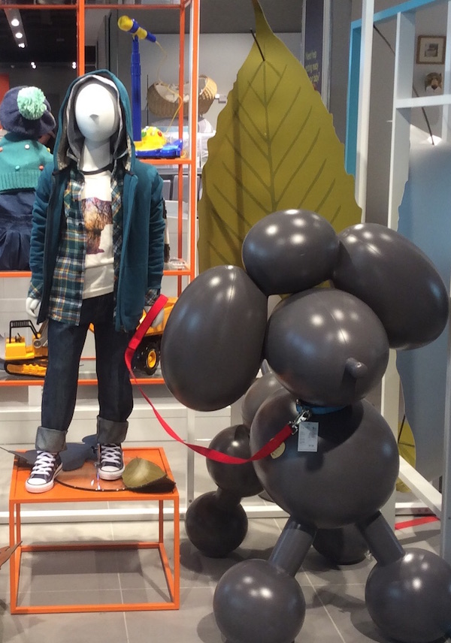
The store showed awesome retail guidelines and a wealth of retail staff, all with new lilies in their lapels. All over the place was composed onto rails and basic apparatus, with faultlessly styled and facilitated mannequins, and heaps of tables utilized as components with level dress.Fall leaves were the key prop and subject for POS in all divisions (Riisberg& Munch, 2015). In any case, the standouts were the room sets that felt so unattractive – ideal for those short, comfortable, cool fall evening.
The store has the opportunity to present its products in the best possible light while the customer freed urgent attention of the seller, can take the time needed to examine the goods. From the very beginning, Store’s windows are a sensation among passers who have not used to seeing so many attractive things.

3.2.4 Lighting
The lighting exerts a decisive impact on customer buying behaviour (Dagger & Danaher, 2014). The store’s windows present a scene of small theatre stages, between dream and reality. Although, in Britain, lingering in front of the windows is considered vulgar by good society and the policemen do not like gatherings they cause; however, the dressing, decoration and beauty of John Lewis windows compel the passers to be glued to it.
To verify that the passer has the image to be transmitted, it is essential that during assembly several times outside the store to see if he has attracted towards the focal point and light assembly without dazzling (both day and night). To control daylight, lighting systems are used to regulate automatically. To highlight a small object, playing with the beam width of the bulb. Finally, a showcase add reflectors will take the spotlight.
The elements used outdoors or window-light, colour, animation, environments, clearly-recreate artificially stimuli for attract buyers into the store. Once there, other elements such as the provision of goods, testers, use of technology, comfort or recreation of the collection to encourage customers to remain there long enough and to make a purchase. With visual branding and merchandising of store, buyer gets to enjoy a positive experience of purchase and will return to the store on another occasion.

3.2.5 Christmas Theme
In 2014, John Lewis store presented a campaign of the story of the friendship between Sam, a little boy and his Monty "real" Penguin. Monty the penguin, is an ideal playmate accompanying Sam wherever he goes, sleeps with him, plays hide and seek. Through this adorable tale, John Lewis unpacks its love for the beautiful gifts: those that we dream for Christmas.
Like every year, this campaign was created by its agency DDB Adam & Eve does not merely of a spot, even if it was viewed more than four million times in a week. It transformed the little Penguin into a genuine star by dragging it on the red carpet. Monty was available for sale in the John Lewis store in Oxford Street and in which was set up by Microsoft, a device allowing all scanner children their favourite teddy and transformed it into 3D view, on a larger scale. They were able to make them wake up, dance and interact with.
As every year, the British department store chain John Lewis unveils advertising for the Christmas period.
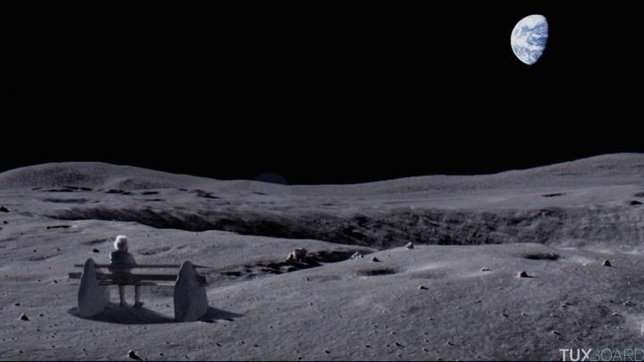
After a beautiful spot on the friendship between a boy and a penguin in 2014, the store staged, in 2015, a little girl, looking at the sky through a telescope discovering an old man living on the moon. Only the latter spends his time watching the blue planet sitting on a bench. For 2015, this is the song Half the World Away Oasis which was reinterpreted by Aurora.

3.2.6 Website
In the year 2001, John Lewis store had started its online store (Glancey, 2014). Although no online catalogue is available about the available products, the website is really user friendly and easy to navigate. The site is just another channel through which the client can communicate with the brand.

3. 3 Selfridge

3.3.1 Store Design
Selfridges Store, located at Oxford Street, receives 250,000 individuals a week and considered as one of the busiest department stores of Europe (Fisher &Keeble, 2011). The store has made new space to showcase the 'most elite' every season. It is not about the big names; they are likewise quick to "develop" lesser-known, rising brands and London-based creators – symbolized by the white cast of a hornbeam tree that is the room's point of convergence. A portion of the building's specialty deco components have been deliberately re-established, from cornicing on the roof to the French hand-blocked wallpaper wrapped around the till focuses. Behind it, the first high windows confronting Oxford Street have been revealed, letting in that uncommon thing in a retail establishment, common light. Cash is additionally being immersed men's design.
Three characteristics that define the best way to show the product and promote corporate image inside the store: create a nice space (got by plant layout, lighting and ambient); help locate the product (through exhibitors and murals) systems; and inform clearly about him (through graphics and signalling). The professionals refer to the need to understand the product that it is exposing to reach the consumer influence.
The ideal route that should be taken by the customer must address two key points: access or access to the store (as in the surface closest to them will be located most consumer products and therefore more sales appeal) and the benchmarks or focal (exhibitors, name brands or shelves) to the store, to remain as long as the consumer may therefore also increase the chances of buying. They establish focal points where the eye of the consumer (line vision) that accesses the store is pose, meaning that anything in its path should hinder it. The halls of the store are huge, splendidly lit excellence corridor, which stocks around 100 brands.
The number of exhibitors will depend on the number of products to expose and turn this functional criterion or exclusive nature of the brand. To expose the products can opt for linear (glass exhibitors) or glass exempt (tables, furniture, shelves and found objects). The decision will depend on the type of articles to expose and the amount and the customer to whom it is directed. The advantage of exempt, provided that their size suits the articles which have, lies mainly in its ability to give visibility to the object from all angles, as in used in Habitat stores. Tables allowed folded articles as jeans, and shirts point and accessories. Join two tables of different heights is a good resource for attention, although the amount exposed product should be rearranged frequently. Another Exhibitors formats used in jewellery are gondolas, shelves as a rectangular cabinets with interior lighting to show all best merchandise. Finally, there are crates, boxes and pedestals that provide a change of pace on the inside, because like in the window is vital to keep the attention of the buyer.

3.3.2 Lighting
The store has shown prodigious effects from lighting, spotlights on the roofs signal the presence of the store for many miles away and the crowd moves every year to admire the Christmas decorations. The best designers are contacted to design posters of great artistic value. Advertisements and press campaigns aimed at forging a myth and give a personality to the Selfridges store. Thus, by inserting in each of its ads a sort of homily with its ​​amazing signature, Selfridges gives the impression that it has a personality of its own which is highlighted by its Shopping bags, the unique architecture of its building, the art of window dressing, Christmas decorations etc.

3.3.3 Windows
Selfridges and John Lewis as well as other stores like Liberty or Harrods etc. uses specific iconic symbols which customers finally learn to decipher the codes of interpretation: the packed showcases goods mean that the store does not belong to the top range, and window dressers practice elitist presentation. From the 1970s, the windows were showing murder victims, cooking scenes accompanied by broken objects etc. (Brătucu, 2013). In the same city, the Barney showcases become as famous for their deliberate bad taste and excessive caricaturing celebrities like Madonna or Margaret Thatcher, which proves that the art of window dressing has lost none of its relevance and its popular charm.
To facilitate understanding of the message and the concept of the window, the traveller show interest in the product, and therefore will access the store (Brătucu, 2013). As for the pictures, their usual widespread use, due to digital technology and easy installation, stuck to the glass or on paper to be hung from the ceiling.
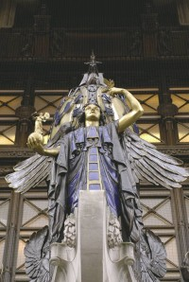
The store's windows are its major resource in offering itself. Gone by a large number of individuals by walking, they can possibly make a gigantic effect. The windows are hugely critical: 20 percent of business-winning exchange is from the windows. The layout of the product in the window is performed according to space and the depth of the store and the amount of product exhibit. Regardless of the window through which chooses each mark, taken into account in any case the use of a false ceiling and pavement with removable panels on the ground, with the dual aim which may be used for fixing screws and at the same time go unnoticed. It is necessary to equip the window of other "silent" elements as lighting quality; hidden power outlets; Blinds to work discreetly; Speaker to be informed of what happens in the great surface and fire suppression system to prevent accidents.
When Alannah, who imparts an adoration for craftsmanship to her dad, were on board, she drew artists to plan the windows; when Alison Jackson put her trademark Tony Blair and David Beckham in window, it attracted a mob towards Selfridges Windows (Brătucu, 2013). The police at last demanded to stop the venture because it was stopping up the Oxford Street.

3.3.4 Themes
Under the innovative leadership of Vittorio Radice –Selfridges got to be known for its vast themed advancements, now abundantly imitated by opponents. Tokyo, Brazil and Las Vegas filled the store with exceptionally foreign products, live execution, and intuitive shows and appear bars. These advancements are proceeding under the new administration however on a littler scale (Opriş&Brătucu, 2013).
Windows of Selfridges are most effectively used in Christmas time. For example few years back the store used a fairy-tale theme created by author Maggie Prince, the highwayman. As he escapes over the windows with his swag, past flawlessly manicured topiary, he leaves a sparkling trail of gold stash.
The Christmas windows were a tremendous undertaking; essentially dressing them takes the group and outside temporary workers. Despite the fact that the current year's outlines have just barely gone in plain view, meetings to generate new ideas for Christmas began ahead of schedule and the topic is usually selected in November. In general, the events as Christmas are prepared a year in advance to research, design and ordering accessories manufacturing time, while the calendar of the other projects is six months away. From the immovable dates the rest of the year is structured, targeting the specific time to install and disassemble each window and numbering the windows next to the assigned date.
Last year Christmas decoration of Selfridges has engaged consumers of all ages by using themes of 25 classical stories. The attention of different generations moves well in splendid wide open Old Things of the shop that invites craftsmen, architects, artists and business visionaries. Selfridges resembles the older generations to reorganize campaign.

3.3.5 Advertising and Campaign
To attract the crowds Selfridges need advertising, despised by the world of small traders, will become a major concern of the department stores. Employees advertising media are infinite in number: ornaments, posters, banners, printed (postcards, catalogues) paid advertisements and press releases in the media. For example, Selfridges use yellow shopping bags as iconic symbol of store. Providing customers with paper bags is a way to encourage them to take their purchases rather than delivered. The building of the store itself become the first holder of the outdoor advertising: facades and windows offer a perfect stage to launch promotions, cornices serve podium for fashion shows, balconies receive the speakers. Each is covered with signs, luminous letters indicating the name of the establishment or even giant paintings.
Selfridges is also famous for its yellow shopping bags. The innovative retail experience offered by Selfridges brand strategy has moulded a solid legacy that has come to be symbolized by the yellow colour bags. Yellow is invigorating colour which catches the enlivened imagination and creativity of Selfridges. The shopper's acknowledgment of this and the way they feel about the brand has even brought about an attractive exhibit of Selfridges' pantone 109 stock and a pop-up: 'The Big Yellow Shop'. The Selfridges Yellow bagis now become a status symbol for customers (Fisher &Keeble, 2011).
Selfridges launches a campaign in a process of peace and wholeness, the famous brand decided early this year to do an operation entitled "NO NOISE". The Idea is to meet a concentration of advertising and visual information daily by removing the logos of certain products. Thus the Levi's brand, Heinz, Clinic and many others have accepted to play the game by creating limited editions of their products without logo. Selfridges has also removed its logo from their bags, thus giving birth to the yellow bags. The store also offers rest and relaxation areas with meditation sessions to its consumers. The music volume is lowered in some rays and cell phones are prohibited to avoid noise and do not disturb the clients.
It is highly likely that a product without logo or trademark does not attract the consumer. It will identify with other characteristics of the product but will nevertheless be obliged to identify the brand before making the purchase. A product without logo does not stand out from other products and becomes uninteresting to the consumer. The logo encourages the consumption of this or products to which the client identifies and develops shopping habits. As we are constantly "bombarded" information, the world has become a noisy and stressful place. So the goal of the organizers is to show the power of peace, to show the beauty of the product by its function and find peace among the crowd.

3.4 Harvey Nicholas

3.4.1 Store Design and Décor
Harvey Nichols, the largest luxury retailer in the world presents the new concept of brands design which are the models for Harvey Nichols stores. Harvey Nichols provides the buyer with unmatched experience in luxury retail. Harvey Nicholas new store is located in the heart of the mailbox, with 45,000 square feet covered area. It is designed in collaboration with the specialist retail design, Virgil + Partners (Banks, 2015). The new concept introduced innovative ideas and revolutionary design to create a unique and imaginative translation of the Harvey Nichols brand integrates digital technology and exceptional services to enhance the customer experience and transform innovative retail environment.
The store presents over 200 of the most desirable brands in the world related to fashion, beauty, food and wine, many of which are exclusive to Harvey Nichols Birmingham. The change exquisite brands are complemented by the design, décor and service of the store. Offering experience unparalleled in the food, wine and hospitality, the elegant restaurant has an open kitchen and a table of leaders, a cocktail bar and an exclusive private dining room, which will be open after hours Opening of the store.
The upscale brand "Harvey Nichols" initially in direct competition with the Harrods London, opened in Liverpool a concept store named "Beauty Bazaar". This new store is located on 2'000 m²covered area on 3 levels, fully dedicated to beauty(Russell & Cohn, 2015). The ground floor focuses on perfumes and skin care, while the first floor is as a care space and wellness including a hair salon, a nail bar and eyelashes, and a champagne bar and cocktails. The second floor has a medical office-like since it is reserved for treatments like tooth whitening, permanent makeup or Botox injections. The brand has become over the years a powerful chain that has managed to conquer a young and wealthy clientele.

3.4.2 Lighting
Lighting of the store was made by PJC Light Studio Limited, London(Russell & Cohn, 2015). They promptly homed in on two of the most prestigious Reggiani fittings to be utilized as a part of an extensive variety of zones over the store, including women’s’ wear, menswear, perfumery, underwear and shoe offices.
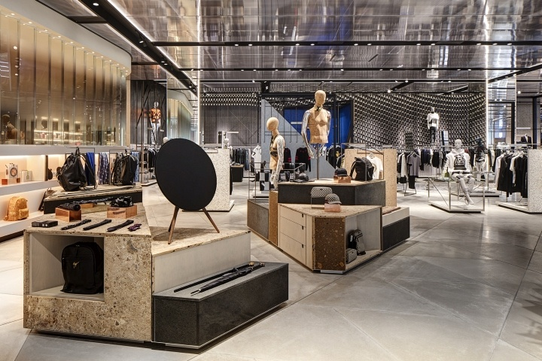
Source: Walter, 2015 (http://www.dalziel-pow.com/blog/harvey-nichols-birmingham)
More than 800 extensive Reggiani YORI luminaires consolidating 30W LEDs were chosen in dark fitted onto prior tracks and set inside of dark channels to mix flawlessly with the dull roof plan. Furnished with a limited bar reflector and a cross-sharp edge louver to kill any glare, the YORI luminaire offers exact brightening that is perfect for stock territories and it can without much of a stretch be balanced for more characterized lighting control.
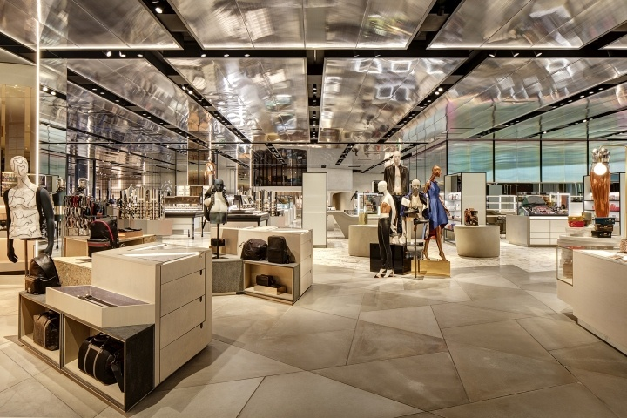
Source: http://www.harveynichols.com/store/birmingham/
PJC determined the vast YORI luminaire in white for the undergarments and swimwear division with the fittings, at the end of the day, secured on previous tracks yet inside of white roof spaces against a white roof to make an altogether different style to this specific region. The augmented and rich changing room space for the new store uses Reggiani's round recessed luminaires utilizing 8W LEDs. The Trybeca fitting supplements the extravagant outline of the exceptionally roomy changing zone and orchestrates well with the current, unwinding surroundings, whilst giving a magnificent nature of light – a flat out basic for an unrivalled changing area for recognizing customer (Russell & Cohn, 2015)
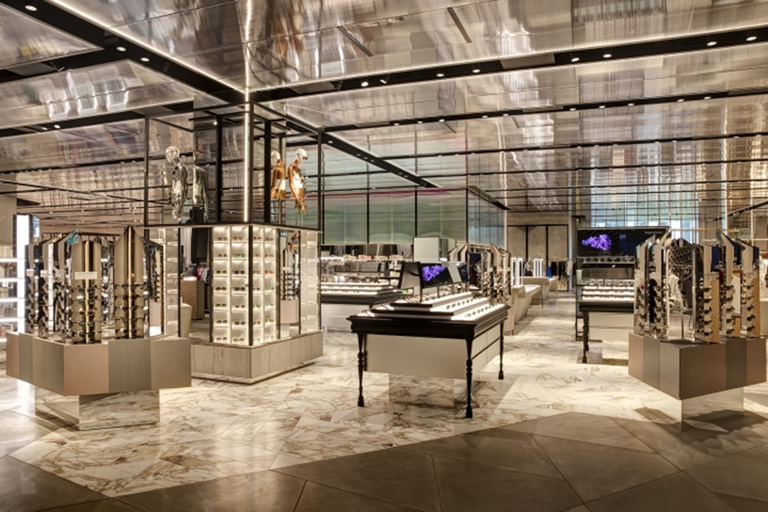
Source: http://ivanka.hu/projects/hospitality/harvey_nichols

3.4.3 Windows
Harvey Nicholas show high creativity and innovation in their window designs. These present an attractive view to the passer-by.
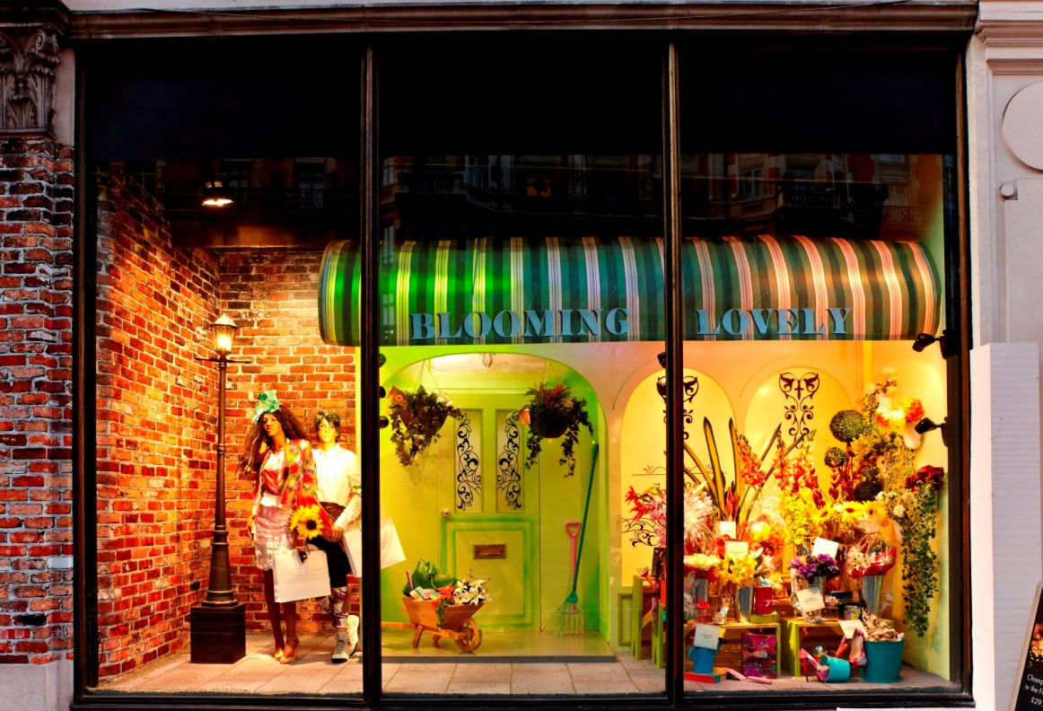
Source: Carr, 2014 (http://www.alumind.com/article/keeping-creatively-individual-harvey-nichols/)
Harvey Nichols takes its windows and visual merchandising to a new level with the introduction of a high-impact digital display positioned above the main entrance Harvey Nichols, accessible through the mall mailbox.

3.4.4 Christmas Campaign
For its Christmas campaign, the chain of stores Harvey Nichols raised awareness to those who may give gifts that they may be ill-chosen. This is the case in the countryside where one can see a person with family at Christmas receiving gifts which he did not really want. Note in fact that the protagonist of the commercial strength her smile when she receives a book or a knitted sweater. The brand puts its finger on this situation to become a certainty of quality.
72% of UK admitted to having already received a gift they did not want. Also, 63% recognize to wear this gift the opportunity to continue what fulfilled: to fool the sender of the gift. On this basis, the brand therefore depicts a situation that we all lived. The notion of the gift against gift is important here and focuses on recurrent social behavior through which the brand built its message. It allows to be a better friend, a better lover, a better brother etc. within the social group by revealing a truth. The brand wants us to realize that nobody will tell whether our gift is not appreciated.

3.4.5 Advertising Campaign
In every store there are thieves, but this is the first time a brand decides to stage them for an advertising campaign. In recent years, it is a fact that the British retail chain lacks creativity to establish its reputation. Everyone remembers the campaign Walk of Shame, starring women, drunk and wandering the streets. This whereupon Harvey Nichols gave them sound advice: even has a hangover the day after the New Year holidays, so wear a chic dress!
Little controversy at the time, but nothing had compared to posters featuring mannequins to wet crotch, expressing the excitement of women to approach balances. This year the brand plays on another level but equally amazing: it has unveiled an assembly made ​​up of small snippets of film cameras.
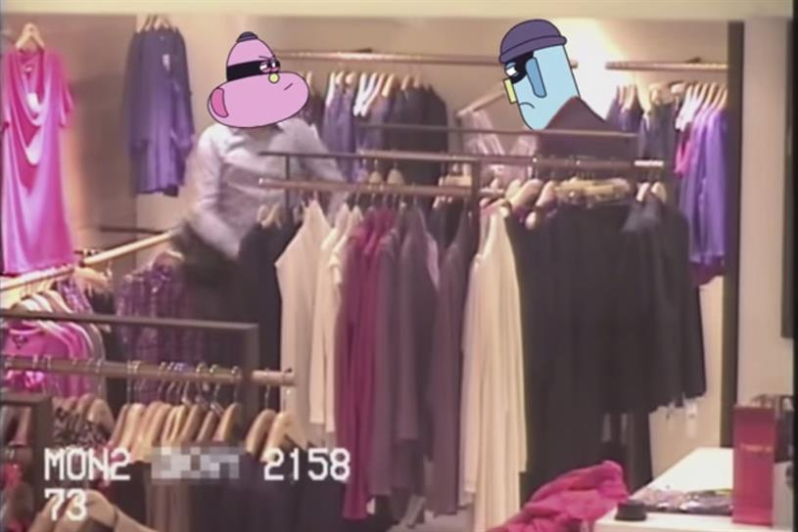
Source: Swift, 2015 (http://www.campaignlive.co.uk/article/watch-harvey-nichols-cctv-shoplifter-ad/1355738)
Films that target shoplifting and especially scroungers whose faces were covered by cartoons heads that we owe to Layzel brothers (Swift, 2015).

Conclusion
This study has served the purpose of analysing the concepts ofbrand identity and corporate communications. This work has tried to show the elements which make the brand identity of a department store and have shown some aspects that are embodied in various ways to provide information about the symbolism of the elements of brand identity to get a closer contact with customers. Specifically and in view of the results obtained, we can answer the research questions and draw some conclusions of interest for management.
During the golden age of department stores, elegant thronged the aisles of luxurious Bon Marché, Bergdorf Goodman, Saks Fifth Avenue and Selfridges. Originally, department stores were like huge ships that anchored in the city centre and offering products from around the world. These were the souks of the nineteenth century. People do not go to buy, but to spend time there, stroll and enjoy those wonderful things they had heard about them. It all started when large discount stores and specialty channels have captured some product categories: books, CDs, computers and furniture. They have attracted mass customers, before becoming the giants of e-commerce, such as Amazon. Department stores then bet everything on department store, a sector with high margins, and where to touch and feel the items are essential for customers.
When the study delves into each of theelement of brand identity of department stores, notable differences are perceived. Thus, it has been found that the logos often refer to elements of the region that have historically operated. These are also reflected in the slogan, and as point of perceptions of some of the stakeholders targeting more than purely aesthetic aspects, logos have more social orientationexplained through the messages they convey to their environment.
There are various objects that visually support thecreation of brand identity of department store. It is, therefore often from the original drawings of the visual merchandiserwhich is specifically designed accessories and finishes to customize. According to this pattern, the exposed continuous series of accessories of Showcase wall, are broken at one point by a potently space to attract the eye of the traveller and make better as a consequence of successful game. The possibility of reuse of accessories inside the store becomes more profitable, as long as after its makeover (painted, decorated or mixed with other) is not recognizable by customers.
Colour can be provided in different ways: painting, graphics, lighting etc. It considers two main criteria: the significance to each culture and the psychological reaction that causes viewing. The dominant colour of the brand helps to be effective in making this decision, and therefore, the department stores usually serves three colour classifications: First, the criterion of the primary colours (red, yellow and blue) apart from the secondary (the result of the combination of two primary, orange, green and purple) and tertiary (the combination of a primary with a secondary, up to six colours: brown, burgundy, indigo, light orange, green light and dark green). A second classification distinguishes high density of colour (red, yellow and blue) colours of low density or achromatic (grey, white or black).Finally, they all vary according to the applied hue (darker if mixed with black, clearer if they do with white) and depending on the light intensity in colour (known value).
The literature review in this paper concludes that the department stores have gone from being a place to distribute the product, to a tool of communication. The department store considered as a communication tool for emotional bonding getting this phenomenon with the public. If the department store is the product, the street is the market; then strategic location and design of windows is as important as control what happens inside.
The visual brand identity of department stores has the potential to change the perception of the traditional marketing mix variables, becoming of place in promotion tool. Similarly brand identity of department stores has assumed parameters or values ​​of luxury brands when design their windows and inside their stores. As 90% of the information people collect is visual, the effort of visual branding affect the active perception and behaviour of consumer regarding brand identity of department store.
Literature review research leads to the conclusion that the impressions and perceptions of public (image) are built on communication of the organization (Identity) and it is actually the public perception and image of the department store which makes its brand identity. In addition to that, this research has also proved that brand identity and corporate image are interrelated, which, in a way, build the organization itself, for its own reading of these external impressions (Christensen &Askegaard, 2001). This dialogic identity-image process is made possible by the amalgamation function that meets the organizational culture. According to this study, this effort of clarification and notions of identity and corporate image has a potential applicability in business management.

References
Aaker, J. (2004). Dimensions of Brand Personality.Journal of Marketing Research, 34 (3), 347-
356.
Abratt, R. &Kleyn, N. (2012). Corporate identity, corporate branding and corporate reputations:
Reconciliation and integration. European Journal of Marketing, 46(7/8), 1048-1063.
Alessandri, S. (2001). Modelling Corporate Identity: a Concept Explication and Theoretical
Explanation.Corporate Communications: An International Journal, 6 (4), 173-182.
Alvesson, M. (1990). Organization: from Substance to Image. Organization Studies, 11, 373-394
Baker, M.J. &Balmer, J.M.T. (1997). Visual identity: trappings or substance? European Journal
of Marketing, 31 (5/6), 366-382
Balmer, J. (2008). Corporate Identity, Corporate Branding and Corporate Marketing: Seeing
through the Fog. European Journal of Marketing, 35 (3/4), 248-291
Balmer, J.M.T. &Gray, E.R. (2000). Corporate identity and corporate communications: creating
a competitive advantage. Industrial and Commercial Training, 32 (7) 256-261.
Balmer, J.M.T. &Greyser, S.A. (2006). Corporate marketing: Integrating corporate identity,
corporate branding, corporate communications, corporate image and corporate reputation. European Journal of Marketing , 40 (7/8), 730-741.
Banks, Tom (2015). Harvey Nichols looks to “redefine luxury” with new store designs. Design
Week. Retrieved on 6th January 2016 from:
http://www.designweek.co.uk/harvey-nichols-looks-to-redefine-luxury-with-new-store-designs/
Bernstein, D. (2009). Rhetoric and reputation: some thoughts on corporate dissonance.
Management Decision, 47 (4), 603-15.
Bhattacharya, C. &Sen, S. (2003). Consumer-company Identification: a Framework for
Understanding Consumers’ relationships with Companies.Journal of Marketing, 67, 76-88.
Biloslavo, R. &Trnavčević, A. (2009). Web sites as tools of communication of a "green"
company. Management Decision, 47 (7) 1158-1173.
Brătucu, G. (2013). Visual Merchandising Window Display.Bulletin of the Transilvania
University of Brasov. Series V: Economic Sciences, 6(2).
Breugelmans, E. & Campo, K. (2011). Effectiveness of in-store displays in a virtual store
environment. Journal of Retailing, 87(1), 75-89.
Carr, Amanda (2014). Keeping it Creatively Individual at Harvey Nichols. Retrieved on 6th
January 2016 from:
http://www.alumind.com/article/keeping-creatively-individual-harvey-nichols/
Chajet, C. &Shachtman, T. (2008).Image by Design: from Corporate Vision to Business
Reality. New York: McGraw-Hill.
Christensen, L. &Askegaard, S. (2001). Corporate Identity and Corporate Image Revisited: a
Semiotic Perspective.European Journal of Marketing, 35 (3/4), 292-315.
Cocheo, S. (2009). Banks wade into new media stream. ABA Banking Journal, 101 (5) 14-29.
Cornelissen, J. &Elving, W. (2003). Managing Corporate Identity: an Integrative Framework of
Dimensions and Determinants.Corporate Communications: An International Journal, 8 (2), 114-120.
Cornelissen, J.P., Lock, A.R. & Gardner, H. (2001). The organization of external communication
disciplines: an integrative framework of dimensions and determinants. International Journal of Advertising, 20 (1), 67-88.
Cornelius, N. Wallace, J. &Tassabehji, R. (2007). An analysis of corporate social responsibility,
corporate identity and ethics teaching in business schools. Journal of Business Ethics, 76(1), 117-135.
Dagger, T. S. & Danaher, P. J. (2014). Comparing the effect of store remodeling on new and
existing customers. Journal of Marketing, 78(3), 62-80.
Dolphin, R.R. & Fan, Y. (2000). Is a strategic corporate communications function? Management
Decision, 38 (2), 99-106.
Fisher, Fiona &Keeble, Trevor (2011).Performance, Fashion and the Modern Interior: From
the Victorians to Today. Bloomsbury Academic
Freeman, K. (2005). Creating strategic taglines. Strategic Direction, 10 (21), 3-4.
Gioia, D., Schultz, M. & Corley, K. (2000). Organizational Identity, Image and Adaptive
Instability.The Academy of Management Review, 25 (1), 63-81.
Glancey, Jonathan (2014).A Very British Revolution: 150 Years of John Lewis. Laurence King
Publishing.
Goodman, M.B. (2001). Current trends in corporate communication. Corporate
Communication, 6 (4) 117-123.
Greyser, S.A. (2009). Corporate crises brand reputation and brand management, Management
Decision, 47 (4), 590-602.
Gylling, C & Lindberg-Repo, K. (2006). Investigating the Links between a corporate brand to
customer and brand. Journal of Brand Management, 13 (4/5) 257-267.
Henderson, P.W., Cote, J.A., Leong, S.M. & Schmitt, B. (2003). Building strong brands in Asia:
Selecting the visual components of brand image to maximize strength. International Journal of Research in Marketing, 20 (4), 297-313
Hutton, J. (1997). The influence of brand and corporate identity on consumer behavior: a
conceptual framework. Journal of Brand Management, 5 (4), 428-439
Hynes, N. (2009). Colour and meaning in corporate logos: an empirical study. Brand
Management, 16 (8), 545-555.
I, H.W. &Balmer, J.M.T. (2007). Identity studies: Implications for multiple perspectives and
corporate-level marketing. European Journal of Marketing, 41 (7/8), 765-85.
Jorda-Albiñana, B., Ampuero-Canellas, O., Vila, N. & Rojas-Sola, JI (2009). Brand identity
documentation: a cross-national examination standards of identity manuals. International Marketing Review, 26 (2), 172-197.
Kapferer, J.N. (2004). The new strategic brand management. New York, NY: Kogan.
Keller, K. L., Parameswaran, M. G., & Jacob, I. (2011). Strategic brand management: Building,
measuring, and managing brand equity. Pearson Education India.
Kim, T. J., Kim, K. W., Lee, I. H., Jang, S. J. & Park, S. S. (2013). A Research on the Effect of
Duty Free Shop's Visual Merchandising (VMD) to Customer Loyalty with Parameter Effects of Brand Awareness and Image.Journal of the Korean Society for Aviation and Aeronautics, 21(2), 47-61.
Kirby, A.E. & Kent, A.M. (2010). Architecture as brand: Store design and brand
identity. Journal of Product and Brand Management, 19 (6), 432-439
Law, D., Wong, C. & Yip, J. (2012). How does visual merchandising affect consumer affective
response? An intimate apparel experience. European Journal of Marketing, 46(1/2), 112-133.
Lentschner, K. (2001). Behind the wave of corporate rebranding. Christian Science Monitor, 16-
18.
Loonam, M. &O'Loughlin, D. (2008). Exploring e-service quality: A Study of Irish online
banking. Marketing Intelligence & Planning, 26 (7), 759-780.
Melewar, T.C. (2003). Determinants of the corporate identity construct: A review of the
literature. Journal of Marketing Communications, 9 (4), 195-220.
Melewar, T.C., Hussei, G. &Srivoravilai, N. (2005). Corporate visual identity: The re-branding
of France Telecom. Journal of Brand Management, 12 (5), 379-394.
Melewar, T.C. & Jenkins, E. (2002). Defining the corporate identity construct. Corporate
Reputation Review, 5 (1), 76-90
Melewar, T. &Karaosmanoglu, E. (2006). Seven Dimensions of Corporate Identity: A
Categorisation from the Practitioners’ Perspectives.European Journal of Marketing, 40 (7/8), 846-869.
Miles, S. &Mangold, G. (2004). A conceptualization of the employee branding process. Journal
of Relationship Marketing, 3 (1), 65-87.
Northover, Jim (2011). Trust in Modernism. Eye Magazine. Accessed on 19th December 2015
from
http://www.eyemagazine.com/feature/article/trust-in-modernism
O'Cass, A. & Grace, D. (2004). Exploring consumer experiences with a service brand. Journal of
Product and Brand Management, 13 (4), 257-268
Opriş, M. &Brătucu, G. (2013).Visual merchandising window display.Bulletin of the
Transilvania University of Braşov,Vol., 6(55).
Otubanjo, B. &Melewar, T. (2007). Understanding the Meaning of Corporate Identity: a
Conceptual and Semiological Approach.Corporate Communications: An International Journal, 12 (4), 414-432.
Park, H. J. (2015). How does visual merchandising in fashion retail stores affect consumers’
brand attitude and purchase intention? International Review of Retail, Distribution and Consumer Research, Volume 25, Issue 1, 87 - 104.
Riisberg, V. & Munch, A. (2015). Decoration and Durability: Ornaments and their
‘appropriateness’ from fashion and design to architecture. Artifact, 3(3), 5-1.
Rowley, J. (2009). Online branding strategies of UK fashion retailers. Internet Research, 19(3),
348-369.
Russell, Jesse & Cohn, Ronald (2015).Harvey Nichols. Book on Demand
Stone, R. (2006). Expressing identity anywhere.ABA Banking Journal, 98 (8), 36-42.
Stuart, H. (1999). Towards a Definitive Model of the Corporate Identity Management Process.
Corporate Communications: An International Journal, 4 (4), 200-207
Swift, James (2015). Watch: Harvey Nichols CCTV shoplifter ad. Retrieved on 6th January 2016
from:
http://www.campaignlive.co.uk/article/watch-harvey-nichols-cctv-shoplifter-ad/1355738
Van Marrewijk, A. H. (2012). Retail stores as brands: performances, theatre and space.
Consumption Markets and Culture, Volume 15, Issue 4, Pages 374-391.
Walter, Chris (2015). Harvey Nichols, Birmingham. Dalziel&Pow. Retrieved on 6th
January 2016 from:
http://www.dalziel-pow.com/blog/harvey-nichols-birmingham
Weaves, M. (2009). Uncovering the corporate brand's core Values. Management Decision, 47(4),
616-38.
Zhang, X. (2012).2012 International Conference on Information Management, Innovation
Management and Industrial Engineering (ICIII), Volume: 1, 473 - 477.
Zhang, X. H. (2014). Virtual display design and evaluation of clothing: A design process support
system. International Journal of Technology and Design Education, Volume 24, Issue 2, 223 - 240.

