PUBH610: History & Principles of Public Health
PUBH610: History & Principles of Public Health

Student Name:

Student ID:

Contents
Foreword 3
Sources of information 3
Zones of understanding 3
Developing focuses and appropriate zones for Investigation 3
Introduction 4
Tools of gathering Clinical information 4
Methods 5
Quality and Outcomes Framework (QOF) information 5
Results 6
Strength and limitation of the examination 7
Discussion 8
Conclusion 9
REFERENCES 10

Foreword
The amplification of UK health consideration by the tool of Quality and Outcomes Framework which has discharged a remarkable contribution of information that in principle could help health value review as well as minimize health imbalances, the present paper takes into consideration special case announcing whereby patients can be prohibited from computation of repayment for reasons that is inequity in health. This paper has theorized that such avoidances could be connected to financial hardship.

Sources of information
Information resources are done by the data collected from the Disease of Global Burden and the Public Health England reports and Commonwealth Fund..

Zones of understanding
The study finds an elevated weight of avoidable illnesses and unsatisfactory imbalances in the country England. There is extensive desire as the amplifications to be made in counteracting ill health and handicap thus mitigating interest on medicinal services. Despite concurrence on the necessity for remedial action, the Government has deducted general health expenditure plans by combined 11% to 2020.Human health experts comprehensively steady of staying in the Europe face a intimidating struggle to hold health, work surroundings as well as ecological insurances.
The Case think about regions were picked in light of the fact that they had settings that speak to a test for health improvement and have comparative topographical profiles of provincial urban areas and post-modern territories over the three nations. The top to bottom subjective meetings were attempted with key partners (n=130) inside the eight contextual analysis destinations among March and April 2007. The key partners spoke to a scope of positions at vital and operational dimension, for example, Hospital Managers, Performance Managers, Directors of Public Health, Finance Directors and Member of Association. Meeting information were enhanced with data from limited Delivery Plans, execution reviews reports and measurements identifying with health imbalances.

Developing focuses and appropriate zones for Investigation
There is renewed awareness for air infectivity. Extraordinary climate occasions are trying reaction and hierarchical aptitudes of general health experts and demonstrating the requirement for more prominent support around environmental adaptation, biodiversity and assurance of biological frameworks. Environmental health and biological general health are thoughts and the time has definitely arrived.

Introduction
In the event that social and different disparities in health are to be handled, at that point fitting review instruments should be grown in order to advise the arranging and charging of health administration conveyance. Considering the characteristic in the Uk of the new contract of the General Medical Services (GMS), (GPs). Those are urged to utilize the proof based intercessions that is especially in the administration of ceaseless maladies. That for example, diabetes. the basic piece of this agreement that is the Quality and Outcomes Framework (QOF) framework. (DOH 2005).The QOF is fundamentally an installment framework for GPs yet is as of now appearing as a rich new asset of essential consideration information, especially for those inspired by incessant infections. One fascination of this record is the competence to connect health data to different resources of information in a row about the causative observing, for example nearby financial surroundings.

Tools of gathering Clinical information
Routine clinical and statistic information were gathered from training PC databases. The utilizing Morbidity Information Query and Export Syntax (MIQUEST) is an encoding software and EMIS Web from 152 of the 161 GPs in the three PCTs with a consolidated GP-enlisted populace that of 829 710 in mid-2008. Practice information secured over 98% of the GP-enrolled populace in the three PCTs. The Cross-sectional information were removed in the April of consistently somewhere in the range of 2008 and 2011 for all patients on the registers of Chronic diseases. All information was unknown and overseen as per the to the NHS data administration necessities of United Kingdom. (National Health Services, 2011). Detailed information to review in Tower Hamlets was likewise gathered from first to last by the software. Quiet dimension information on financial position or a indicator of hardship were not accessible during the time of the examination

Methods

Quality and Outcomes Framework (QOF) information
The study inspected chronic diseases pointers by using the information from the main year of accumulation (2005– 06) from general practices. This information was removed and two to three practices were disqualified from our investigation: two in light of absence of the electronic records and one in view of an atypical populace of the solely vagrants. The absolute numbers of patients with DM were recorded as marker 1 (DMGroupA). For every single consequent pointer, the quantity of patients who accomplished the marker was calculated that in the numerator and the quantity of patients who assented and were viewed as reasonable for the healing was documented in the denominator. neighborhood government and association associations (Local Strategic Partnerships; Health, Social Care and Well-being system gatherings; Community Health Partnerships) in 8 regions in the three nation. The Case think about regions were picked in light of the fact that they had settings that speak to a test for health improvement and have comparative topographical profiles of provincial urban areas and post-modern territories over the three nations. The top to bottom subjective meetings were attempted with key partners (n=130) inside the eight contextual analysis destinations among March and April 2007. The key partners spoke to a scope of positions at vital and operational dimension, for example, Hospital Managers, Performance Managers, Directors of Public Health, Finance Directors and Member of Association. Meeting information were enhanced with data from limited Delivery Plans, execution reviews reports and measurements identifying with health imbalances.

Results
The account concluded by the strategy explanations Policies in every the three nations have reliably accentuated the need to handle health disparities from 1997 onwards (for example both when devolution) and every one of the three nations have concentrated on health contrasts between financial gatherings and topographical zones fundamentally additional, for instance, the racial and sexual category based health disparities which are additionally recognized). Be that as it may, the three nations have adopted very unique strategies to execution appraisal of general medical problems and to the setting of pertinent targets Clinical needs and the job of the NHS The post-2004 approach proclamations to a great extent keep on underlining the significance of handling health disparities however a move is discernible concerning the accentuation set on the favored methods for accomplishing this point. In Wales, in any case, where the underlying accentuation on handling the more extensive Influences of health was maybe most simple, this move was increasingly substantive, speaking to a move far from authority enthusiasm for handling social determinants of health and health disparities to an emphasis on holding up times and health improvement. For instance, definitions included land contrasts in health inside territories, topographical contrasts among regions and the national normal, disparities between various ethnic gatherings, imbalances in access to administrations (especially in connection to rustic regions), the remarkable health worries of populace bunches who were considered „vulnerable‟, (for example, individuals encountering psychological wellness issues, those with learning handicaps, and individuals with medication and alcoholic conditions). Barely any respondents alluded to explicit meanings of health disparities from either nearby corporate plans or national approach explanations, uncovering the absence of shared definitions. There was, however, far reaching reference to social model of the health and comprehension of the effects of the more extensive determinants on the health disparities.
Smoking rates among Chronic Obstructive Pulmonary Disease patients diminished by a little however comparative sum over the entire examination populace. (NHS 2007 and Diabetes UK 2004).The focal point of our undertaking was on the decrease of contrasts between gatherings in the mediation PCTs. This is outlined in which indicates accomplishment of target esteems for every ailment for 2006 and 2009 . A decrease in health disparities is shown by chances proportions moving to gain the incentive for reference gathering. An incident of this is represented by the 82-year-old diabetic congregation, which demonstrates diminish in contrast in accomplishing intention of Blood Pressure control contrasted and the suggestion collection after some time. A large portion was of alternate a gathering which demonstrates an ingenuity of disparities.

Strength and limitation of the examination
This assessment makes use of routinely gathered information, which empowers us to take a gander everywhere populaces, except relies upon the precision of coding in numerous training locales. Tolerant dimension information on financial status was not accessible at the season of the investigation. Albeit internal east London rehearses have abnormal amounts of hardship, including an indicator for hardship has empowered us to assess that few observed contrasts between gatherings could have been clarified by changes in hardship. The health value reviews were a piece of a bigger improvement venture. The level and wide extent of the undertaking implied that, without a randomized mediation preliminary, the training health value reviews were probably not going to show a reasonable effect among the commotion of a varying NHS and a background of numerous nearby advanced activities. Other quality improvement extends in comparable inward city territories have focused on very explicit mediations, and have required extra financing and organized authoritative help to accomplish consequences that are supportable (Cockmann et al., 2011)
Zone: Queensland, Tasmania, Sydney
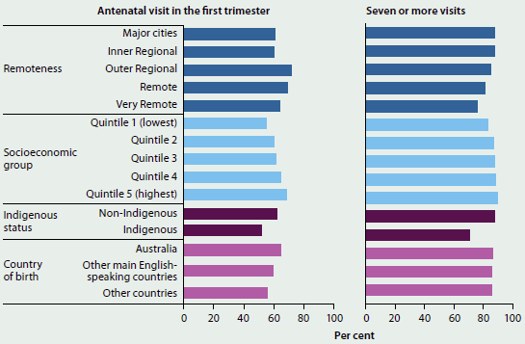
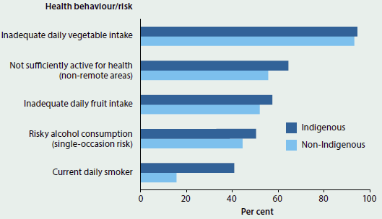
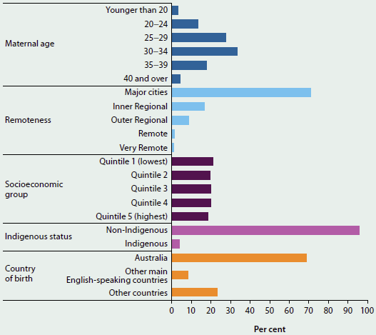

Discussion
Keep in mind that this examination is multifaceted and this short paper fundamentally clouds a portion of this unpredictability. It ought to likewise be noticed that there are inescapable difficulties both in contrasting arrangement proclamations and respondents also, in contrasting distinctive nations with one another through reference to contextual analyses inside those nations (especially when these contextual investigations consolidate a scope of various associations and populace profiles). It is obviously hard to catch neighborhood subtleties and mirror the unpretentious, subjective contrasts in style and qualities in every area and in this manner the investigation has fundamentally to be expansive brush. Be that as it may, the exploration was set up to examine wellbeing imbalances as an issue with regards to contrasting ways to deal with execution evaluation; what it offers is an impression of how a variety of interviewees in an assortment neighborhood settings (both as far as hierarchical setting and financial setting) have deciphered and incorporated approach direction.
A decrease in health disparities is shown by chances proportions moving to gain the incentive for reference gathering. An incident of this is represented by the 82-years-old diabetic congregation, which demonstrates diminish in contrast in accomplishing intention of Blood Pressure control contrasted and the suggestion collection after some time. A large portion was of alternate a gathering which demonstrates an ingenuity of disparities.
There is high-quality verification that strategy or the audits supplied on their own have modest impact on presentation, whereas the calculation of enhancement personalized to the instructive or decision-making needs of the practice has a superior contact on medical presentation (Miller and Archer, 2007; Feder et al., 1999; Phillips et al., 2010). While not unproblematic, and obviously recognized as time-limited, this methodology gives a vital understanding into how the three nations making up post-devolution Britain are reacting to the difficulties of decreasing wellbeing imbalances; a region that has so far gotten generally little research consideration. This article gives a valuable preview how sighted and how quick decentralization is affecting on approach difference in this unpredictable field of wellbeing disparities. The investigation of arrangement articulations attempted for this task uncovers an obvious move in strategy ways to deal with wellbeing imbalances at the national dimension, which happened in each of the three nations around 2003-2005.While more extensive determinants of wellbeing still component in later approach proclamations, the accentuation on way of life practices, singular duty.

Conclusion
Execution board frameworks, hierarchical arrangement and general authority and law enforcements have all changed amid the duration of the commission and the record exhibited in this paper may before long be supplanted, especially now the supporting administration of each of the three nations have alienated which recommends that strategy and work on identifying with wellbeing imbalances are starting to turn all the more effectively.

REFERENCES
Cockmann, P., Dawson, L., Mathur, R. and Hull, S. 2011: Improving MMR vaccination rates: herd immunity is a realistic goal. British Medical Journal 343, d5703.
Department of health. 2003: Tackling Health Inequalities: A Programme for Action. Retrieved from http://www.dh.gov.uk
Department of Health. NHS Patients and Staff Reap Rewards of GP Incentive Scheme as World’s Biggest Health Database Goes Live. London: Department of Health, 2005 http://www.dh.gov.uk/PublicationsAndStatistics/PressReleases/PressReleasesNotices/fs/en?CONTENT_ID=4118533& chk=q8TvGU
Diabetes UK.Diabetes in the UK 2004 . Diabetes UK, 2004. http://www.freepint.com/issues/160206.html.
Feder, G., Griffiths, C., Highton, C., Eldridge, S., Spence, M. and Southgate, L. 1995: Do clinical guidelines introduced with practice based education improve care of asthmatic and diabetic patients? A randomised controlled trial in general practices in east London. BMJ 311, 1473–78.
Miller, A. and Archer, J. 2007: Impact of workplace based assessment on doctors’ education and performance: a systematic review. BMJ 341, c5064
NHS Health and Social Care Information Centre. National Quality and Outcomes Framework Statistics for England 2004/2005 . NHS Health and Social Care Information Centre, 2005 . http://www.ic.nhs.uk/services/qof/statisticalbulletin/Bulletin.PDF

Phillips, C.B., Pearce, C.M., Hall, S., Travaglia, J., De Lusignan, S., Love, T. and Kljakovic, M. 2010: Can clinical governance deliver quality improvement in Australian general practice and primary care? A systematic review of the evidence. The Medical Journal of Australia 193, 602–07

